Books on Legs!
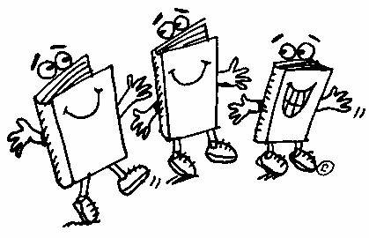

FREE BOOKS!

These books can be borrowed for as long as you like! You do not have to sign them out.
You can return them to this bookcase or pass them on to someone else.
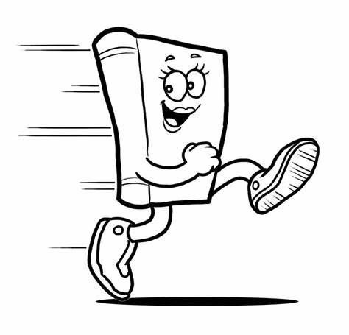
We hope you enjoy reading them!

