MyMaths Online Homework
‘How To’ Guide
About MyMaths
- MyMaths is an online-based maths homework system, which will be used to set children homework once a week on most weeks.
- This online system contains homework for most of the topics covered across the national curriculum.
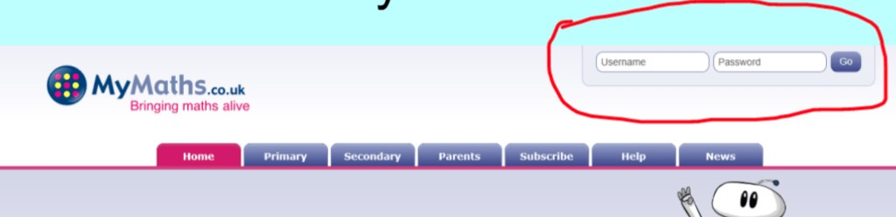

Website URL: www.mymaths.co.uk
- This is the homepage.
- In order to log in, you need to use the username and password
- Username: Bosmere
- Password: Square26
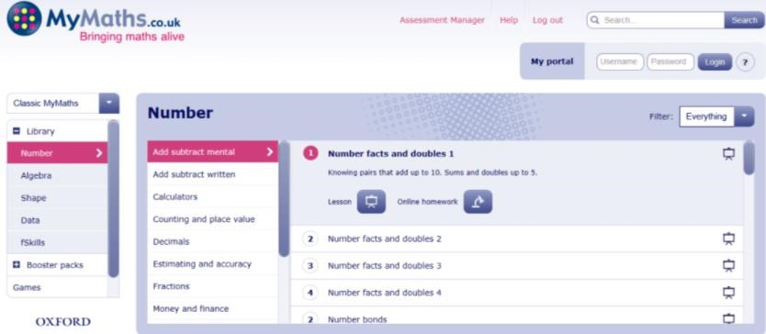
- You will then be taken to this page.
- Here, you can take part in any activities or games that you want to, without any results being sent to your child’s teacher.
e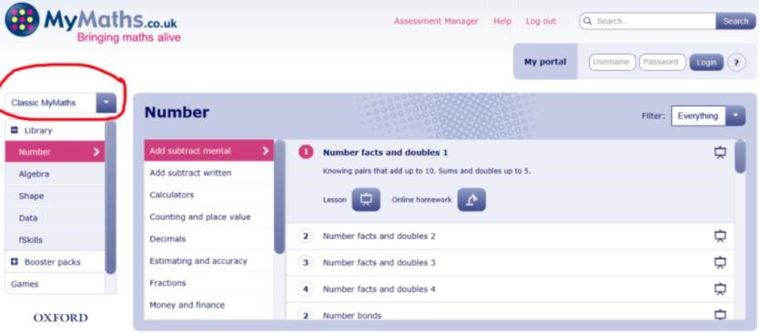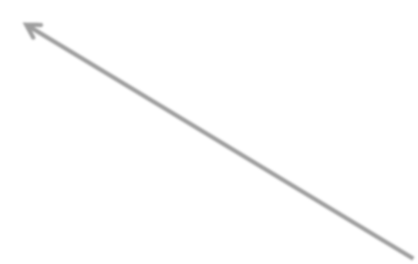
- If you change the bar shown above to
‘National Curriculum (Eng)’, then the activities offered are organised by year group.
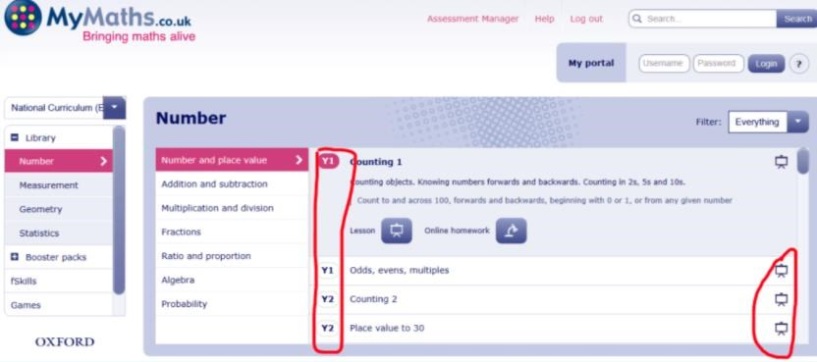• Here, you can choose to practise any activities.
- Also, you can access the online lessons here (where the icons in the shape of screens are).
- This is where your child can go over a topic that they may have found challenging at school.
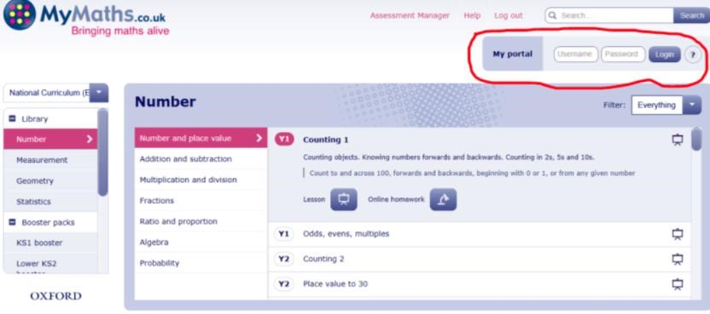
- In order to access your child’s homework, you will need to have their individual log-in details (their class teacher will have given these out).
- Enter their log-in details in the section shown above.
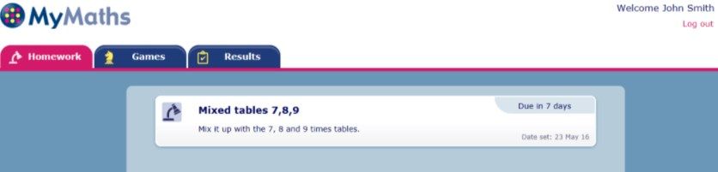
- When you log in, any homework tasks set by the class teacher will be displayed on this screen.
- It will also show when they are due to be completed.
- When you click on the homework task, the following screen will appear:
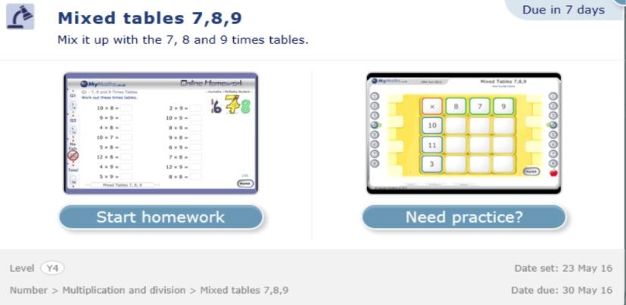
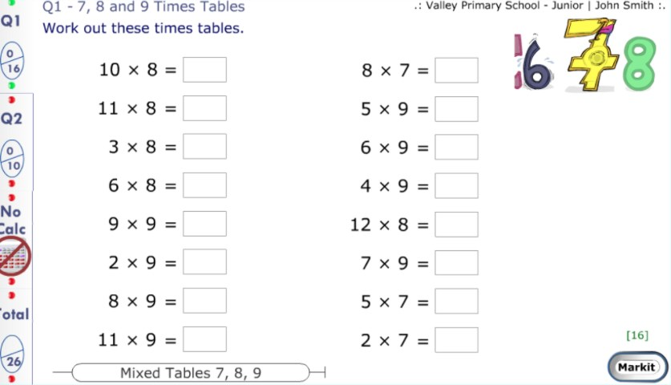
- Once your child has completed the first screen, click ‘Markit’.

- You then need to click ‘Q2’.
- Important part – ‘Checking out’!
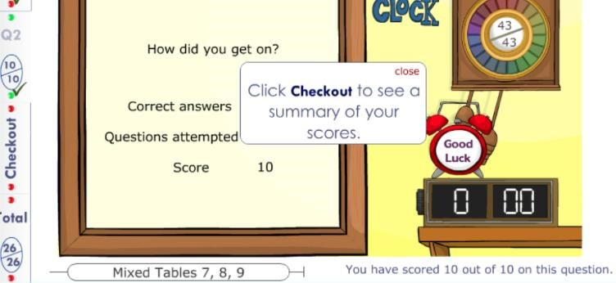
- Once you have completed both Q1 and Q2, you will be prompted to click ‘Checkout’.
- This sends your child’s overall score to their class teacher.
- IMPORTANT NOTE: If they don’t click ‘Checkout’, it won’t be shown as completed!
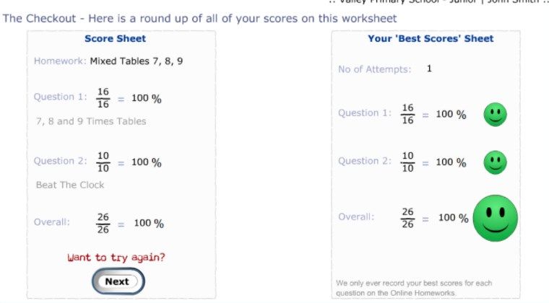
- You will then be taken to this screen, where you will be offered the chance to try the homework again.
- If the initial score shows room for improvement, remember that it is good practice to try again!
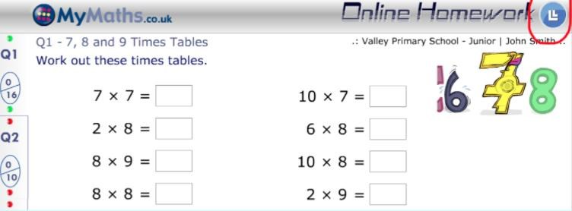
- If, at any point, your child is struggling with their homework, you can click on the lesson icon and work through the online lesson before completing the homework.
After Finishing the Task:
- Once your child finished their homework, if you then click the cross in the top right-hand corner, you will be taken back to your child’s home screen.
- If they have any other homework tasks to complete, they will be shown here.
- If not, you can click on the results tab and leave feedback for the class teacher.
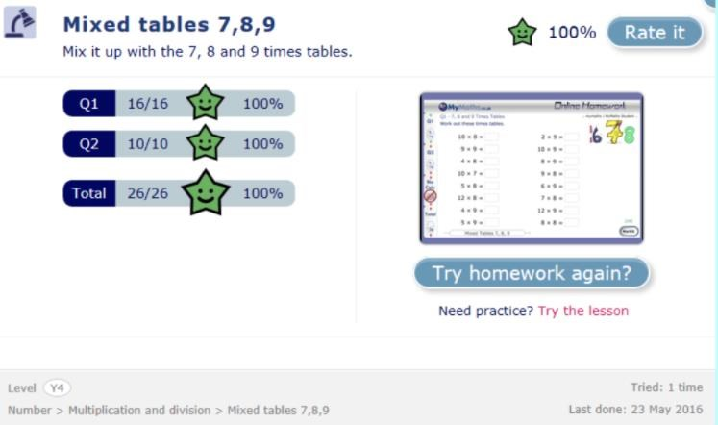
- Click on ‘Rate it’ and you can let the class teacher know how you child found the homework task.
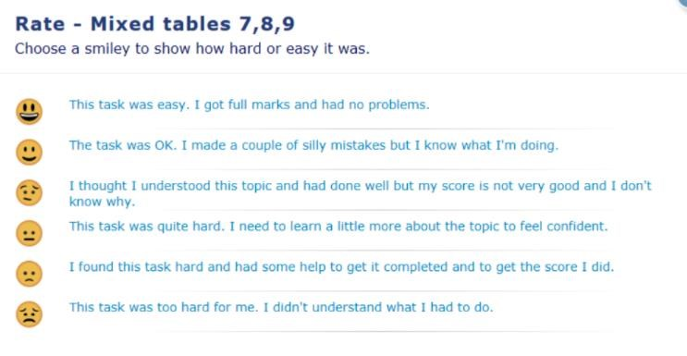
- Discuss with your child how they found the homework before clicking on one of the smiley faces.
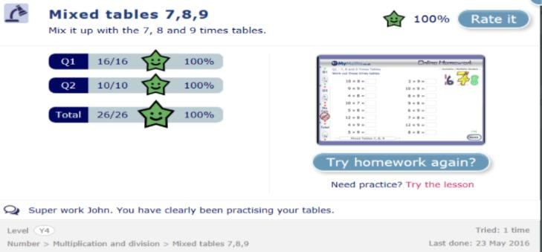
MyMaths can be used on an iPad/tablet!
(However, certain tools cannot be accessed such as the interactive ruler.)
Instructions on how to download the app are as follows:
- If you go to the App Store (or other tablet equivalent), download Puffin Academy.
- Once downloaded, type MyMaths in the search box.
- You will be given three options – choose the middle one, which is MyMaths for the UK, and install it.
Points to remember:
- Children can still use pencil and paper to show their working out.
- The class teacher can see how many times a task has been attempted.
- Only the child’s highest score is recorded.
- Make sure your child takes regular breaks away from the computer screen, if they are using it for longer than 20 minutes at a time.

