
Bosmere Junior School
South Street
Havant

Special Education Needs and Disabilities (SEND)
Appendix

Date: | September 2026
Review Date: | September 2027
Responsibility: | SENCO
STATUTORY
Checked against Equality Policy

Inclusion Manager: | Date:
SEND Governor: | Date:
Headteacher: | Date:

Entering Bosmere Junior School
The SENCO liaises with each child’s previous school to help identify children who have been assessed as having SEND. The SENCO ascertains what parental and outside agency involvement there has been to date. Once a child has entered Bosmere Junior School, the school is responsible for assessing the needs of the child and for keeping parents informed of any developments.

SEND Support
When a child is identified as having SEND, their needs will determine how work needs to be differentiated or whether they require either individual or small group work to reinforce the National Curriculum. This will generally be delivered in the classroom, but the child may be withdrawn to a nearby space if deemed appropriate at the time.

When a child is listed as ‘SEND Support’ a Pupil Profile will be written with the child, clearly stating their needs. Parents will be informed of their child’s progress and made aware of any extra support their child is receiving regularly through Assessment Updates and at parents’ evenings. The Pupil Profile will be updated on a termly basis and shared with parents at consultation meetings. It will include targets and progress towards these targets.

For children at SEND Support, the SENCO or Headteacher may also contact an outside agency to obtain advice on how to best support the child. This advice will be passed back to the parent, class teacher and LSA and a suitable support programme devised. The child might also be withdrawn from class to receive additional support with specific areas of learning, speech and language, social skills, behaviour support, improving fine and gross motor skills or reading. The SENCO will monitor the progress of the child and, if necessary, arrange for more advice from outside agencies.

Number of Pupils Identified as SEND Support or EHCP in the school’s SEN Audit: July 2026
Whilst numbers recorded represent current picture, Sept 26 is likely to have similar numbers of pupils with SEND.

 | SEND Support | EHCP | Total in year groups
3 | 16 | 2 | 18
4 | 18 | 3 | 21
5 | 16 | 7 | 25
6 | 18 | 2 | 20
Total | 68 (19.8%) | 14 (4%) | 82 (24%)
These numbers represent 24% of the whole school population.( 343 on role July ‘26)

Children with an Education Health and Care Plan

For children with EHCPs, targets will have been set when the final version of the EHCP was first distributed to the school and the child’s parents. The EHCP must be reviewed at least once a year. The annual review will look at the child’s progress towards the targets and new targets agreed for the next year. Further details are contained in the SEND Code of Practice (2015) on the identification and assessment of special educational needs.

Listed below are children with statements or EHCPs, their year group, their area of need and their additional funded hours of support.

EHCPs - July 2026
Pupil | Year Group | Area(s) of Need | Level of Support / Banding
EMR | Year 3 | - Communication and interaction | Enhanced B (£5600)
JC | Year 3 | - Social, Emotional, Mental Health | Enhance B (£5600)
BP | Year 4 | - Communication and Interaction | Enhanced B (£5600)
HP | Year 4 | - Social, emotional, Mental Health | Exceptional (£8755) and £14000 top up
TD | Year 4 | - ASC | Enhanced A (£3333)
AH  (PLAC) | Year 5 | - Cognition and Learning  - Moderate Learning Difficulty | Enhanced A (£3333)
FP  (LAC) | Year 5 | - Social, Emotional, Mental Health | Exceptional (£8755)
SH | Year 5 | - Social, Emotional, Mental Health | Targeted B (£2200)
FP | Year 5 | - Severe Learning Difficulty  - Autism  - Speech, Language or Communication Need | Exceptional (£8755)
GR | Year 5 | - Social, Emotional, Mental Health  - Cognition and Learning | Enhanced A (£3333)
TM | Year 5 | - Social, emotional, mental health | Exceptional ( £8755) and £8820 top up
BC | Year 5 | - Assessment in progress | Targeted B £2231
BH | Year 6 | - Social, emotional, mental health | Targeted B £2231
PH | Year 6 | - Social, emotional, mental health | Targeted B £2231
LG and RN to join yr 3 Sept 26

Areas of Need:

Speech, Language and Communication Needs
Children and young people with speech, language and communication needs (SLCN) have difficulty in communicating with others. This may be because they have difficulty saying what they want to, understanding what is being said to them or they do not understand or use social rules of communication. The profile for every child with SLCN is different and their needs may change over time. They may have difficulty with one, some or all the different aspects of speech, language or social communication at different times of their lives. Children and young people with ASC, including Asperger’s Syndrome and Autism, are likely to have particular difficulties with social interaction. They may also experience difficulties with language, communication and imagination, which can impact on how they relate to others.

Cognition and Learning
Support for learning difficulties may be required when children and young people learn at a slower pace than their peers, even with appropriate differentiation. Learning difficulties cover a wide range of needs, including moderate learning difficulties (MLD), severe learning difficulties (SLD), where children are likely to need support in all areas of the curriculum and associated difficulties with mobility and communication, through to profound and multiple learning difficulties (PMLD), where children are likely to have severe and complex learning difficulties as well as a physical disability or sensory impairment. Specific learning difficulties (SpLD), affect one or more specific aspects of learning. This encompasses a range of conditions such as dyslexia, dyscalculia and dyspraxia.

Social Emotional and Mental Health Difficulties
Children and young people may experience a wide range of social and emotional difficulties which manifest themselves in many ways. These may include becoming withdrawn or isolated, as well as displaying challenging, disruptive or disturbing behaviour. These behaviours may reflect underlying mental health difficulties such as anxiety or depression, self-harming, substance misuse, eating disorders or physical symptoms that are medically unexplained. Other children and young people may have disorders such as attention deficit disorder, attention deficit hyperactive disorder or attachment disorder.

Sensory and/or Physical Needs
Some children and young people require special educational provision because they have a disability which prevents or hinders them from making use of the educational facilities generally provided. These difficulties can be age related and may fluctuate over time. Many children and young people with vision impairment (VI), hearing impairment (HI) or a multi-sensory impairment (MSI) will require specialist support and/or equipment to access their learning, or habilitation support. Children and young people with an MSI have a combination of vision and hearing difficulties. Information on how to provide services for deafblind children and young people is available through the Social Care for Deafblind Children and Adults guidance published by the Department of Health Some children and young people with a physical disability (PD) require additional ongoing support and equipment to access all the opportunities available to their peers

Areas of Need: | Numbers of Pupils with this need listed:
Speech, Language and Communication Needs | 19
Cognition and Learning / Specific Learning Need | 39
Social Emotional and Mental Health Difficulties | 25
Sensory and/or Physical Needs | 5
*Numbers may not match with the number of children on the SEND register as some children have multiple needs

INSET
The school acknowledges the importance of in-service training and the professional development of teaching and non-teaching staff, to help them work effectively and efficiently with children with SEND.
Training needs will be made available through Performance Management of teachers and Individual Performance Plans for support staff. SEND strategies will be included within the induction period of new staff.

Admission arrangements for children with Special Educational Needs
The admission arrangements for children with SEND do not differ from the arrangements for children without SEND unless the child has an EHCP (Education Health and Care Plan). The SENCO will liaise closely with our feeder schools to ascertain details of children with special educational needs so that their needs can be more readily met. Details of admission arrangements can be found in the school’s prospectus and admissions policy.

Admission of children with more complex needs
Wherever possible, Bosmere Junior School promotes the inclusion of children with more complex needs.
Children with disabilities are not treated less favourably unless there is clear justification for doing so.
Access to most areas of the school has been provided for children with physical disabilities by the installation of ramps, handrails and linking doors. However, there are still areas of the school that can only be accessed internally via short flights of stairs. There are two toilets for the disabled situated at either end of the school.
Temporary ramps, stair lifts and other modifications to assist mobility and ensure access can be installed following assessment by and in consultation with Health Service professionals and County Advisory Staff.
(See accessibility policy)

Special provision for Children with English as an Additional Language (EAL)
The aim of Bosmere Junior School is to promote all cultures as being valuable, for this not only creates a more harmonious and understanding environment for all children, it specifically raises the self-esteem of children with EAL, encouraging them to take a pride in their culture and their abilities.
The addition of special provision for a child with EAL is not based on intellectual ability but rather on providing opportunities to gain better access to the curriculum. A child who speaks more than one language is supported in both the first/home language and English following an application to EMTAS. The SENCO contacts EMTAS as soon as there is a concern about the progress of a child who has English as a second language. EMTAS then sends a teacher experienced in the child’s home language to carry out an assessment of the child’s needs. If deemed necessary, EMTAS will then supply relevant support which could be in the form of a bilingual assistant working 1:1 in class during the literacy hour or a bilingual teacher working alongside the class teacher. We have an LSA trained as a SEAL who supports all teachers and LSAs to support EAL pupils.

Curriculum
We provide effective opportunities for all children using as a basis the National Curriculum 2014. In our planning and teaching at Bosmere Junior School teachers set suitable targets, respond to pupils’ diverse learning needs and overcome potential barriers to learning for both individuals and groups of children. The SENCO will monitor the differentiated curriculum provided for children with SEND. They will also support class teachers and LSAs with their planning if requested. Learning objectives are always made explicit but activities may be adapted or planned separately as appropriate. There may be times when there is a flexible approach to the curriculum when teachers or LSAs might withdraw children as groups or individuals to meet negotiated targets. Children with SEND will be provided with opportunities to engage in a variety of activities with children who do not have SEND in both curricular and non-curricular activities. On transfer to secondary school or another primary school, be it mainstream or special school, we will liaise appropriately with the relevant staff on behalf of children with SEND.

Resources
At the beginning of each financial year the school’s governing body allocate a sum of money for the resourcing of SEND within the overall school budget. Funding is delegated through the local authority and is primarily based on the school’s census data. Additional funding may also be provided for pupils with an Education Health and Care Plan. At present the majority of SEND funding is primarily used to provide LSAs, HLTAs and nurture support (including ELSA) to helping to meet the appropriate level of provision for those children included in the SEND register and the provision detailed within Education Health and Care Plans. LSAs usually work within the class base. However, there will be times when the child’s needs are more readily met outside the class base, usually in the adjoining shared area or tutorial room. Physical and digital resources are purchased as appropriate and are matched to the needs throughout the school. The SENCO contributes to the school development plan on an annual basis, including the level of resourcing required.

Governors
It is the Governors’ responsibility, with the Headteacher, to determine the school’s general policy and approach to meeting children’s special educational needs. They must set up appropriate staffing and funding arrangements and oversee the school’s work. The governors receive a report on the provision for SEND annually. There is a named governor for Special Needs.

Partnership with Parents
We actively seek to work with parents and value the contribution they make, seeking their involvement as part of the home/school partnership of Bosmere Junior School. As well as the usual termly parents’ meeting to discuss progress, we have an open-door policy, whereby parents are able to make an appointment to see a member of staff within a short period of time.

Complaints
We will work with parents to enable difficulties to be addressed by discussions with class teacher, SENCO or Headteacher. If matters cannot be resolved through discussion, parents will be invited to write to the Chairman of the Governing Body setting out their complaint. It is expected that the Governing Body will respond promptly to parent’s concerns.

Support Services
As a school we actively engage with professionals from a wide range of outside agencies to help us meet the needs of our children. Outside agencies include the following:

- Hampshire’s Educational Psychology
- Specialist Teacher Adviser for Specific Difficulties
- Specialist Teacher Adviser for Hearing Impairment
- Specialist Teacher Adviser for Physical Impairment
- Children’s Services
- Physiotherapist
- Occupational Therapist
- Speech and Language Therapist
- Child and Adolescent Mental Health Service (CAMHS)
- OWL
- Primary Behaviour Support
- South Domestic Abuse Services
- ND Hampshire
- ND Portsmouth

Looked After Children:
The ‘Designated Teacher’ for LAC must meet with the carers and representatives from outside agencies three times per year to ensure everyone has a complete picture of the children’s needs and progress. At this meeting a Personalised Education Plan (PEP) is created. Depending on their needs they may also receive pastoral support from the Home School Link Worker & Emotional Literacy Support Advisor.

The table below illustrates the interventions for the LAC who were on the roll in the 2025-2026 academic year.
Pupil and Year | Caring Authority | Identified Need | Intervention | Impact
MBT Year 4 | Hampshire | Childhood trauma | Transition support  Nurture support  Phonics  Targeted learning support  Collaborative play | Less negative behaviours seen  More kindness to others  Feels happy and part of school team
HP Year 4 | Hampshire | Childhood trauma | Transition support  Nurture support  1:1 support at all times  Play support  Bespoke timetable with reduced hours provision | HP is happy at school and receives personalised learning
RW Year 4 | Hampshire | Childhood trauma | Transition support  1:1 /small group support in class  Emotional support | Huge improvement in attendance  Willingness to complete tasks  Will talk about his feelings with trusted adults  Engaged in school life
CW  Year 5 | Hampshire | Childhood trauma | Transition Support (start of key stage)  1:1 / Small Group intervention groups for academic support | Huge improvement in attendance.  Establishing positive relationships with key staff.  Opportunities for sharing ongoing worries / concerns / feelings with trained ELSA.  CW is happy in school
FP  Year 5 | Hampshire | Attachment / Self-esteem  Childhood trauma | Transition Support (end of key stage)  Behaviour Support  Nurture support around placement instability  Regular communication with residential setting  Five is against the law  Hampshire Outdoors | Establishing positive relationships with key staff.  Key staff members moving to support transition  Reduction in frequency of violent/ sexualised incidents  Increased levels of compliance when dysregulated.  Improved integration with class (working within the classroom almost exclusively by the end of the year).  Structure transition to yr 6 programme in place
SN  Year 6 | Hampshire | Focus  Relationships with peers  Independence | Transition Support for secondary  Academic support (writing and metacognition)  ELSA Friendship/ sibling support when required | Placement stability maintained  Solving friendship issues independently  Academic progress including some improvement in independent writing.
PH  Year 6 | Portsmouth | Pastoral support,  Academic support (where necessary) | 1:1 Transition Support for secondary  Pastoral support from the Home School Link Worker & Nurture team  Teacher focus / small group academic support. Writing conferencing. Greater Depth Maths support.  Hampshire Outdoors | Social, Emotional and Mental Health support to address issues related to wellbeing and self-esteem.  Behaviour support when required.  Emotional support provided by Second Chance  Academic support to ensure pupil securely are Age Related Expectations / pushing towards Beyond ARE.

LAC on roll at start of July 2026
Pupil and Year | Year |  |  | Caring Authority / Virtual School
Pupil A RW | Year 4 |  |  | Hampshire and IOW
Pupil B HP | Year 4 |  |  | Hampshire and IOW
Pupil C MBT | Year 4 |  |  | Hampshire and IOW
Pupil D FP | Year 5 |  |  | Hampshire and IOW
Pupil E CW | Year 5 |  |  | Hampshire and IOW
Pupil F SN | Year 6 |  |  | Hampshire and IOW
Pupil G PH | Year 6 |  |  | Hampshire and IOW

At the time of producing this appendix there were also three pupils with Post Looked After Children (PLAC) status, they are also entitled to Pupil Premium Funding. These children will receive additional help in class or small group academic support where necessary. These children have termly PLAC reviews with the DT.
SEND Progress Data (July 2026)

YEAR 6 – SEND Data 2025-2026
Progress
DOMAIN PROGRESS |  | Y6 M1 | Y6 M2 | Y6 EoY | Y6 EoY (SATS) |  | Progress (TA) (SATS)
Reading | SEN | 6% | 11% | 20% |  | 26% | 14% 20%
 | Not SEN | 68% | 78% | 88% |  | 88% | 20% 20%
Writing | SEN | 0% | 5% | 25% |  | 58% | 25% 58%
 | Not SEN | 62% | 79% | 83% |  | 97% | 21% 35%
Maths | SEN | 17% | 16% | 25% |  | 32% | 8% 15%
 | Not SEN | 81% | 84% | 91% |  | 89% | 10% 8%

YEAR 5 – SEND Data 2024-2025
Progress
DOMAIN PROGRESS TRACKER |  | Y5 M1 |  | Y5 M2 |  | Y5 EoY |  | Progress
Reading | SEN |  | 4% |  | 4% |  | 4% | =
 | Not SEN |  | 73% |  | 76% |  | 84% | 11%
Writing | SEN |  | 0% |  | 0% |  | 9% | 9%
 | Not SEN |  | 72% |  | 73% |  | 78% | 5%
Maths | SEN |  | 9% |  | 9% |  | 13% | 4%
 | Not SEN |  | 66% |  | 73% |  | 76% | 10%

YEAR 4 – SEND Data 2024-2025
Progress
DOMAIN PROGRESS TRACKER |  | Y4 M1 | Y4 M2 | Y4 EoY | Progress
Reading | SEN | 10% | 10% | 10% | =
 | Not SEN | 59% | 62% | 70% | 11%
Writing | SEN | 0% | 0% | 0% | =
 | Not SEN | 38% | 49% | 51% | 13%
Maths | SEN | 10% | 10% | 14% | 4%
 | Not SEN | 54% | 57% | 61% | 7%

YEAR 3 – SEND Data 2024-2025
Progress
DOMAIN PROGRESS TRACKER |  | Y3 M1 | Y3 M2 | Y3 EoY | Progress
Reading | SEN | 8% | 14% | 18% | 10%
 | Not SEN | 62% | 66% | 64% | 2%
Writing | SEN | 8% | 21% | 24% | 16%
 | Not SEN | 40% | 48% | 56% | 16%
Maths | SEN | 10% | 10% | 14% | 4%
 | Not SEN | 54% | 57% | 61% | 7%

STAFFING PROVISION

For the academic year 2025-2026 the staffing provision is as follows:

The Special Needs Co-ordinator designated by the Headteacher is: Mrs C Reed

The Learning Support Assistants and the hours they work are:

 |  | Weekly Hours
 | Name
LSA | 1 | 29.33
 | 2 | 29.33
 | 3 | 29.33
 | 4 | 18.00
 | 5 | 29.33
 | 6 | 14.25
 | 7 | 20.00
 | 8 | 17.67
 | 9 | 17.67
 | 10 | 29.33
 | 11 | 8.50
 | 12 | 35.00
 | 13 | 20.00
 | 14 | 29.33
 | 15 | 29.33
 | 16 | 24.67
 | 17 | 29.33
 | 18 | 17.67
HLTA | 19 | 24.67
 | 20 | 30.33
 | 21 | 12.00
 | 22 | 34.08
 | 23 | 30.33
 | 24 | 30.33

The job descriptions for these roles are listed below.

The Governor(s) with responsibility for Special Educational Needs is:

Mrs. H Faulkner


BOSMERE JUNIOR SCHOOL

JOB DESCRIPTION

POST TITLE: INCLUSION LEADER (SENCo)
(Leading on inclusion for SEND and Disadvantaged Pupils)

RESPONSIBLE TO: HEADTEACHER

PURPOSE: Lead and develop teaching and learning, ensuring equal access and inclusion for Pupils with SEND and disadvantaged pupils

RESPONSIBILITIES:
- To provide effective strategic leadership and management of inclusive practice across the school for all groups of pupils (including higher attainers)
- To be accountable for raising the standards of teaching, learning and attainment for all pupils identified as having SEND across the school (including EAL)
- To take a lead role in supporting the progress and welfare of all disadvantaged pupils across the school (including the role of Designated Teacher for Looked After Children)

KEY TASKS:
- Promote a culture of inclusion within the school community
- Line manage the Learning Support Staff, including supporting with recruitment and performance management
- Ensure the effective induction for newly appointed Learning Support Staff with respect to inclusive practices and where appropriate their specific deployment
- Develop and lead INSET programmes to support effective inclusive practices and provision in school
- Provide a role model for excellent inclusive practices, setting high expectations in relation to standards of pupil achievement and the quality of teaching
- Develop and advise on assessment strategies, data analysis and identified support to ensure the identified standards of pupil achievement are met
- Support teachers and support staff in improving practice through:
  - Pupil progress meetings
  - Joint planning / shared teaching / modelled teaching
  - Observation and coaching
  - Monitoring and feedback
- Analyse and interpret relevant national, local and school data, research and inspection evidence to inform decisions relating to pupils with SEND, higher attainers and disadvantaged pupils
- Establish, review and update as necessary the School Development Plan for Inclusion
- Meet termly with the Inclusion Governor, updating the SEND dashboard
- Report to the Full Governing Body on an annual basis
- Update the annual SEND Information Report and Appendix
- Update the SEND Policy in line with the review cycle
- Lead the strategic management and development of learning support across the school so that all pupils with SEND, higher attainers and disadvantaged pupils make good progress
- Ensure a high standard of provision is in place for pupils with SEND, higher attainers and disadvantaged pupils with a particular focus on ‘Quality First Teaching’
- Ensure an up to date SEND register and provision map is maintained, including the update of SIMS records, including informing parents when children are added to / removed from the register
- Oversee the ongoing updating of Individual Pupil Profiles for pupils with SEND
- Monitor, evaluate and promote improvement strategies to secure effective teaching and learning for pupils with SEND, higher attainers and disadvantaged pupils
- Seek out ways to enrich the learning experience of pupils with SEND, higher attainers and disadvantaged pupils
- Work collaboratively with staff to ensure the effective co-ordination of intervention programmes to support pupils with SEND, higher attainers and disadvantaged pupils, including monitoring and evaluating outcomes
- Ensure that communication with parents of SEND pupils is effectively managed and of consistently high quality
- Liaise with external agencies /advisors as required to support the needs of pupils with SEND and disadvantaged pupils
- Ensure the organisation of Annual Reviews for pupils with EHCPs
- Make applications for further EHCPs where appropriate
- Oversee the smooth transition of pupils with SEND and disadvantaged pupils from KS1 and into KS3
- Liaise with EMTAS and work collaboratively with staff to ensure effective provision for pupils with EAL
- Act as Designated Teacher for Looked After Children, ensuring the completion of termly Personal Education Plans

July 2025


BOSMERE JUNIOR SCHOOL

POST TITLE: Higher Level Teaching Assistant (HLTA)

RESPONSIBLE TO: Class Teacher / Deputy Headteacher

RESPONSIBLE TO: Headteacher

Purpose: To provide learning activities for classes and deliver lessons set by or with teachers, under the professional direction and supervision of a qualified teacher. To support the education and welfare of all pupils, fostering independence and successful learning.

Areas of Responsibility:
- Safeguarding and Child Protection
- Teaching, Learning, and Assessment Support
- Personal Development, Behaviour, and Welfare Support
- Administrative Support
- Wider Professional Responsibilities

Key Duties:
This job description is to be performed in accordance with the provisions of the school’s Pay Policy and within the range of Support Staff duties set out in that document.

Safeguarding and Child Protection:
- To safeguard pupils by following the school’s Child Protection and Safeguarding policies
- Maintain an up to date knowledge of pupils through the reading of all CPOMS logs
- Log all concerns with Designated Safeguarding Leads in accordance with school policies and practice
- Participate in ongoing training e.g. Safeguarding refresher, Prevent training, weekly updates
- Maintain confidentiality at all times

Teaching, Learning, and Assessment Support:
- Assume responsibility for whole class and small group teaching and learning, providing regular cover for PPA and leadership release time, and cover in the absence of the class teacher
- Plan and prepare, with the support of year group colleagues and subject managers, a teaching programme appropriate to the needs of the class
- Work with year groups to provide appropriate learning support for pupils, including running targeted interventions for small groups or individuals
- Develop and implement an effective pedagogy using a variety of teaching strategies to engage students and foster a lifelong love for learning
- Work with colleagues to take responsibility for providing an engaging curriculum that complies with National Curriculum requirements and all school curriculum policies and schemes of work
- Demonstrate a secure knowledge in the subjects and curriculum areas that are being taught
- Adapt teaching methods to meet the diverse needs of all students, including those with special educational needs
- Providing feedback to the pupils in line with the school’s marking policy
- Evaluate pupil responses to activities and adjust plans as appropriate
- Set high expectations that inspire, motivate, and challenge pupils
- Support class teachers with assessment judgements when responsible for delivering a curriculum subject

Personal Development, Behaviour, and Welfare:
- Promote the school's vision and values.
- Support teachers in sustaining classroom environments based on mutual trust and respect, where children feel valued and secure.
- Help develop children’s self-esteem through motivation and encouragement
- Implement the school’s behaviour policy and positive approach to behaviour management
- Have high expectations of behaviour, and establish a framework for discipline with a range of strategies, using praise, rewards and sanctions appropriately
- Manage classes effectively, using approaches which are appropriate to pupils’ needs
- Teach and model conflict resolution through restorative practices
- Promoting the spiritual, moral, social and cultural development of children, including the promotion of British values.

Administrative Support:
- Help maintain an organized learning environment within the year group
- Perform tasks such as creating resources, photocopying, laminating, creating displays, and preparing equipment or materials
- Support the teaching staff in organising and running events in and outside school

Wider Professional Responsibilities:
- Fulfil wider professional responsibilities by participating in professional development, ensuring effective communication and being a consistently positive role model
- Engage in ongoing professional learning to stay updated with the latest educational practices and policies
- Work collaboratively with other teachers, support staff, and school leadership to enhance the educational experience
- Adhere to school policies and practices
- Manage school resources to enhance student learning and ensure the efficient use of materials and equipment
- To provide effective supervision for pupils outside the classroom e.g. during break times, school trips etc
- Take responsibility for improving professional practice through appropriate development, responding to advice and feedback from colleagues
- Administer basic first aid
- Assist children with personal hygiene

March 2025


BOSMERE JUNIOR SCHOOL

JOB DESCRIPTION

POST TITLE: LEARNING SUPPORT ASSISTANT

RESPONSIBLE TO: ASSISTANT HEADTEACHER / SENCo

ACCOUNTABLE TO: HEADTEACHER

PURPOSE: To work in partnership with the teacher to improve outcomes for all pupils by providing the support they need to become independent and successful learners and positive members of our community.

AREAS OF RESPONSIBILITY:
- Safeguarding and Child Protection
- Teaching, Learning and Assessment Support
- Personal Development, Behaviour and Welfare Support
- Administrative Support
- Wider professional responsibilities

KEY DUTIES:
This job description is to be performed in accordance with the provisions of the school’s Pay Policy and within the range of Support Staff duties set out in that document.

Safeguarding and Child Protection
- To safeguard pupils by following the school’s Child Protection and Safeguarding policies
- Maintain an up to date knowledge of pupils through the reading of all CPOMS logs
- Log all concerns with Designated Safeguarding Leads in accordance with school policies and practice
- Participate in ongoing training e.g. Safeguarding refresher, Prevent training, weekly updates
- Maintain confidentiality at all times

Teaching, Learning and Assessment Support
- Work with the class teacher to provide appropriate learning support for pupils within the classroom, including running targeted interventions for small groups or individuals
- Encourage independent learning skills and resilience providing the ‘minimum’ amount of support required for pupils to make progress
- Support the teacher in fostering a lifelong love of learning for pupils
- Develop a clear understanding of the needs of individual pupils that are supported
- Demonstrate a secure knowledge in the subjects and curriculum areas where support is being provided
- Liaise frequently with teachers regarding their role and provide information to school staff about specific pupils e.g. pupil progress meetings, annual review
- Assist with the collecting and collating of SEND data
- Liaise with the teacher to help implement support recommended by outside agencies e.g. Speech and Language Therapist, Educational Psychologist etc

Personal Development, Behaviour and Welfare
- Promote the vision and values of the school
- Support the teacher in establishing a classroom environment based on mutual trust and respect, in which children feel valued and secure
- Help develop children’s self-esteem through motivation and encouragement
- Follow the school’s behaviour policy and positive approach to behaviour management
- Use class-based and school-wide strategies for behaviour management, using praise, rewards and sanctions appropriately
- Support the teacher by providing specific and general supervision in class
- Teach and model conflict resolution through restorative practices
- Support pupils’ emotional needs and provide targeted pastoral support for individuals
- Help the teacher ensure that pupils are supported at key transitions and information is shared with professionals (e.g. end of year, change of setting)

Administrative Support
- Support the teacher in maintaining a well organised learning environment
- Help the teacher to prepare and review pupil profiles
- Assist with photocopying, laminating, making topic books, creating displays of children's work, preparing equipment or materials and other tasks
- Support the teaching staff in organising events in and outside school

Wider professional responsibilities
- Fulfil wider professional responsibilities by participating in professional development, ensuring effective communication and being a consistently positive role model
- Engage in ongoing professional learning to stay updated with the latest educational practices and policies
- Work collaboratively with teachers, other support staff, and school leadership to enhance the educational experience
- Adhere to school policies and practices
- To provide effective supervision for pupils outside the classroom e.g. during break times, school trips etc
- Administer basic first aid
- Assist in maintaining a clean and safe environment during school hours
- Assist children with personal hygiene

January 2025

Pupil Profiles with personalised assessment data:
The SENCO works with the support staff and each child on the SEND register to produce a personalised Pupil Profile which includes important information regarding the child’s needs. As well as providing staff with relevant information the document is used as a discussion point for parents’ evenings and as a transition document at the start of each academic year.
By definition pupils with SEND have “…significantly greater difficulty in learning than the majority of others of the same age….” While we accept that children on the SEND register may not reach Age Related Expectations by the end of the year, we do expect progress to be made. Therefore this we report on personalised assessment information (reading ages, spelling ages, notes on progress) to ensure that their achievements are recognised and celebrated. Clear targets are set and progress towards these targets is reported termly.

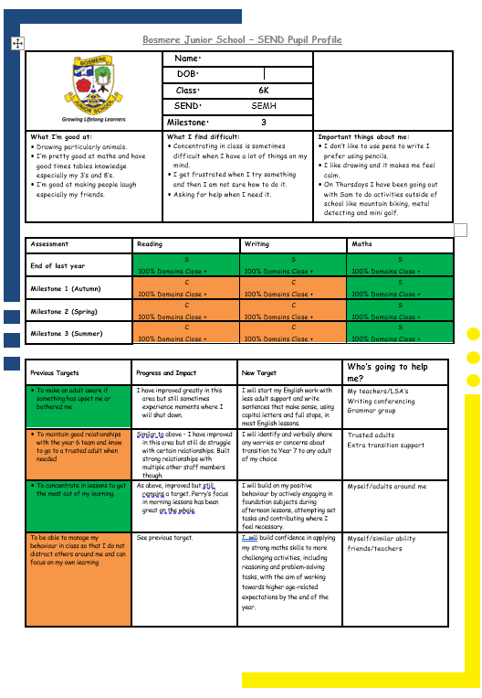

Provision for SEND
Identification of SEND – There are different ‘Areas of Need’ for Special Needs. These include: Cognition and Learning, Social Emotional Mental Health, Communication and Interaction and Physical Disability In order to improve the consistency of the identification of SEND, teachers and LSAs must use documents which contain ‘descriptors’ of SEND to justify the decision to put a child on the SEND register. It is expected that children will display a minimum of four characteristics, however these characteristics may be displayed across multiple areas of needs. For example a child may have Cognition and Learning difficulties and also have difficult in Communication and Interaction. Below is an example of an SEND Identification Sheet: These have been adapted to reflect OAP and targeted interventions.

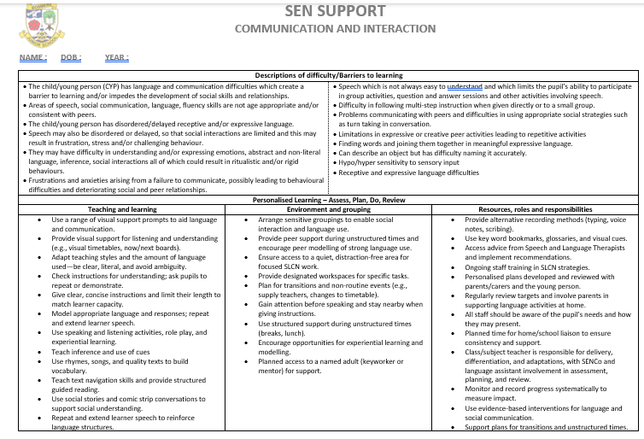

Pupil Progress Meetings and Provision Maps:
Prior to ‘Pupil Progress Meetings’ at each assessment milestone, a provision map for SEND pupils is updated with all relevant assessments to show ongoing progress and attainment. During the meeting the teacher, SENCO and HT determine what additional provision each child needs to meet their learning, emotional and/or physical needs. We ask all class LSAs to join the discussion about the SEND pupils because they often have important knowledge of these children, what barriers to learning they are facing and the progress they have made. After the meeting the provision map is updated with the additional support and intervention programmes that each child will receive.

Year 4 Class SEN Provision Map – Final Assessment (MS3)
Name | SEN Stage | Area of Need | Outside Agency | KS1 Result |  |  | Y3 ARE |  |  | Mile stone | Y4 ARE |  |  | Reading Age & Comp Age | Spelling Age | Reading Provision | Writing Provision | Maths Provision
 |  |  |  | R | W | M | R | W | M | Mile stone | R | W | M
Pupil A | SEN Support | C&L  SLCN |  | WTS | WTS | WTS | N | N | N | MS 1 | N  0 | N  17 | N  17 | 8Y 1M  8Y7M | BL5 | 1:1 reading; Precision teaching; Teacher focus | Spelling intervention; GR group | Teacher focus; Gap intervention; HB group
 |  |  |  |  |  |  |  |  |  | MS 2 | N  0 | N  17 | N  0 | 9Y5M  9Y 11M | 5Y4M | 1:1 reading; Precision teaching; Teacher focus | Spelling intervention; GR group | Teacher focus; Gap intervention; HB group
 |  |  |  |  |  |  |  |  |  | MS 3 | N  38 | C  83 | N  33 | 9Y 8M  10Y7M | 5Y 4M | 1:1 reading; Precision teaching; Teacher focus | Spelling intervention; GR group | Teacher focus; Gap intervention; HB group

Name | SEN Stage | Area of Need | Outside Agency | KS1 Result |  |  | Y3 ARE |  |  | Mile stone | Y4 ARE |  |  | Reading Age & Comp Age | Spelling Age | Reading Provision | Writing Provision | Maths Provision
 |  |  |  | R | W | M | R | W | M | Mile stone | R | W | M
Pupil B | SEN Support | SEMH | PBS  EP | ARE | ARE | ARE | C | C | C | MS 1 | N  62 | N  33 | C  83 | 10Y6M  10Y7M | 9Y 1M | LSA support; 1:1 reading; Small focused GR group (GR) | LSA support; GR group; Spelling intervention | LSA support; GR group
 |  |  |  |  |  |  |  |  |  | MS 2 | N  62 | C  83 | C  100 | 10Y11M  12Y | 9Y 6M | LSA support; 1:1 reading; Small focused GR group (GR) | LSA support; GR group; Spelling intervention | LSA support; GR group
 |  |  |  |  |  |  |  |  |  |  |  |  |  |  |  | Pastoral Support: 1:1 LSA + ELSA
 |  |  |  |  |  |  |  |  |  | MS 3 | C  100 | S  100 | S  100 | 11Y0M 12Y | 9Y 10M

Parent / Teacher Meetings
Our ‘Collaborative Meetings’ put the pupil at the centre of the discussion between parent and teacher regarding their progress. This ensures parents are kept up to date with their current targets. All pupils will go through this progress twice a year.

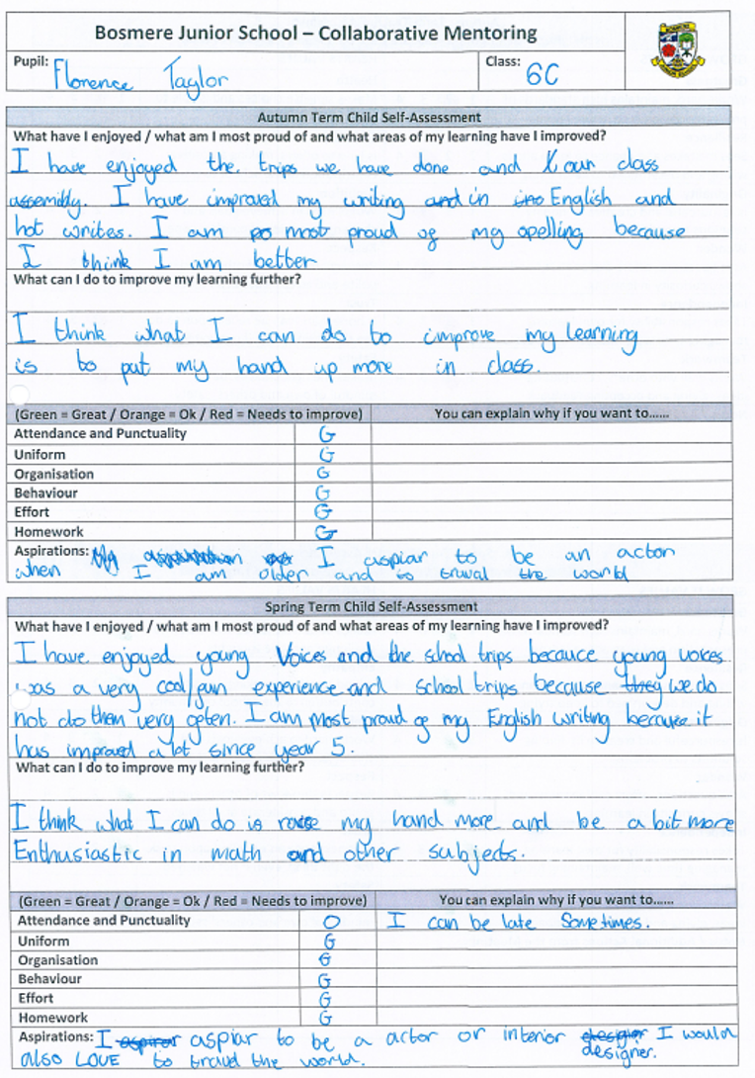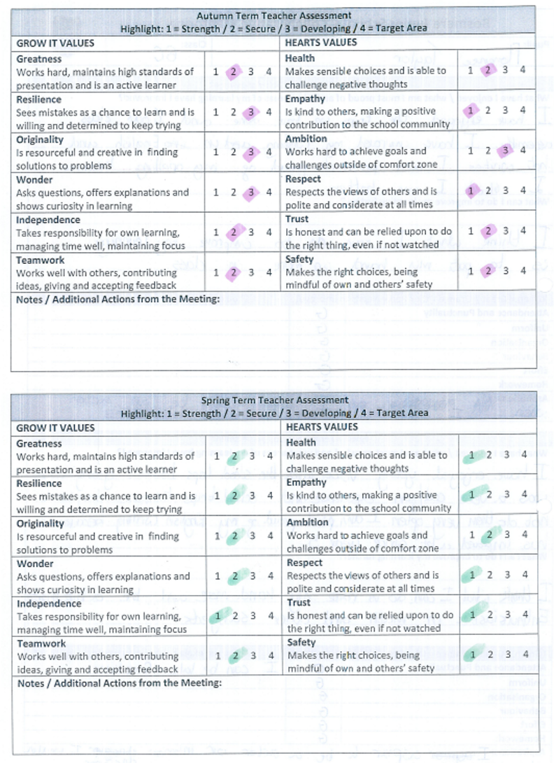

Tracking Backwards
Pupils who are not on track in any domains across a subject area will receive a tracking back sheet. These will help to identify areas where the pupils have made progress and provide a useful tool for planning future provision. These assessment documents will be shared with parents at the assessment milestones and can be used for target setting.

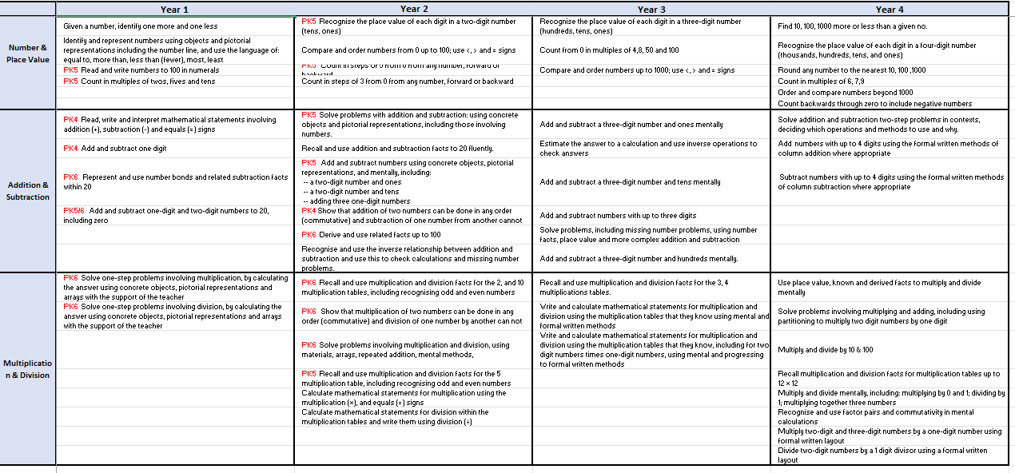

Position Statement and Development Plan 2026 – 2027

Subject / Area: Inclusion Person responsible: Charlotte Reed / Becky Calcott

POSITION STATEMENT (Summer Term 2026)
Notes about provision:
Special educational needs are a whole school responsibility. At Bosmere Junior School, we believe that all children with a Special Educational Need or Disability (SEND) must have their needs recognised and assessed, with appropriate and timely intervention put in place. All children have the same entitlement to the whole school curriculum, and we are committed to making this accessible to all children by:
• Providing suitable learning challenges
• Meeting the students diverse learning needs
• Overcoming the barriers to learning and progress

Effective SEND practice ensures there is provision for any child who has special educational needs and that those needs are known to all who are likely to work with them. We ensure that teachers can identify and provide for those children with special educational needs, allowing them to join in all school activities together with their peers. All SEND pupils, as far as is practicable, are fully-integrated into mainstream classes. Every effort is made to ensure that they have full access to the National Curriculum other aspects of school life i.e. Teaching is based on a clear understanding of cognition and learning and uses knowledge of different learning styles to maximise teaching impact. Personalised learning provides challenge and support where necessary.

Good practice for students with SEND is good practice for all. To a casual observer, it should not always be obvious which pupils in a class are SEND. High quality, inclusive teaching ensures that planning and implementation meets the needs of all pupils, and builds in high expectations for all pupils, including those with SEND. Differentiation for individual pupils is the first step in responding to pupils who have or may have SEND.
Teachers are aware and implement strategies to reduce cognitive load and support executive functioning
Ordinarily Available Provision SEND document has been developed and is used to support good practice.

The SENCo is strategically involved in SIP implementation, pupil progress meetings, TAC meetings and statutory processes.
SEND leadership capacity has been strengthened through the restructured leadership model combining AHT and SENCo responsibilities and adding capacity to DT.
Clear systems for SEND accountability are embedded across whole-school monitoring cycles, including lesson drop ins, learning walks and book scrutiny.
The SEND register is centrally maintained and monitored by the SENCo and Headteacher and includes a further register of children who are being monitored for educational need and a register of pupils for whom, by implementing interventions, we are preventing educational need.
All pupils on the SEND register have a concise pupil profile outlining needs, strengths and strategies.
Pupil voice is incorporated into pupil profiles.
These profiles shared with parents at Milestones 1 and 2 (and 3 from July 26) and updated annually.
TAC meetings and enhanced transition planning is in place for vulnerable pupils, including transition passports for those going to year 7.

Whole-school mental health strategy embedded (see MH and WB plan) with ARC Silver accreditation achieved and work underway towards Gold. Use of tools and pupil wellbeing surveys to identify need and monitor impact.
There is regular communication and meetings with parents of pupils with SEND, EHCPs and additional needs.
We have a strong working relationships established with external agencies including EP, MHST, PBS, social care and health professionals.
SENCo actively involved in LA SEND developments and working parties
Main Areas of Strength
SEND was identified as a key strength in the most recent Ofsted inspection (February 2023), and this has been sustained through strong strategic leadership. Inclusion and SEND are consistently articulated and embedded as a whole-school responsibility, supported by a clear and shared vision across staff, governors and external professionals.
Pupils with SEND are identified through a consistent and comprehensive approach, drawing on a range of information sources including assessment data, pupil observations, parental consultation, external agency input and agreed identification criteria.
There are clear and well-understood processes for reviewing SEND status, ensuring decisions are based on pupil need rather than data-driven thresholds.
The SEND register is fluid and reviewed formally at each assessment milestone through Pupil Progress Meetings. Pupils are added or removed from the register in response to their needs, rather than for data management purposes, with parents kept informed throughout. The register has been updated to include a Monitoring for SEND list of pupils and a Preventing SEND list of pupils this allows early intervention and prevention strategies.
Pupils on the SEND register are supported through quality first teaching using ordinarily available provision, alongside targeted support from skilled support staff. Provision is carefully managed and monitored by the SENCo and Headteacher, with detailed provision mapping ensuring clarity for all stakeholders.
Each pupil on the SEND register has an individual Pupil Profile, co-produced with pupil voice, which clearly outlines their needs and support strategies. These are concise, accessible documents shared with parents at each milestone (MS1, MS2, MS3), and are used effectively to support transition between classes and staff. These pupil profiles have been updated to include a section to monitor impact.
Assessment systems, including the HAM model, have been further refined to accurately demonstrate progress for pupils working below age-related expectations. Teachers track learning against prior objectives, ensuring progress is recognised even when pupils remain below ARE. Milestone data also incorporates effort grades to provide a holistic view of attainment.
The SENCo provides termly updates to the SEND governor and annual reports to the full governing body, ensuring transparency and accountability in SEND provision.
A wide range of extracurricular activities is offered and carefully monitored to ensure pupils with SEND are fully represented and able to participate alongside their peers.

The school has a robust approach to SEND identification, with 81 pupils on the SEND register, including 13 with EHCPs and 1 undergoing assessment.
A large, experienced, and highly skilled support staff team is deployed flexibly to meet pupil needs, working collaboratively with teachers, the SENCo and senior leaders.
Historically, pupils with SEND at Bosmere Junior School make accelerated progress, narrowing the gap with their peers in reading, writing and maths between Key Stage 1 and Key Stage 2.
Quality first teaching is a consistent strength, with effective strategies such as rich questioning, higher-order thinking, problem-solving and enquiry-based learning supporting both SEND pupils and those working at greater depth. Ordinarily Available Provision (OAP) is clearly defined and increasingly embedded across the school.
A consistent relational approach to behaviour is embedded across the school, supported by clear systems and skilled staff. The Behaviour Mentor role is having a demonstrable positive impact, particularly for pupils with SEMH needs. Mental health and wellbeing provision is well established and recognised externally through ARC accreditation.
The school maintains strong, trusting relationships with parents of pupils with SEND, underpinned by clear communication and transparency. Transition arrangements are highly effective, particularly for vulnerable pupils, supported by Team Around the Child (TAC) meetings and enhanced information sharing.
External monitoring, including LLPR visits, has recognised the effective implementation of Ordinarily Available Provision and the strength of SEND practice across the school.

Main areas for development:
KO1
Meeting the Needs of Pupils with Increasingly Complex SEND Profiles
Support increasing numbers of EHCP, CLA and PCLA pupils joining from September.
Ensure statutory and non-statutory review processes are timely, well‑planned and impact‑driven.
Strengthen provision mapping, transition planning and information sharing.
Ensure SEND systems remain manageable and responsive as demand increases.

KO 3
Promoting Positive Behaviour Through Executive Functioning Support
Embed executive functioning support as a universal classroom approach.
Link executive functioning explicitly to learning behaviours, independence and engagement.

KO 3
Strengthening Leadership and Strategic Capacity for Inclusion
Continue to embed the new SEND leadership structure.
Complete and apply learning from the NPQSENCo qualification.
Ensure SEND leadership remains sustainable as pupil numbers and complexity increase.
Maintain effective governance oversight through clear reporting and accountability.

INCLUSION DEVELOPMENT PLAN 2026 - 2027
School’s key priorities:
Key Objective 1: Continue to improve the quality of inclusive teaching and learning, planning for a review of the curriculum
Key Objective 2: Continue to improve behaviour, personal development and wellbeing, with a particular focus on the promotion of executive functioning skills
Key Objective 3: Continue to ensure strategic leadership, future planning to reflect predicted pupil numbers

Objectives:  (Refer to whole school priorities where possible) | Success Criteria | Actions planned (with dates): | Cost / Resources  (Time / £ / training) | Review  (Including impact on learning)
Meeting the Needs of Pupils with Increasingly Complex SEND Profiles  Support increasing numbers of EHCP, CLA and PCLA pupils joining from September.  Ensure statutory and non-statutory review processes are timely, well‑planned and impact‑driven.  Strengthen provision mapping, transition planning and information sharing.  Ensure SEND systems remain manageable and responsive as demand increases. | Statutory and non-statutory processes are timely, well-planned and compliant  Full compliance; no missed deadlines; improved organisation | Create and maintain a whole-year SEND calendar Sept 26 | SENCO time
 | SEND systems remain manageable despite increasing demand  Staff report workload is manageable; improved efficiency of provision | Use provision mapping to identify overlap and deploy staff efficiently At milestones | SENCO time
 | Provision for EHCP, CLA and PCLA pupils is effective and impact-driven  Strong pupil progress; evidence of impact in reviews and data | Conduct termly reviews at each milestone Termly  Ensure clear target setting and review within EHCPs and PEPs to ensure overlap Termly  Monitor progress through assessment and CPOMS tracking  PLAC documents completed at start of year and reviewed at end of the year | SENCO / DT/ teacher time
 | External agency involvement supports pupil outcomes effectively  External advice implemented effectively; improved pupil outcomes  Summary sheets of reports shared with staff | Schedule and attend network/TAC meetings as needed Termly  Ensure clear communication and shared targets following meetings | SENCO time
 | Information sharing is clear and consistent  Staff confidently adapt teaching consistency across classrooms | Share one-page pupil profiles and summary documents with all staff  Monitor use through learning walks and staff feedback | SENCO time
 | Transition processes support vulnerable pupils effectively  Smooth transitions; reduced anxiety; positive pupil feedback | Develop individual transition plans (including transition passports) and share with new schools and SW as needed Summer term  Arrange multi-agency transition meetings for high-need pupils  Evaluate transition success in first half term Autumn 1 | SENCO, teacher, LSA time
 | Inclusion strategy is clearly communicated and monitored  Governors informed; strategic oversight strengthened | Write and share Inclusion Action Plan with staff and governors Autumn | SENCO time
 | Inclusive practice is embedded across curriculum leadership  Inclusive practice consistent across care subjects | Schedule joint monitoring (SENCO and core subject leaders) termly  Focus monitoring on adaptive teaching and inclusion  Share findings and next steps | SENCO / subject leader time
 | Leadership capacity is strengthened (DT and AHT roles)  Distributed leadership effective; increased capacity | Gradually increase responsibility for TACs, transition and PEP leadership to DT | Release time
 | External moderation of Inclusive practice  External validation of provision within school | Audit of OAP with Laura Bitri from SEN team July 26 | Senco time
Key Objective 2: Continue to improve behaviour, personal development and wellbeing, with a particular focus on the promotion of executive functioning skills  Promoting Positive Behaviour Through Executive Functioning  Support  Embed executive functioning support as a universal classroom approach.  Link executive functioning explicitly to learning behaviours, independence and engagement. | A consistent whole-school executive functioning (EF) approach is embedded  Shared language across school; improved consistency | Develop a whole-school EF framework with year group expectations Autumn  Link EF skills to planning and learning behaviours  Share with staff and pupils through training/ display | Staff meeting time
 | EF strategies are embedded in teaching and learning  EF strategies evident in all classrooms; improved independence | Adapt planning templates to include EF strategies  Introduce visual supports (checklists, chunking, timelines) in all classrooms Autumn  Monitor through learning walks and planning scrutiny  Add EF to PBL passports Autumn | SENCO time
 | Staff consistently apply EF strategies  Increased staff confidence; consistent practice | Deliver whole-staff training Autumn inset  Share best practice examples in staff meetings  Monitor implementation regularly | Training time
 | Pupils demonstrate improved independence and learning behaviours  Improved engagement, organisation and independence | Possible use of SDQs to monitor impact  Monitor through pupil voice and behaviour data Gov monitoring Spring | SENCO time
 | Parents understand and support EF strategies  Improved home-school consistency | Share EF guidance with parents each half term  Provide/signpost resources to support learning at home | SENCO time
 | EF is embedded across the curriculum  EF supports visible in all subjects | Review curriculum to ensure explicit EF opportunities are planned  Monitor through subject leader reviews | SENCO / subject leader time
 | School achieves ARC Gold and sustains high-quality provision  ARC Gold achieved; improved wellbeing and behaviour | Attend ARC conference and training and cascade  Implement actions towards Gold accreditation Sept 26  Share practice with all staff including lunchtime supervisors Sept 26 | Training / release time
Strengthening Leadership and Strategic Capacity for Inclusion  Continue to embed the new SEND leadership structure.  Complete and apply learning from the NPQSENCo qualification.  Ensure SEND leadership remains sustainable as pupil numbers and complexity increase.  Maintain effective governance oversight through clear reporting and accountability. | SEND leadership structure is fully embedded and sustainable  Sustainable leadership; improved efficiency | Monitor leadership workload and effectiveness termly | SENCO / SLT time
 | NPQSENCO learning is applied to school improvement  Improved systems; stronger strategic leadership | Complete NPQSENCO qualification Spring  Implement key learning into school systems and practice  Evaluate impact through monitoring and outcomes | SENCO release time
 | Governance oversight of SEND is strong  Governors confident in SEND provision | Provide termly updates to SEND governor  Share clear data, case studies and impact  Governor monitor of MANAGE | SENCO time

