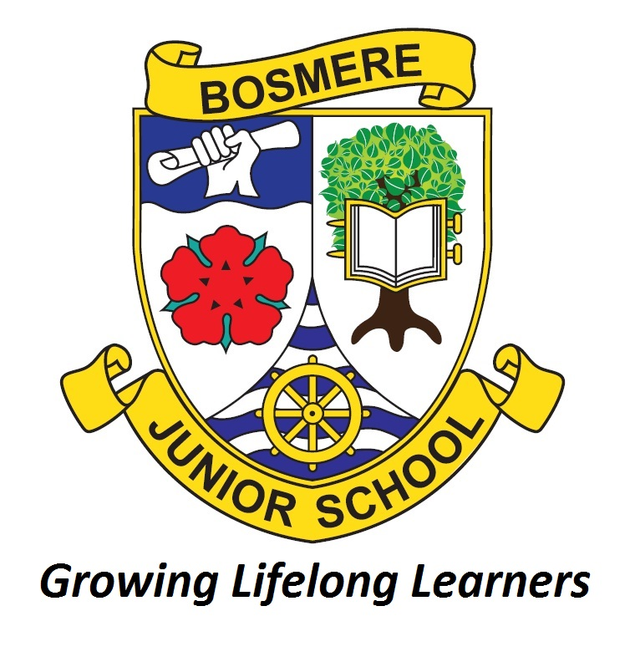
Bosmere Junior School – Remote Education Provision
The DfE has published expectations regarding the provision of remote education for any pupils who cannot attend school at all due to coronavirus (COVID-19). The school has produced a contingency plan for this eventuality.
This information is intended to provide clarity and transparency to pupils and parents or carers about what to expect from remote education if local restrictions require entire cohorts (or bubbles) to remain at home.
For details of what to expect where individual pupils are self-isolating, please see the final section of this document.

The remote curriculum: what is taught to pupils at home:
What should my child expect from immediate remote education in the first day or two of pupils being sent home?
A pupil’s first day or two of being educated remotely might look different from our standard approach, while we take all necessary actions to prepare for a longer period of remote teaching.
There are home learning resources on the school website and the children have access to several online learning platforms including Read Theory, MyMaths and Times Table Rockstars. Staff may also recommend several other online resources to access whilst they move learning and online and ensure that home learning is in-line with our curriculum.
Following the first few days of remote education, will my child be taught broadly the same curriculum as they would if they were in school?
We will plan to teach broadly the same curriculum remotely as we do in school wherever possible and appropriate especially in the core subjects – Reading, Writing, Maths and Science. However, we will need to make adaptations in some subjects. For example, it may not be realistic to deliver the same curriculum in practical based subjects (e.g. Art, Design and Technology) which would typically involve the use of various resources and materials in school. The Physical Education and Games curriculum will also have to be adapted to suit the remote learning environment.
How long can I expect work set by the school to take my child each day?
In accordance with guidance from the DfE, when teaching pupils remotely we will set work that is the equivalent length to the core teaching pupils would receive in school. For Primary pupils this is approximately 4 hours per day on average. Staff will try to adjust the pace or difficulty of what is being taught in response to pupils needs.

Accessing remote education:
How will my child access online remote education?
Our staff have been working hard to ensure that our children have free access to Microsoft Office 365. Members of our team have secured funding from the Department for Education (DfE), making substantial technical changes to our current ICT setup and training the staff and children in the use of Office 365.
The COVID 19 Pandemic has revealed how essential it is for children to be able to work remotely and this will provide a universal provision for children attending Bosmere Junior School. In providing all our children with remote access to Office 365, we can ensure that every child has access to a range of online resources including:
- Microsoft TEAMS
- Email (MS Outlook)
- Desktop Publishing tools (Word, PowerPoint etc)
In the event of a class, year group, school or national lockdown remote learning will be distributed via Microsoft TEAMS.
Office 365 and Microsoft TEAMS can be accessed through laptops, computers and most mobile devices like tablets and phones. TEAMS assignments can be completed electronically or if your child wants to work on paper then photos of their work can be sent to staff via the children’s emails – there should be no need for children to have printed copies of work. Work packs create the need for unnecessary travel and we also feel that they do not provide the same quality of education that we can now facilitate through Microsoft TEAMS.
If your child does not have digital or online access at home, you should contact the school to discuss how this could potentially be addressed.
How will my child be taught remotely:
Children will have to log onto Office 365 and access Microsoft TEAMS each day. Guidance on how to do this will be provided via the website and ParentMail. Therefore:
- A morning briefing will be available each morning via Microsoft TEAMS – this will include key messages about the days learning. This is most likely to in the format of PowerPoint with written instructions. It may also include pre-recorded audio or video clips
- School staff will also be available via email and live text chat on Microsoft TEAMS to support children with their home learning
- An English, Maths and Foundation/Core subject lesson will be provided each day in the format of a PowerPoint presentation – children will be able to respond to tasks and submit them via Microsoft TEAMS
- Parents can submit work in the form of electronic documents (e.g. Word, PowerPoint) or by providing photos of written work that children have produced
- Some activities will provided through online platforms such as MyMaths and Read Theory.
- Reading books can be distributed electronically through the School Libraries’ eplatform: https://www.eplatform.co/uk/school

Engagement and feedback
What are your expectations for my child’s engagement and the support that we as parents and carers should provide at home?
The school understands that parents may find it difficult to facilitate home learning during a lockdown. Limited access to technology, having children in multiple year groups and simultaneously working from home are just a few of the issues that parents may be facing. We do not want to make a difficult situation worse. However, the school also has a duty of care to our pupils and having children access their home learning will help to ensure that they do not slip behind.
Therefore when an assignment is posted on MS TEAMS, ideally children will complete it on the same day.
However circumstances do get in the way, and therefore children still access older lessons under the ‘Returned’ section of assignments on subsequent days. If parents are anticipating a delay in their children accessing home learning then they should contact their class teacher.
Allowances will of course be made initially while parents and pupils become familiar with remote learning through Microsoft TEAMS.
How will you check whether my child is engaging with their work and how will I be informed if there are concerns?
Staff can see whenever a pupil completes and returns an assignment in Microsoft TEAMS. They can provide feedback through TEAMS.
If no work is completed for 48 hours then staff will send an email reminding children and parents about the expectations of home learning.
If no work is completed / a response is not received by the end of the third day then staff will call the parents of the child to discuss what support might be needed to facilitate home learning.
If no work is submitted following the conversation with parents then the issue will be passed to a member of the School’s Safeguarding Team (Mrs Robinson, Mr Adam and Mrs Lever).
How will you assess my child’s work and progress?
Providing timely and helpful feedback is a cornerstone of good teaching and learning, and whilst this may be more challenging with remote learning, staff will endeavour to provide regular feedback to learners on pieces of work that they are required to submit. Under normal circumstances, not all pieces of work are formally assessed by staff and this would continue to be the case should the school employ remote learning.
Given the nature of the tasks, the type of feedback staff can provide is unlikely to have the same format as marking an exercise book. Staff are encouraged to ensure, when they set assessed work, that it is designed in such a way that meaningful feedback may be provided. Possible methods may include:
- Providing remote feedback via MS TEAMS
- Providing whole class feedback rather than feedback on individual pieces of work – this is an effective way of providing feedback, supported by findings from educational research
- Providing individual feedback via email
- Feedback via a learning platform or website e.g. MyMaths

Remote education for self-isolating pupils
Where individual pupils need to self-isolate but the majority of their peer group remains in school, how remote education is provided will likely differ from the approach for whole groups. This is due to the challenges of teaching pupils both at home and in school.
The symptoms of COVID 19 are shared with many common childhood illnesses. Therefore it is inevitable that there will be small numbers of pupils who display potential symptoms of COVID 19 and will subsequently have to isolate for up to 14 days or until they test negative for the disease. There may also be children who are returning from oversea visits who will be forced to self-quarantine for up to 14 days because their destination countries were removed from the UK’s list of travel corridors.
In the event that a child has to self-isolate and the learner in question is healthy enough to work from home:
Their teacher will contact their parent within 24 hours to provide resources for home learning.
These resources will mirror (as closely as possible) the learning that is taking place in the classroom and will include an English, Maths and Foundation lesson each day. Resources will be distributed via MS TEAMS.
Teachers will ask for the child/parent to submit work to them via email on a daily basis or a soon as possible. The teacher will then provide feedback in a timely manner (within 24 hours). 90% of respondents to our parental survey said they would be able to correspond with the class teacher on a daily basis.
Teachers and support staff will respond to questions from parents as quickly as possible, however parents should be aware that when the majority of children are in school, the teaching and support staff will be occupied for the majority of the school day and may not be able to respond immediately.
If there are a substantial number of pupils isolating within a year group (10+), a specific member of staff may be allocated to help manage their home-learning.

