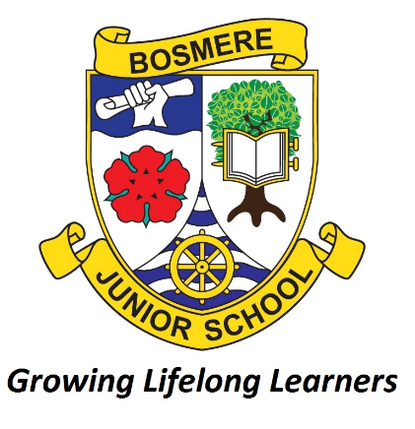
Bosmere Junior School
South Street
Havant

Sustainability

Date Approved: | June 2026
Review Date: | June 2029
Responsibility: | Sustainability Leader
Statutory: | No
Check against Equality Policy

Sustainability Leader: | Date:
Sustainability Governor: | Date:
Headteacher: | Date:

SUSTAINABILITY POLICY

RATIONALE
At Bosmere, we are committed to nurturing a generation of environmentally conscious individuals. We aim to inspire respect for the planet, embed sustainable practices into daily school life, and empower our pupils to be proactive stewards of a greener, fairer future. Together - with our staff, families, and wider community - we’re building a culture of responsibility and resilience in the face of climate change.

What are the aims for sustainability at Bosmere Junior School?
- To raise awareness of issues affecting our local environment and the world.
- To educate children, staff, and families about climate change and its impacts.
- To encourage actions such as reducing waste, conserving energy, and adopting eco-friendly habits within the school community.
- To foster stewardship and participation in all children when discussing climate change issues.
- To embed explicit sustainability lessons across the curriculum, encouraging critical thinking and problem-solving skills related to sustainability.
- To support all living things we share our planet with by increasing biodiversity on our school grounds.

PILLARS OF SUSTAINABILITY
Sustainability can be broken down into four main pillars, as outlined within the Department for Education’s Sustainability and Climate Change Strategy:
- Decarbonisation
- Adaptation and Resilience
- Biodiversity
- Climate Education and Green Skills/Careers
Empowering our school community with knowledge and understanding of climate change is not just an educational priority – it is our moral duty. As stewards of the planet, pupils must be equipped with the knowledge and tools to be able to protect their planet. Sustainability education fosters curiosity, responsibility and drive, helping young people see themselves as agents of change. Climate and sustainability education must extend beyond the classroom and become ingrained in all that we do at Bosmere. In the words of Sir David Attenborough, “No one will protect what they don’t care about; and no one will care about what they have never experienced.”

- Decarbonisation
We will:
- Ensure energy efficiency by:
  - Replacing lightbulbs with more eco-friendly alternatives.
  - Monitor energy use regularly and identify areas for improvement.
  - Encourage all members of the school community to make eco-friendly decisions by turning off lights, computer screens, interactive whiteboards and all other energy-using items when not in use.
- Promote and encourage eco-efficient transport to school by:
  - Providing parents with public transport information.
  - Offer local ‘park and stride’ opportunities.
  - Make bike and scooter parking available.
  - Encourage all stakeholders to consider their own carbon footprint by participating in Walk to School Week
- Monitor and reduce waste by:
  - Use food waste bins consistently and dispose of food waste effectively.
  - Promote the sale of pre-loved uniform and other clothing items.
  - Make conscious choices about printing to reduce paper use.
  - Encouraging a range of recycling possibilities.

- Adaptation and Resilience
We will:
- Ensure sustainability is promoted in school, with response to climate change by:
  - Highlighting Eco Council and Sustainability News in the Termly Newsletter
  - Promote opportunities for children to learn about climate change
  - Regular meetings between Sustainability Governor and Sustainability Leader
  - Monitoring progress with the schools sustainability actions

- Biodiversity
We will:
- Encourage purposeful time in nature by:
  - Giving children opportunities to engage in outdoor learning across the curriculum
  - Promoting time in nature through structured events
  - Promoting the positive effects of time in nature on people’s mental health and wellbeing
- Promoting the use of outside areas as habitats by:
  - Monitoring bug hotels and bird boxes, carrying out repairs where necessary
  - Encouraging children to notice and wonder about the wildlife on our school grounds
- Develop skills and knowledge about taking care of the local environment by:
  - Explicitly teaching about the environment and climate change
  - Regular meetings with Eco Council, with feedback to classes
  - Exploring the opportunity for visitors to upskill teachers and members of Eco Council

- Climate Education and Green Skills
- Ensure sustainability is taught across the curriculum by:
  - Making explicit links to climate and environmental education across the curriculum, focussing on Art, Science and Geography
  - Explicitly teaching Sustainability Lessons that link to existing curriculum units
- Promoting sustainability through events and assemblies by:
  - Delivering sustainability focused assemblies, e.g Walk to School Week
  - Regular encouragement for children to engage in opportunities to learn about their environment and climate change, e.g. 30 Days Wild
- Promote Sustainability through display by:
  - Regularly updating the Eco Council display
  - Circulating posters and information with important information to classes

Monitoring
The Sustainability Lead will regularly monitor children’s engagement in explicit Sustainability teaching, sharing findings with the Sustainability Governor. The Sustainability Lead and Sustainability Governor will meet termly to discuss progress towards goals and next steps. There will be opportunities for the Sustainability Governor to engage in monitoring opportunities, such as Pupil Interviews.

Eco Council
Each class will elect two Eco Council members in September. Candidates will have to explain why they are the most suitable individual to represent their class within the Eco Council. This will then be voted for, allowing each child an input into who represents their thoughts and ideas. The members of Eco Council will then meet every term to discuss progress and ideas for how to make Bosmere more sustainable. Eco Council are responsible for leading sustainability and climate education in their classes.

