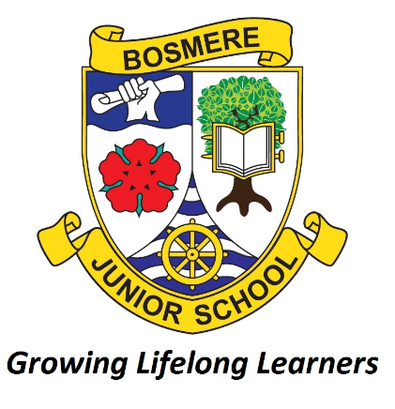
Bosmere Junior School
South Street
Havant

Behaviour Policy
(Including Anti-Bullying)

Date: | June 2026
Review Date: | June 2027
Responsibility: | Deputy Headteacher
STATUTORY

Checked against Single Equality Scheme

Deputy Headteacher: | Date:
Chair of Governors: | Date:
Headteacher: | Date:

PURPOSE
This policy aims to promote outstanding behaviour and self-discipline in our school community, as we see it as essential to successful teaching, learning and social development. We aim to create an atmosphere of mutual respect, evident in the relationships between all members of our community; adults, children and visitors. Adults should see themselves as models for the behaviour of children. Every individual should know and feel that they are a valued member of the community. Everyone deserves to be treated with courtesy and good manners. Cooperation and trust between adults will be reflected in the way children interact with each other.

SCHOOL RULES
Our school rules are:
- Make sensible choices
- Be polite and kind to others
- Always do your best
- Listen to others and follow adults’ instructions
- Be honest and look after other people’s property
- Keep yourself and others safe

CLASS CHARTER / CLASS RULES
Each class will create its own charter or list of rules as part of PSHE. Guidance will be provided by the class teacher to ensure the rules support the values of the school.

VALUES OF THE SCHOOL
At Bosmere our school motto is ‘Growing Lifelong Learners’ because we recognise our responsibility to help prepare our pupils for their future lives. We hope to engender the children at Bosmere Junior School with the values that will help them to become moral citizens of Britain and the wider world.

At Bosmere we value the use of good manners: behaviour generated by knowledge of and concern for children and adults alike. The school encourages: open friendly relationships, high levels of trust and responsibility, positive teamwork with a high value placed upon children’s contributions by staff and peers alike. We believe the creation of such a safe and secure environment permits individual self-esteem to grow. We believe in the positive reinforcement of good behaviour as a first principle in behaviour management. We also believe these values permeate all aspects of school life; everyone’s behaviour is everyone’s responsibility.

We have identified six GROWIT ‘learning values’ which are promoted and celebrated throughout the school:
Greatness
- Great learners strive to do their best in all aspects of school life.
- They challenge themselves outside their comfort zones.
- They think about what they are doing and the choices they make.
- They use this to learn from their mistakes and improve for the future.

Resilience
- Resilient learners cope with challenges and deal with difficult situations with positivity and optimism.
- They are willing and determined to keep trying, especially when things are difficult.
- They take their learning as far as they can with practice and support.

Originality
- Original learners are creative.
- They find solutions to problems and build on their knowledge in a creative way.
- They are willing to take risks and to try something new.
- They allow themselves to be inspired by others.

Wonder
- Wondering learners are curious about the world around them.
- They ask questions and are hungry for answers.
- They like to find things out for themselves.

Independence
- Independent learners take responsibility for their own learning.
- They organise themselves well for any task and make decisions for themselves about how to tackle a challenge.
Teamwork
- Team players are willing and able to work and learn with others, sharing resources, to get the job done well.
- They are able to both lead and be led.
- They can give constructive feedback to others and are able to accept it for themselves.

We have also identified six ‘Hearts Values’
Healthy Children:
- Make good choices with their diet, exercise and lifestyle
- Make sure they get enough sleep
- Talk about their feelings and challenge negative thoughts
- Ask for help if they have a problem
- Balance screen time with other leisure activities
- Know how to relax and unwind
- Have fun, smile and laugh

Empathetic children:
- Connect with friends and family
- Help others wherever they can
- Are thankful for all the things they have
- Contribute positively to the school and wider community
- Understand the consequences of their behaviour and actions on others

Ambitious children:
- Learn new things every day
- Are mindful and take notice of what is happening around them
- Set goals for themselves and embrace their wishes and dreams
- Try to be the best version of themselves

Respectful children:
- Treat people how they would like to be treated
- Respect the beliefs and cultures of others
- Value their own and other people’s view points
- Are polite and considerate towards all others
- Demonstrate good manners at all times
- Take care of the environment

Trustworthy children:
- Know the difference between right and wrong and how to apply this in their life
- Can be relied upon to tell the truth
- Will do the right thing even when others are not watching
- Are reliable and true to their word

Safe children:
- Know how to keep themselves safe in all situations, including online
- Make the right choices
- Are mindful for the safety of others
- Say ‘No’ to bullying
Adults will celebrate and reward pupils that demonstrate these values in any form; including, but not limited to, their school work, relationships and personal pursuits.

ROLES AND RESPONSIBILITIES
Behaviour Management is the responsibility of all staff at Bosmere Junior School. We believe in the importance of dialogue with children about their behaviour, providing opportunities to explain their behaviour, examining and accepting the rights and wrongs of situations and measuring them against the school’s values.

Teachers and Support Staff
It is the responsibility of class teachers and support staff to ensure that the school rules are enforced in their classes, and that their classes behave in a responsible manner during lesson time. The class teachers in our school have high expectations of the children with regard to behaviour, and they strive to ensure that all children work to the best of their ability. The teachers and support staff must be role models for the children and treat each child fairly, and enforce the school rules consistently. Staff treat all children in their classes with respect and understanding. The class teacher should ensure that parents are aware of repeated low level negative behaviours such as calling out or disrupting the class. If a child misbehaves repeatedly in class, the staff keep a record such incidents using the behaviour card system.

In most instances, rewards or sanctions for good or poor behaviour is typically the preserve of the class teacher and support staff during lesson times, the duty teachers during break times or the lunchtime supervisors at lunch times.

School Leaders
In the case of more serious unacceptable behaviour, sanctions will involve in the first instance Year Leaders, then the Deputy Headteacher, Headteacher and finally Governors. These incidents will be fully investigated and sanctions discussed between the appropriate staff.

The Deputy Head and Headteacher are highly visible in their leadership of behaviour at Bosmere Junior School. They regularly lead assemblies and share messages to promote a positive ethos within the school. They share a responsibility for addressing the most challenging behaviour within the school. The Headteacher presents a weekly celebration assembly to all pupils, staff and parents that highlights the best examples of positive learning behaviour.

It is the responsibility of the Headteacher to implement the school behaviour policy throughout the school, and to report to governors, when requested, on the effectiveness of the policy. It is also the responsibility of the Headteacher to ensure the health, safety and welfare of all children in the school. The Headteacher supports the staff by implementing the policy, by setting the standards of behaviour, and by supporting staff in their implementation of the policy. The Headteacher keeps records of all reported serious incidents of misbehaviour including bullying and racism. The Headteacher has the responsibility for giving fixed-term exclusions to individual children for serious acts of misbehaviour. For repeated or very serious acts of anti-social behaviour, the Headteacher may permanently exclude a child. These actions are taken only after the school governors have been notified.

Pupils
All pupils deserve to learn in an environment that is calm, safe, supportive and where they are treated with dignity. To achieve this, every pupil is made aware of the school behaviour standards, expectations, pastoral support, and consequence processes. Pupils are taught that they have a duty to follow the school behaviour policy and uphold the school rules, and should contribute to the school culture.

Parents
The role of parents is crucial in helping schools develop and maintain good behaviour. To support the school, parents are encouraged to get to know the school’s behaviour policy and, where possible, take part in the life of the school and its culture. A Home-School Agreement that includes behaviour expectations is shared with parents every year. Parents are encouraged to reinforce the policy at home as appropriate. Where a parent has a concern about management of behaviour, they should raise this directly with the school while continuing to work in partnership with them.

PROMOTING POSITIVE BEHAVIOUR
This will be achieved through:
- Adults role model positive behaviour
- Appropriate praise from teachers or supervisors
- House Points
- Head Teacher Awards, certificates and badges
- Reference to / recognition of school values
- Pastoral support e.g. ELSA
- Support from outside agencies e.g. Primary Behaviour Support

RESPONDING TO INAPPROPRIATE BEHAVIOUR
All behaviour management at Bosmere Junior School is underpinned by a relational and trauma-informed approach. We recognise that behaviour is a form of communication and aim to respond in a way that maintains dignity, safety, and positive relationships for all pupils.

A range of sanctions are used. These should always be appropriate to the level of misdemeanour. Teachers are encouraged to develop rules, rewards and sanctions within their individual classrooms. These sanctions may include:
- Moving pupil’s position in class
- Isolation from peers within class
- Moving of pupils to different class/year group
- Losing minutes from playtime
- Use of ‘Restorative Practices’ – (Please see Appendix 1).

However if poor behaviour persists or there is a more serious incident, teachers can employ the whole-school system for sanctions and issue pupils with a White, Yellow, Orange or Red Behaviour Card. These are kept as a record of the behavioural incident. (Please see Appendix 1).

LUNCHTIMES
During lunchtimes minor incidents will be dealt with by the lunchtime supervisors under the supervision of the senior lunchtime supervisor. Persistent or significant incidents of poor behaviour will be addressed using the Behaviour Card System in keeping with school procedures. Serious incidents will be reported to the Headteacher or Deputy Headteacher who will follow them up.

Children who are identified as needing additional support during lunchtimes on a regular basis will be supported by the Home-School Link worker and Emotional Literacy Support Assistants until such time as they are able to enjoy lunchtime safely and sensibly. The school has created additional lunchtime provision for pupils who need help in socialising with their peers.

OFF-SITE BEHAVIOUR
Sanctions may be applied where a pupil has misbehaved off-site when representing the school. This means misbehaviour when the pupils is:
- Taking part in any school-organised or school-related activity (e.g. school trips)
- Travelling to and from school
- Wearing school uniform
- In any other way identifiable as a pupil of our school

Sanctions may also be applied where a pupil has misbehaved off-site at any time, whether or not the conditions above apply, if the misbehaviour:
- Could have repercussions for the orderly running of the school
- Poses a threat to another pupil or member of the public (e.g. peer on peer abuse)
- Could adversely affect the reputation of the school

ANTI-BULLYING
Bosmere Junior School complies with the legislation set out in The Equality Act 2010. A key provision of the act is a ‘Public Sector Equality Duty’ which has three aims. It requires public bodies to have due regard to the need to:
- eliminate unlawful discrimination, harassment, victimisation and any other conduct prohibited by the act
- advance equality of opportunity between people who share a protected characteristic and people who do not share it
- foster good relations between people who share a protected characteristic and people who do not share it.

Incidents of bullying, racism, use of bad language or violence or inappropriate sexual behaviour are rare at Bosmere School; however, if any incidents of this nature should occur they will be treated very seriously and dealt with directly by members of the Senior Management Team or Headteacher who may involve parents. If appropriate, the school may seek support from outside agencies such as Primary Behaviour Support, CAMHS and the Police. Incidents of bullying or discrimination will be documented.

Definition of Bullying:
Bullying is a form of harassment in which an individual is in fear of their own emotional or physical wellbeing. It is behaviour that persistently criticises, condemns and humiliates people, and can undermine their ability and self-confidence.
Its key features at school are:
- deliberately hurtful behaviour
- wilfully repeated and targeted at a specific child over a period of time
- difficult for those being bullied to defend themselves

Bullying can also take the form of unwanted conduct of a sexual or racial nature, or conduct based on sexual orientation, religion/belief, disability, age, or other grounds, which is offensive to the recipient.

Cyber Bullying:
The rapid development of, and widespread access to, technology has provided a new medium for ‘virtual’ bullying, which can occur in or outside school. Behaviour that is classed as cyber bullying includes:
- abusive comments, rumours gossip and threats made over the internet or using other digital communications
- sharing pictures, videos or personal information without the consent of the owner and the intent to cause harm and/or humiliation
- hacking into someone’s email, phone or online profiles to extract and share personal information, or to send abusive or inappropriate content while posing as that person
- creating specific websites that negatively target an individual or group
- blackmail or pressuring someone to do something online that do not want to such as sending a sexually explicit image
If comments are threatening or abusive, sexist, of a sexual nature or constitute a hate crime, the school may consider contacting the local police. Online harassment is a crime; therefore, bullying of staff, whether by pupils, parents or colleagues, is also unacceptable.

Managing incidents of bullying:
Children are encouraged to be assertive, ignore provocation and seek the help of an adult rather than retaliate. We listen to both/all sides of a problem before judging behaviour and to consider the child’s self-esteem when dealing with difficult situations.
Staff will:
- provide immediate support
- listen to the child
- involve parents of both the victim and the bully
- record the incident (using incident form)
- respond positively in a non-aggressive manner
- follow up and review progress
- ensure there are serious talks with the bully including teaching of interpersonal and social skills
- explain the problem and help everyone to understand how the bullied child feels
- use sanctions within the behavioural policy

The school has also created a Child-Friendly Anti-Bullying Policy that is attached to this policy: please see Appendix 2

CHILD ON CHILD ABUSE
Our staff are aware that safeguarding issues can manifest themselves via Child-on child abuse which can include, but may not be limited to:
- bullying (including cyberbullying, prejudice-based and discriminatory bullying)
- abuse in intimate personal relationships between children (sometimes known as ‘teenage relationship abuse’)
- physical abuse such as hitting, kicking, shaking, biting, hair pulling, or otherwise causing physical harm (this may include an online element which facilitates, threatens and/or encourages physical abuse)
- sexual violence, such as rape, assault by penetration and sexual assault; (this may include an online element which facilitates, threatens and/or encourages sexual violence)
- sexual harassment, such as sexual comments, remarks, jokes and online sexual harassment, which may be standalone or part of a broader pattern of abuse
- causing someone to engage in sexual activity without consent, such as forcing someone to strip, touch themselves sexually, or to engage in sexual activity with a third party
- consensual and non-consensual sharing of nude and semi-nude images and/or videos (also known as sexting or youth produced sexual imagery)
- ‘upskirting’, which typically involves taking a picture under a person’s clothing without their permission, with the intention of viewing their genitals or buttocks to obtain sexual gratification, or cause the victim humiliation, distress, or alarm, and
- initiation/hazing type violence and rituals (this could include activities involving harassment, abuse or humiliation used as a way of initiating a person into a group and may also include an online element).

At Bosmere Junior School we are committed to the prevention, early identification and appropriate management of child-on-child abuse. We continue to ensure that any form of abuse or harmful behaviour is dealt with immediately and consistently to reduce the extent of harm to the young person, with full consideration to impact on that individual child’s emotional and mental health and well-being.
The school has procedures in place to respond to any allegations or concerns regarding a child’s safety or well-being. These include clear processes for making a report – members of the safeguarding team (including the Designated Safeguarding Lead) will then assess, where appropriate, to help determine whether to:
- Manage the incident internally
- Refer to early help
- Refer to children’s services
- Report to the police

Please refer to our Safeguarding and Child Protection Policy for more information.

Confiscation of inappropriate items
Children are not allowed to bring toys to school. If a child brings a toy or an object to school which is inappropriate then a member of staff may confiscate that item and retain it. This will usually be until the end of the day when it will be returned to the child or parent to take home.

Stolen Items/Searching with consent
School staff can search a pupil for any item if the pupil agrees. Headteachers and staff authorised by them have a statutory power to search pupils or their possessions, without consent, where they have reasonable grounds for suspecting that the pupil may have a prohibited item.

Prohibited items are:
- knives or weapons
- alcohol
- illegal drugs
- stolen items
- cigarettes, tobacco and cigarette papers
- e-cigarettes / vapes
- fireworks
- pornographic images

School staff can seize any article that the member of staff reasonably suspects has been, or is likely to be, used to commit an offence, or to cause personal injury to, or damage to the property of, any person (including the pupil).
Headteachers and authorised staff can also search for any item banned by the school rules which has been identified in the rules as an item which may be searched for. The Headteacher and Deputy Headteacher may authorise a search of storage areas i.e. drawers as they remain the property of the school. Searches must be carried out in the presence of another member of staff and if named pupils are implicated, they should be present.

Staff should try to persuade the voluntary production of any unlawful substances, i.e. asking the pupil to turn out their pockets. If it is necessary to search a pupil’s property or person and parents need to be informed as soon as possible. If a pupil is found in possession of a substance suspected of being illegal, the police should be informed immediately. Direct supervision will be necessary to ensure the substance is not disposed of or swallowed.

Any search by a member of staff for a prohibited item and all searches conducted by police officers should be recorded in the school’s safeguarding reporting system, including whether or not an item is found. This will allow the designated safeguarding lead (or deputy) to identify possible risks and initiate a safeguarding response if required.

Electronic devices, including mobile phones, can contain files or data which relate to an offence, or which may cause harm to another person. This includes, but is not limited to, indecent images of children, pornography, abusive messages, images or videos, or evidence relating to suspected criminal behaviour.

Staff may examine any data or files on an electronic device they have confiscated as a result of a search if there is good reason to do so. If the member of staff conducting the search suspects they may find an indecent image of a child (sometimes known as nude or semi-nude images), the member of staff should never intentionally view the image, and must never copy, print, share, store or save such images. When an incident might involve an indecent image of a child and/or video, the member of staff should confiscate the device, avoid looking at the device and refer the incident to the designated safeguarding lead (or deputy) as the most appropriate person to advise on the school’s response. For more details please see Searching, Screening and Confiscation, Advice for Schools 2022 published by the DfE.

MALICIOUS ACCUSATIONS
Where students are found to have made malicious accusations that are proved unfounded the school may choose to exclude the student concerned. Dependent on the severity of the accusation and the distress caused, this exclusion may be permanent.

TRANSITION
The school uses a variety of positive strategies to ensure that transition for all pupils is successful including, but not limited to:
- Transition Days
- Additional visits for groups of vulnerable pupils
- Individual transition meetings. (These will always take place for Looked After Children and pupils with Education Health and Care Plans)
- Assigning children a Key Adult
- ELSA Support
- The use of Social Stories
The school will communicate and share information with other schools regarding pupils’ behaviour if there are significant issues that may need to be addressed. This will take place when children are transitioning into Bosmere Junior School and when children are leaving the school in order to help ensure positive outcomes.

REMOVAL FROM THE CLASSROOM
Removal is where a pupil is asked to spend a limited time out of the classroom at the instruction of a member of staff. This is to be differentiated from circumstances in which a pupil is asked to step outside of the classroom briefly for a conversation with a staff member and asked to return following this. Removal should be used for the following reasons:
- to maintain the safety of all pupils and to restore stability following an unreasonably high level of disruption;
- to enable disruptive pupils to be taken to a place where education can be continued in a managed environment; and
- to allow the pupil to regain calm in a safe space.

Children should only be removed from the classroom for the time it takes for the child to
- regulate their behaviour to the point where it is appropriate for them to return
- refocus and show that they are ‘on-task’ with their learning
- and/or to demonstrate through positive dialogue with a member of staff that they have reflected on their earlier actions and are prepared to change their behaviour

Removal from the classroom is a supportive and non-restrictive strategy and does not prevent a pupil from leaving the space. Where a pupil is prevented from leaving a space (for example by physical obstruction or direction), this may constitute ‘seclusion’. Seclusion is only used in emergency situations to prevent immediate harm and must be managed in accordance with the school’s Physical Intervention Policy.

EXCLUSION
In the event of a serious incident or persistent breaches of the school’s behaviour policy where allowing the pupil to remain in school would seriously harm the education or welfare of themselves or another member of the school community, then temporary (fixed) exclusion may be necessary. Return to school after an exclusion must be preceded with a meeting with the Head Teacher or his representative. If all other avenues of support have been tried the school can take the decision to permanently exclude a child.

PHYSICAL INTERVENTION
In line with the school’s Physical Intervention Policy, the use of reasonable force to maintain good order and discipline will only be considered appropriate where there is a direct risk of harm to the pupil, other pupils, staff or significant damage to property. This force can only be used where the staff member and the pupil are on school premises or somewhere where the member of staff has lawful control or charge of the pupil (for example, a school trip). In all other circumstances, staff will use de-escalation and behaviour management strategies in preference to physical intervention.

The school recognises that the word “reasonable” could be legally problematic as one person’s definition may be completely different to another’s. Therefore staff should follow the principal of applying the minimum force required, in the circumstances, lasting for the shortest practicable time or, in Department for Education (DfE) terms, ‘using no more force than is needed’. For more details please see the school’s Physical Intervention policy.

All incidents involving the use of reasonable force will be recorded in line with the school’s Physical Intervention Policy. Records will be completed within 24 hours and parents/carers will be informed on the same day, unless doing so would place the pupil at risk of harm.

SPECIAL EDUCATIONAL NEEDS AND DISABILITIES (SEND)
Approaches to managing an individual’s behaviour may be adapted to meet their specific needs. Staff will consider whether a pupil’s SEND has contributed to the misbehaviour and if so, whether it is appropriate and lawful to sanction the pupil. In considering this, staff should refer to the Equality Act 2010 and schools guidance to ascertain whether the pupil understood the rule or instruction and whether the pupil was unable to act differently at this time as a result of their SEND. The school should also consider whether any reasonable adjustments need to be made to the sanction in response to any specific needs the pupil may have. It is also important for the schools to seek to try and understand the underlying causes of behaviour and whether additional support is needed. Staff should not assume that because a pupil has SEND, it must have affected their behaviour on a particular occasion – this is a question of judgement for the school on the facts of the situation. Where pupils have identified needs, staff will prioritise proactive strategies, reasonable adjustments, and de-escalation approaches to reduce the likelihood of behaviour escalating to a level requiring sanctions or physical intervention. Individual behaviour support plans and risk assessments will be used where appropriate. For more details please see the school’s SEND Policy.

SUPPORTING OTHER PUPILS WHEN THEY WITNESS EXTREME BEHAVIOUR
Staff will ensure that systems are put in place to support other pupils who witness extreme behaviour in school, both to ensure the minimum disruption to their learning and to guard against a culture of ‘copy cat’ behaviour.
- If the behaviour of child in the classroom is severely disrupting the learning of others and not responding to instructions from adults, the initial response will be to remove the child from the classroom.
- If it is proving difficult to remove the child from the classroom, the rest of the class will be removed and taken to an alternative space where they can continue with their learning.
- All instances of extreme behaviour witnessed by other pupils will be followed up with a discussion with the class, away from the child who displayed the extreme behaviour:
  - The behaviour will be acknowledged as being inappropriate.
  - Pupils will be reassured that it is being dealt with and that there will be consequences. (It may be appropriate to explain the consequences.)
  - The pupils will be praised for calmly dealing with the situation and, if appropriate, a reward agreed e.g. extra play)
(NB It is important that this is done in a way which does not then exclude the child who displayed the extreme behaviour from an activity with the class.)

This policy has been written in consultation with staff and governors to incorporate the following statutory advice:

Behaviour in schools: ADVICE for headteachers and SCHOOL staff (DfE)

Preventing and tackling bullying: Advice for headteachers, staff and governing bodies (DfE)

Cyberbullying: Advice for headteachers and school staff (DfE)

Equality Act 2010

Governing Body Statement of Behaviour Principles

POSITIVE HANDLING POLICY

SAFEGUARDING POLICY

CHILD PROTECTION POLICY

SEND POLICY

SEARCHING, SCREENING AND CONFISCATION: ADVICE FOR SCHOOLS 2022

Appendix 1 - Guidance for Implementation of Rewards and Sanctions
Appendix 2 – Child Friendly Anti-Bullying Policy
Appendix 3 – ‘On Report’ Behaviour Plan
APPENDIX 1
Guidance for Implementation of Rewards and Sanctions

SCHOOL RULES
Our school rules are:
- Make sensible choices
- Be polite and kind to others
- Always do your best
- Listen to others and follow adults’ instructions
- Be honest and look after other people’s property
- Keep yourself and others safe

PROMOTING POSITIVE BEHAVIOUR | REWARDS
- Adults role-model positive behaviour  - Praise  - House Points  - Head Teacher Awards, certificates and badges  - Public commendation  - Reference to / recognition of school values  - Appropriate praise from teachers or supervisors  - Pastoral support  - SEN support | Teachers are encouraged to develop rules and sanctions within their individual classrooms. Whole school rewards include:  - House Points  - Headteacher Awards  - Pupil of the Week  - Attendance Awards  - Behaviour Awards

Headteacher Awards
These may be awarded by any member of staff to children who display particularly clear examples of behaviour in conjunction with the school values. They specifically reward the individual.
3 Headteacher Awards = Bronze Certificate + Text Message to parents
5 Headteacher Awards = Silver Certificate + Text Message to parents
10 Headteacher Awards = Gold Certificate + Letter from Headteacher
20 Headteacher Awards = Platinum Certificate + Headteacher Award ‘Platinum’ Badge
30 Headteacher Awards = Values Certificate + GROW IT Badge

RESPONDING TO INAPPROPRIATE BEHAVIOUR
A range of sanctions are used. These should always be appropriate to the level of misdemeanour. Teachers are encouraged to develop rules and sanctions within their individual classrooms. However if poor behaviour persists, teachers can employ the whole-school system for sanctions.

‘Restorative Practices’; is an approach to managing conflict and behaviour. Restorative Practices give children who have been harmed the opportunity to explain the impact to those responsible, and for those responsible to acknowledge this impact and take steps to put it right.
Research has shown that becoming a restorative school has many benefits, including increased attendance, reduced exclusions and improved achievement. It can also alleviate problems such as bullying, classroom disruption, truancy and poor attendance, antisocial behaviour, and disputes between pupils, their families, and members of staff.
Restorative approaches include a range of methods and strategies which can be used both to prevent relationship-damaging incidents from happening and to resolve them if they do happen. There are specific questions to ask the children involved:

The Wrongdoer(s)
- What happened?
- What were you thinking?
- How were you feeling?
- Who has been affected by this?
- What do you need to do to make things right?

The Harmed Person(s)
- What happened?
- What did you think / feel?
- Who else has been affected / how?
- What has been the hardest thing for you?
- What do you think needs to happen to make things right?

These questions create a very structured conversation between the children involved and helps the wrongdoer to see how their actions have a ‘ripple effect’ that can impact on people. It also helps to ensure that children can see that poor behaviour has been discussed and addressed appropriately. We also hope that by having adults regularly model this process, children will be better equipped to manage conflict themselves before significant problems occur.

White Cards’ will be issued to children where we feel a formal restorative meeting should take place that require a written record. These cards help us to see if any children frequently require help in managing relationships with their peers. However, they do not replace the Yellow, Orange and Red cards which continue to be used to help manage more significant behaviour issues.

Behaviour Penalties:
‘Yellow’, ‘Orange’ and ‘Red’ behaviour cards will be issued depending on the severity of the incident:

Yellow Card
- Child is spoken to by the member of staff issuing the card regarding their behaviour.
- A yellow card will add 1 behaviour penalty to a pupil’s record
- The card must first be given to the office to be logged on SIMS and then sent to the class teacher to be kept in the behaviour file
Orange Card
- Child is spoken to by the member of staff issuing the card regarding their behaviour
- The parent(s) must be contacted so they are aware of the incident (typically done through email)
- An orange card will add 2 behaviour penalties to a pupil’s record
- The card must first be given to the office to be logged on SIMS, shared with the Deputy and Headteacher and then sent to the class teacher to be kept in the behaviour file
- The child goes to a detention during the following lunchtime – run by the Deputy Head or Headteacher

Red Card
- Red Cards should only be issued in discussion with a member of the Senior Management Team
- Due to severity of incident senior members of staff are will be involved in discussing the event with the pupil
- The card must first be given to the office to be logged on SIMS, shared with the Deputy and Headteacher and then sent to the class teacher to be kept in the behaviour file
- Parents will be called by a member of the SMT to make them aware of the incident
- The child will go to an after-school detention run by the Deputy Head or Headteacher (parents may request at least 24 hours’ notice)
- A red card will add 3 behaviour penalties to a pupil’s record

White | Yellow | Orange | Red
White Cards are given to children where there is conflict or behaviour that we feel requires a restorative meeting.  Restorative meetings give children who have been harmed the opportunity to explain the impact to those responsible, and for those responsible to acknowledge this impact and take steps to put it right.  These cards help us to see if any children frequently require help in managing relationships with their peers. However, they do not replace the Yellow, Orange and Red cards which continue to be used to help manage more significant behaviour issues. | Stopping other children from learning | Persistently disrupting the class | Refusing to complete work set by an adult
 | Playing roughly on the playground | Fighting | Causing injury through unprovoked violence
 | Being unkind to another pupil / creating conflict | Purposefully hurting other people’s feelings | Bullying
 | Being disrespectful toward others | Deliberate rudeness to an adult | Refusing to follow instructions from an adult
 |  | Lying to an adult | Consciously lying to adults and blaming others
 | Misusing other people’s property | Deliberately taking, moving or damaging other people’s property | Serious vandalism or theft
 | Rude language | Inappropriate language / swearing | Aggressive or abusive swearing at another person
 | Ignoring safety rules | Being deliberately unsafe | Creating a dangerous situation (may put others at risk)
 | Repeatedly forgetting homework, PE kit, school equipment or school uniform | Deliberately ignoring expectations on homework, PE kit, school uniform and school equipment

Record keeping:
All behaviour cards must be sent to the office to be logged on SIMS. Over the course of an academic year, the number of Behaviour Penalties each child receives will be tracked. Every child will start each academic term with zero behaviour penalties. After being logged on SIMS, the cards will be sent to class teachers so they are aware of the incident and can file the card; these can be shared with the child’s parents if appropriate. Records of behavioural incidents are analysed every half-term.

Being on report:
Putting a child on report is a way of monitoring behaviour closely in order to encourage improvement. The child is helped to understand the severity of the situation by the consistency of the class teacher’s attentions. The issuing of a report card corresponds to the stage of the behaviour procedures that the child has reached as described below:

If a child accumulates 7-8 behaviour penalties, the parents should be called so concerns can be raised and they are aware the child is close to being put on report. When a child reaches a threshold for going on report, a meeting with the child, parent(s) and associated member of staff must be arranged to agree a behaviour plan (see appendix 3) that will improve outcomes for the pupil.

10 Penalties – child goes on report with the class teacher | 20 Penalties – child goes on report with the Year Leader | 30 Penalties – child goes on report with the Deputy Head and Headteacher

A child can come off report if they have shown a substantial improvement in their behaviour.
If they are still on report after 3 weeks, they automatically progress to the next member of staff – i.e. YL / DH & HT. Behaviour penalties are reset to 0 at the end of each term.

Class Teacher Report Card –  - Pupil, parent(s) and teacher to agree behaviour plan  Withdrawn Privileges  While a child is on report, they must have their report card check by the class teacher and their parents at the end of each week. They are not entitled to take part in the following activities:  - Class / school treats (at teacher’s discretion) | Year Leader Report Card –  - Pupil, parent(s) and Year Leader to agree behaviour plan  Withdrawn Privileges  While a child is on report, they must have their report card checked by the Year Leader and their parents at the end of each week. While a child is on a Year Leader report card, they are not entitled to take part in the following activities:  - School trips (at Year Leader’s discretion)  - Class / school treats (at teacher’s discretion) | Deputy Head / Head Teacher  - Pupil, parent(s) and Deputy / Head teacher to agree behaviour plan  Report Card - Withdrawn Privileges  While a child is on report, they must have their report card checked by the Deputy Head or Head Teacher and their parents at the end of each week. While a child is on a DH / HT report card, they are not entitled to take part in the following activities:  - Internal exclusion  - School trips (at senior management team’s discretion)  - Class / school treats (at teachers discretion)

Appendix 2 – Child Friendly Anti-Bullying Policy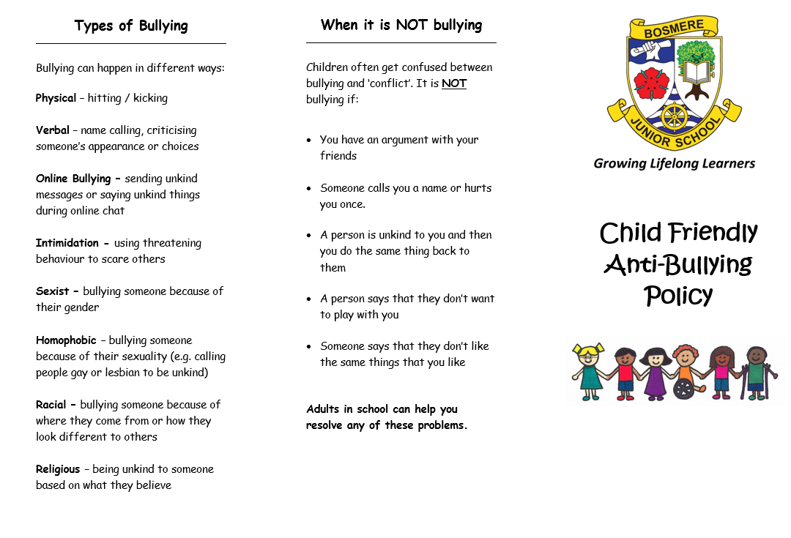
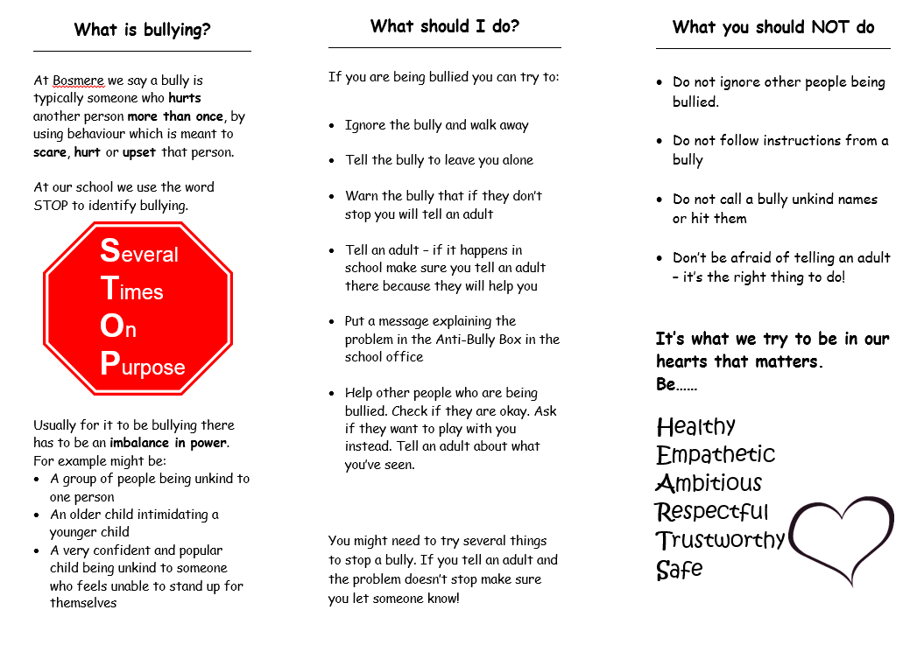
Appendix 3 – ‘On Report’ Behaviour Plan
Behaviour Plan
Pupil on Report: | Class: | Date of plan:

Behaviour Causing Issues:

What will the child do to improve their behaviour (up to three targets):
What will the school do (including communication, rewards & sanctions):
What will my family do at home (including rewards / sanctions):

Date for next meeting (ideally within three weeks of first meeting):
Review (has behaviour improved?):

Actions when a child is put on report:
- Meeting with parents, teacher and child to address the most serious / frequent behaviour issue
- Setting 1-3 clear targets to address this behaviour and make progress
- Using a personalised tracker (focused on the times when there is most frequently problems) to track the child’s behaviour
- Identify rewards that can be given for an improvement in behaviour (ideally should work in tandem with rewards at home)
- Identify privileges that should be restricted if behaviour does not improve

Possible Provision:
- Doing a ‘meet and greet’ each morning
- Arranging for a ‘key adult’ to work with the child on a regular basis to provide behaviour support
- Using the 1:3 rule (praise three things for every one thing that is criticised)
- If the issue is related to specific other children, consider moving them in the classroom / banning them from playing with these individuals at break time
- Give the child a responsibility that they want which can only be kept if good behaviour is sustained

