
Bosmere Junior School
South Street
Havant

POLICY FOR
Off Site & Educational Visits

Date: | October 2025
Review Date: | October 2028
Responsibility: | Educational Visits Co-ordinator
STATUTORY | NO

Headteacher: | Date:
Curriculum and Achievement Chair: | Date:
Chair of Governors: | Date:

Bosmere Junior School Off Site and Education Visits Policy

This policy applies to all members of staff and volunteers supervising pupils of Bosmere Junior School during any activity that takes place off-site. An Off-Site Visit is defined as pupils “going beyond the school gates to pursue an activity organised by the school”. Activities may take place during or after the school day, at weekends or in school holidays and will have an educational basis.

This policy should be read in conjunction with the safeguarding, child protection, equal opportunities, SEND, charging, first aid and data protection policies.

AIMS
Bosmere Junior School has a strong commitment to providing a broad and balanced curriculum with physical, spiritual, moral, social and cultural development. This is fundamental to the process of ‘Growing Lifelong Learners’. Opportunity is frequently taken to enrich and enhance the curriculum through outdoor education and educational visits. These experiences should nurture pupils’ passion for learning, improve progress across the curriculum and foster a sense of cultural aspiration.

School trips provide unique opportunities for different learning experiences and encourage students to engage with people, places and buildings in new ways. This is particularly beneficial for many SEND students who find visual and sensory experiences helpful to their learning and understanding. Hands-on learning activities outside the classroom often lead to better achievement, standards, motivation, personal development and behaviour.

For those pupils from less affluent backgrounds, off-site visits can:
- Tackle social mobility, giving children new and exciting experiences that inspire them to reach their true potential. These real world experiences raise aspirations, equipping young people with the skills they need to become active and responsible citizens and shape a fit and motivated workforce.
- Address educational inequality, re-motivating children who do not thrive in the traditional classroom environment, such as those from disadvantaged backgrounds or with Special Educational Needs. Young people who experience learning outside the classroom as a regular part of their school life benefit from increased self-esteem, and become more engaged in their education both inside and outside the classroom walls.
- Support improved standards back inside the classroom, raising attainment, reducing truancy and improving discipline. Learning outside the classroom is known to contribute significantly to raising standards & improving pupils’ personal, social & emotional development.

SUPPORTING GUIDANCE
In accordance with advice received from Hampshire County Council (HCC), the school has adopted National Guidance from the Outdoor Education Advisors Panel (OEAP) https://oeapng.info/ (see Appendix 1). This is supplemented by additional guidance produced by HCC to address specific questions for Hampshire Schools (see Appendix 2). In the event of any conflict between HCC’s guidance and National guidance, HCC guidance must be followed and clarification sought from the Educational Visits Coordinator or another member of the Senior Management Team.

ROLES
Headteacher:
The person with ultimate management responsibility within the school / establishment. This person will approve all visits taking place (or delegate as appropriate). If an EVC is not nominated, by default this function rests with the Headteacher. The Headteacher also has the responsibility to ensure that staff EV training is up to date.

Educational Visit Coordinator (EVC):
The person(s) appointed by the Headteacher within school to oversee and advise with regard all visits from the establishment. The EVC will not Approve visits (see Headteacher), but will provide support to the Headteacher and all staff involved with visits.

Visit Leader:
The Visit leader holds overall responsibility for planning, risk assessing and supervision of the pupils during the school trip.
This term includes all those employees with a recognised professional qualification and / or evidenced competence for working with young people:
- Teachers and lecturers
- Nationally qualified youth workers
- Other leaders who have an NVQ Level 3 or equivalent and above
- Other school employees (e.g. TAs) deemed to be experienced and appropriate by the Head of Establishment to lead local, low risk and short off-site visits (Leaders cannot be volunteers or other non-employees)

Visit Leadership Team:
All the adults on a visit who share the responsibility for supervision, including the Visit Leader and any assistant leaders, activity leaders and helpers. All should be well briefed by the Visit Leader to be clear about their roles and the task allocated to them.

Volunteer:
A volunteer is someone known to the educational establishment who is considered to be a responsible adult, capable of assisting the qualified leaders with supervision and care of their children or young people. Examples might be:
- A governor
- A parent/family member
- A police officer
(Any child or young person in a helping role should be regarded as a Participant.)

Instructor or coach:
An adult who has a nationally recognised qualification from the governing body of that activity at an appropriate level. They need to be qualified to the level stated in the documents: Safety in adventurous activities or Safety in physical education (Appendix 3 & 4) in order to be registered on the Outdoor Education, PE and DofE Service database and be considered ‘active’. Alternatively:
- They may have an ‘in-house’ accreditation, based upon recognised training or experience , issued by the Outdoor Education, PE and DofE Service
- They may be attached to a centre that has had that particular activity approved by the Outdoor Education, PE and DofE Service

Participants:
All members of the party who are not members of the Visit Leadership Team for whom the school has accepted responsibility. As well as the children or young people from one or more Establishments, this might also include parents or other adults (on a family outing, for example) or children of adults on the staff team.

Parent:
Those parents, legal guardians or others who have parental responsibility for a Participant. If a Parent takes part in a Visit as a member of the leadership team, they will have another role as a ‘voluntary staff member’ within the supervision arrangements for the visit: care must be taken to ensure that the role of Parent does not conflict with this other role.

Governing Body:
This term is used to define the body supporting the Headteacher / management team within a school. They have overarching responsibility for all activities taking place in school, and should be clear regarding the types of visits which require their detailed scrutiny or approval. Governing Bodies should approve the school policy for visits and trips that covers, at least, the following considerations with respect to their own role:
- An overview of all visits taking place within school, and their place within the curriculum
- Determine which visits require specific scrutiny, endorsement and possible ‘sign off’ by Governors. In general, these would be those that are residential, adventurous or overseas.
- Be clear regarding their Statutory Duty with regard to Inclusion and meeting specific medical needs of those on the visit.

(For more information on Roles and Responsibilities, please see Appendix 1 and 2)

APPROVAL SYSTEMS AND PROCEDURES
1) In order for an Off-Site visit to take place, Visit Leaders must obtain the approval of the Head of Establishment (Headteacher) and governors. Visit Leaders must discuss ideas for new Off-Site visits with the Headteacher or EVC, including gaining financial approval, at the preliminary planning stage before any bookings or arrangements are made.

2) When planning trips Visit Leaders must conduct pre-checks and research in order to:
- Clarify the effect on the establishment (cover, equipment needed…)
- Establish the nature of any commercial company or provider to be used (on the approved list, financially bonded, used before…)
- Ensure that the site / establishment is accessible and inclusive for all pupils
- Clarify any costs (including travel)
- Establish if adults either a member of staff or volunteer have needs which should be considered

3) A pre-visit to site and risk assessment (Blank Risk Assessment Stage One and Two – see Appendix 5) must be completed as part of the planning process and to help ensure that potential risks to the safety of leaders, volunteers and participants have been identified and mitigated. Risk Assessments for Off-Site visits must be approved by the EVC (or Headteacher) before children are taken off school grounds.

4) All necessary information should be shared with parents (including a brief itinerary) so that informed consent can be made.

5) All relevant information pertaining to the trip must be shared with the EVC prior to the visit taking place so it can be approved.

6) Many local or frequent off site visits require only Head of Establishment approval, but those falling into the following categories require approval from the Outdoor Education service (EVOLVE Online System – see appendix 6) on behalf of HCC:

- Any activity that involves travelling overseas, even if such a visit is for less than 24 hours and does not involve being residential
- Any activity that involves children or young people in residence away from home for one or more nights, in this country or abroad, including an overnight on the establishment’s own site
- Any ‘open country’ visit, e.g. river or coastal fieldwork activities
- Any adventurous or unusual activity that is classified as potentially hazardous, whether at an approved centre or led by establishment staff. The full details of these activities are contained in Safety in adventurous activities: regulations and guidance (see Appendix 3)
- Any visit or activity taking place more than fifty miles from the school site
- Any visit or activity taking place at a major tourist destination
- Any visit or activity taking place in a major metropolitan area

7) All adults accompanying a party must be made aware, by the visit leader, of the emergency procedures which will apply. Each adult should be provided with an emergency telephone number. This will normally be the school number, but where an activity extends beyond the normal school day the home telephone number of a designated emergency contact should be provided. Clear expectations of behaviour should be shared with all children prior to the trip. If the visit leader decides a child’s behaviour is making a situation unsafe, members of the senior leadership team can be contacted and individuals returned to school. Contact numbers for other adults on the trip will also be shared.

8) Before a party leaves school the school office should be provided with a list of everyone, children and adults, travelling with the party, together with a programme and timetable for the activity. If the trip involves a long walk a map detailing the route should be left. If multiple coaches / minibuses are being used, the school office must be aware of which pupils and adults are on each vehicle. The safety of the party, and especially the children, is of paramount importance. During the activity the visit leader must take whatever steps are necessary to ensure that safety. This involves taking note of any information provided by medical questionnaire returns, and ensuring that children are both safe and well looked after at all times. The Local Authority should be notified of educational visits abroad.

SUPERVISION
Supervision is a key element in the success of any venture. It will determine not only the health and safety of the children and young people and their leaders, but also the quality of the overall experience, enabling learning to take place as well as allowing all those concerned to enjoy the experience and derive satisfaction from it.

Good supervision requires everyone involved knowing what strategies are to be used and what their roles and responsibilities are, as well as having a clear picture of the expectations placed upon them. It is a team effort and shared responsibility, based on small manageable tasks and relationships building into a larger successful system and partnership.

Ratios and styles of supervision need to be complemented by a clear knowledge of the quality of those leaders, volunteers and other responsible adults.

Close or direct supervision
- Here the activity undertaken with children or young people is in close or direct contact with their leaders.
Distant or more remote supervision
- Following on from success with close or direct supervision it may be appropriate to progress strategies. Direct contact with leaders is changed, so the young people work in small groups with the leaders continuously monitoring the group and intervening where necessary.
Remote supervision with self-reliant groups
- This is where members of a group have been together for some time with their leaders and are showing clear evidence of the mastery of skills, understanding of responsibilities and awareness of risk management, and are becoming more self-reliant. Supervision and monitoring can be more remote.

(For more details about specific characteristics of these levels of supervision please see Appendix 2)Please see the table below for detailed information about Supervision Ratios and Qualification Guidance:
Activity | Qualifications/staffing | Minimum ratios | Notes
Local visits – in the local area, close to support at the base | - An experienced group leader  - Other qualified leader(s) (numbers as required)  - At least one Outdoor Leader certificated leader recommended  - Other responsible adult(s) in support  - A minimum of two leaders required, unless exceptional circumstances are agreed | Early Years: 1:6  Key Stage 1: 1:8  Key Stage 2 and above: 1 per activity or supervision group (maximum 1:20) | A minimum of one qualified leader is needed for every group or class. They can then be supported by other qualified leaders or responsible adults  Minimum ratios are not recommended ratios. Small working groups of 6-12 remain the target.  Leaders should reflect the gender of the group  It is recommended that any off-site visit should include at least one certificated Outdoor Leader trained member of staff where possible.
Day visits – more than 60 miles or one hour from base | - An experienced group leader (recommended)  - At least one Outdoor Leader certificated leader recommended  - Other qualified leader(s) (numbers as required)  - Other responsible adult(s) in support  - A minimum of two leaders required | Early Years: 1:6  Key Stage 1: 1:8  Key Stage 2 and above: 1 per activity or supervision group (maximum 1:12)
Residential visit, UK or abroad | - An experienced group leader (recommended)  - At least one Outdoor Leader certificated leader recommended  - Other qualified leader(s) (numbers as required)  - Other responsible adult(s) in support  - A minimum of two leaders required  - Large or complex visits must have an experienced leader | Early Years: 1:6  Key Stage 1: 1:8  Key Stage 2 and above: 1 per activity or supervision group (maximum 1:12)  These ratios do not include the centre/ residential base staff | As above, however it is recommended that the ratio of qualified leader to responsible adult support is low, at 1:1 or 1:2  Where the visit is part host family, part residential, the residential conditions should apply  It is strongly recommended that all residential visits should include at least one certificated Outdoor Leader amongst the supervisory staff group  Leaders should reflect the gender of the group
Host families | - As above; however if wholly residing with families, a minimum of two leaders in country | As above, but if wholly residing with families the 1:12 ratio could be reduced to 1:15
Open country  Working by water  Away from a road or building  In environments containing significant hazards (e.g. steep ground, canals, beaches)  Working in ‘remote’ areas at distance from immediate support | - Qualified and experienced leaders, minimum Outdoor Leader Certificated  - Other qualified leader(s)  - Volunteers and other responsible adult(s) | Early Years: 1:6  Key Stage 1: 1:8  Key Stage 2 and above: 1 per activity or supervision group (maximum 1:12) | Overall group sizes above 20 are not recommended at any one location at the same time (supervision and sustainability issues). Similarly large groups should not be moving together or in convoy. The number of Outdoor Leader certificated leaders will depend on the risk assessment. By water, each group must have someone Outdoor Leader/throw bag trained and competent.
Adventurous Activities | Qualifications and ratios are set out in the document Safety in Adventurous Activities (Appendix 3)

Transportation
A variety of transport is used following local guidance. Transport used may include:
staff members’ cars (if they have business insurance)
public buses (local, non-motorway travel)
coaches (through recognised suppliers)
trains (where appropriate or part of the learning in the venture)
minibuses (for small group transport or local class trip)

When travelling by minibus a second adult is required in the vehicle apart from the driver. On long trips an adequate number of rest periods lasting at least 15 minutes will be planned for. Ideally the second adult will be qualified to act as a relief driver. All drivers must hold an appropriate licence (D1 in most cases) and will complete a MIDAS assessment or a course of training and assessment of a similar national standing. By law seatbelts or lap restraints must be used by passengers if they are fitted in the vehicle. This responsibility rests with the driver to ensure compliance. (The additional adult is expected to assist with this.)

When arranging transportation by coach, the school will always book coaches fitted with seatbelts from suppliers approved by Hampshire County Council. Teachers will ensure that seatbelts or lap restraints are in use during travel. Supervising staff will be spread throughout the coach.

Staff members’ who transport pupils, whether on school trips, home, to hospital, or other venues, must ensure that their insurance policies specifically cover them for this use.

Types of Visits
Pupils at Bosmere Junior School will experience a wide range of school trips across the Key Stage for a variety of different purposes. These include:
- on-site, out-of-classroom activities including nature studies, scientific experiments and sleepovers
- local ventures including Warblington School, St Faith’s Church, Havant Town Centre etc
- sporting events, team matches and tournaments
- small group visits for pupils who have a specific responsibility, require specific support, are most able or have a particular interest in a subject
- day or part-day ventures including visits to historical sites, museums, nature reserves etc
- a residential venture in Year 6
- special events, team building activities or rewards

INCLUSION
Bosmere Junior School aims to treat all stakeholders, including pupils, prospective pupils, staff, governors and other members of the school community favourably and, wherever possible, takes reasonable steps to avoid placing anyone at a substantial disadvantage.

The school aims to work closely with pupils, their families and any relevant outside agencies in order to remove or minimise any potential barriers to inclusion to ensure that they can learn, achieve and participate fully in school life. Staff planning off-site visits will make ‘every reasonable adjustment’ to include a young person with Special Educational Needs or disabilities. However, if those reasonable adjustments cannot ensure their safety and/or that of others, then that may be the reason they cannot attend a particular venture. Where this potential exists, discussions with the senior management team must occur at an early stage.

- Some off-site visit and activities are provided as part of the National Curriculum and are therefore a statutory requirement (for example Year 4 swimming lessons). Inclusion of all pupils is required.
- On class trips / year group trips, comprehensive coverage is desirable. However it may be possible to provide suitable alternatives at school. National Curriculum and similar entitlement is not lost as this is an enhancement or enrichment activity therefore inclusion of all is desired but not required. Moreover parental choice or other factors may mean that not all attend.
- Some off-site visits that have a purpose of enhancing learning or provide wider experiences for specific groups of pupils will be optional. Participation will depend on factors such as parental choice, availability, and academic ability, artistic ability or sporting ability.

SAFEGUARDING
All adults involved have a responsibility to safeguard and promote the welfare of children and young people during outdoor learning, off-site visits and learning outside the classroom. Such visits and activities have many benefits, but there are also potential safeguarding risks which should be considered during the planning process. Visit Leaders must ensure that they are informed of any children and young people who may be particularly vulnerable or have specific safeguarding needs, and ensure that other staff/adults are made aware as necessary.

Overnight Stays:
Where activities and visits involve overnight stays, careful consideration should be given to sleeping arrangements, taking into account issues of privacy and child protection. Where possible, children, young people, staff and parents should be informed of sleeping arrangements prior to the start of the trip. Careful attention should be given to ensuring safe staff/participant ratios and to the gender mix of staff.

New People and New Places:
A key benefit of off-site visits is that children and young people have the opportunity to explore new places and meet new people. This may leave them vulnerable unless they are adequately prepared and appropriate measures have been put in place to control any significant risks.

Relationships and professional behaviour:
During outdoor learning, off-site visits and learning outside the classroom, relationships between staff and participants are often less formal than in the usual school or workplace. Young people may also build relationships with each other and with other adults and young people from outside the group, such as students from another school, activity instructors or members of the public. This can have many positive benefits, but it also brings risks, of which all staff involved should be made aware.

Adults are in a position of trust and need to ensure that their behaviour remains professional at all times and stays within clearly defined professional boundaries. They are responsible for their own actions and behaviour and should avoid any conduct which would lead any reasonable person to question their motivation and intentions. They should operate, and be seen to operate, in an open and transparent way. The same professional standards should always be applied regardless of culture, disability, gender, language, racial origin, religious belief and/or sexual identity.

Staff should:
  - always be publicly open when working with children and young people, and avoid situations where they and an individual child or young person are completely unobserved
  - when physical touching is required (e.g. when coaching an activity or fitting a climbing harness), seek permission and do it openly – ideally with other staff present
  - comfort or reassure a distressed child or young person in an age-appropriate way, whilst maintaining clear professional boundaries
  - follow their employer’s reporting procedures if a child or young person makes a disclosure of abuse
Staff should not:
  - engage in rough, physical or sexually provocative games or horseplay
  - allow or engage in inappropriate touching in any form
  - allow children or young people to use inappropriate language unchallenged
  - make sexually suggestive comments to a child or young person, even in fun

The school’s Safeguarding and Child Protection policies apply during Off-Site visits including residential activities.
They contain further relevant information including:
- how to respond to a disclosure from a pupil about abuse or other safeguarding issues
- guidance on acceptable behaviour and avoiding unnecessary contact
- ensuring suitable checks are made on volunteers and other responsible adults who support these ventures in line with guidance (including DBS requirements)

INSURANCE
Bosmere Junior school insurance is provided through Hampshire County Council.

EMERGENCY PROCEDURES
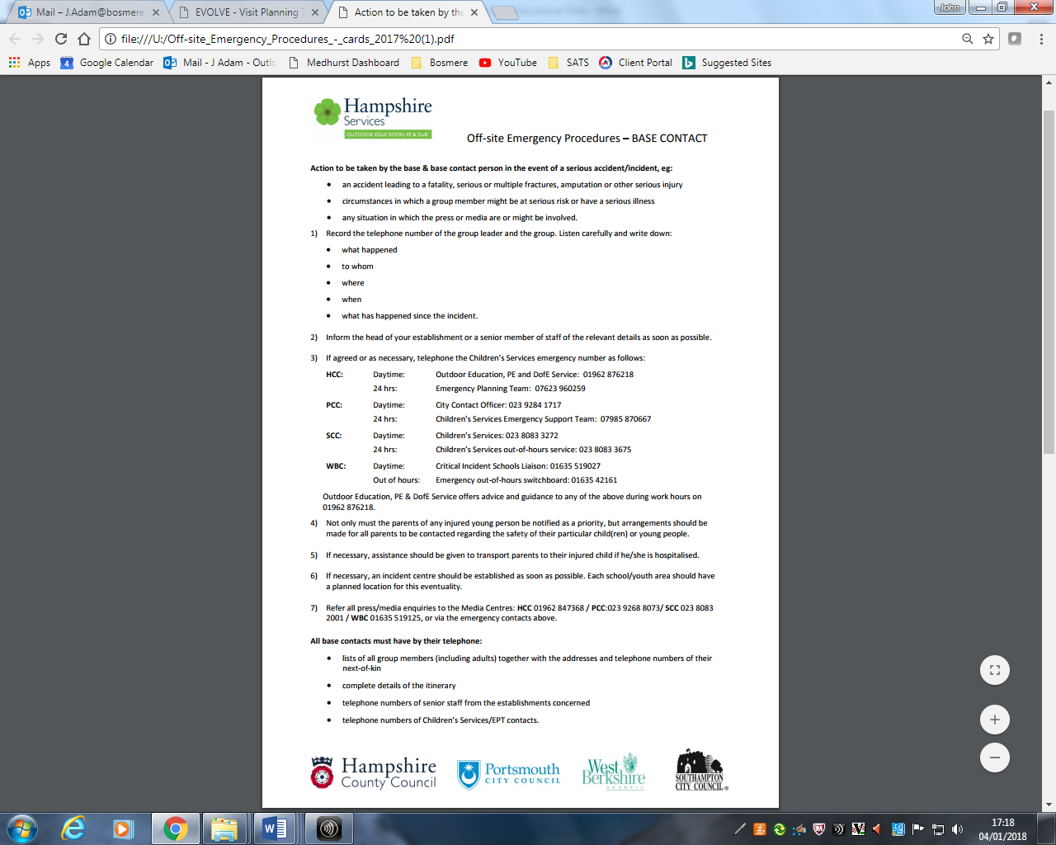
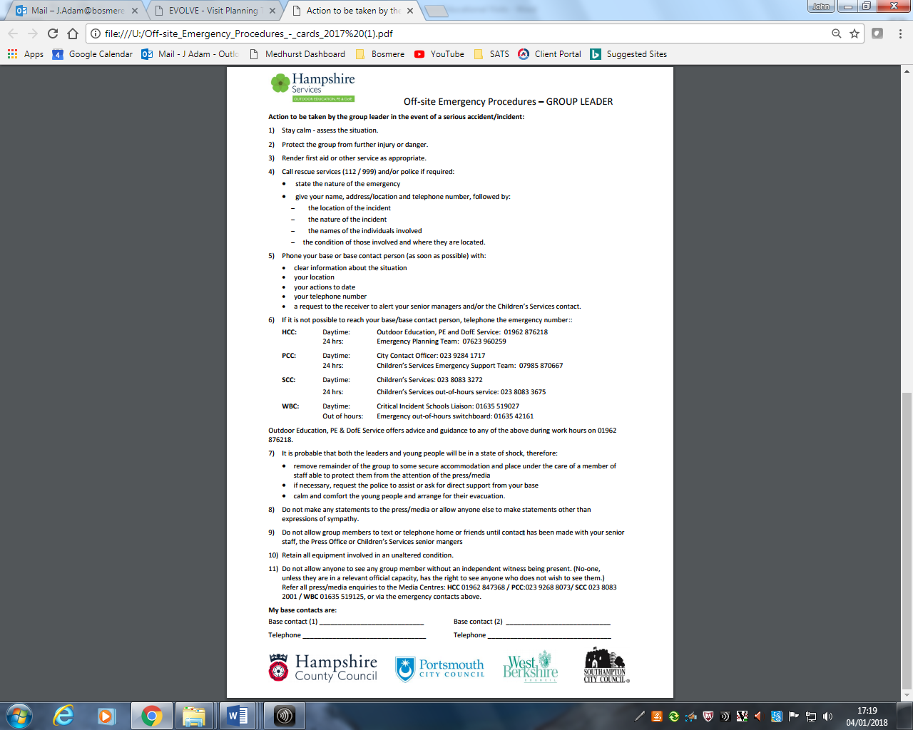

RECORDING ‘NEAR MISS’ INCIDENTS
There is a long standing culture that all accidents and incidents that have resulted in injuries are recorded as fully as possible to enable a full understanding of what happened, why and how, and to help manage the follow up and consequences of such incidents.
Equally, it is common culture within the outdoor world that ‘Near Miss’ incidents are also reported and recorded. This is not intended to allow blame or criticism to be apportioned to members of staff, but to encourage all involved to examine their practice, identify where changes or improvements could be made for the future in a way that leads to the development of best practice at all times. Outdoor practice with respect to off site and educational visits evolves through this process, and Near Miss reporting is seen as being good practice in its own right.
A Near Miss is any event, which under slightly different circumstances, may have resulted in significant unmanaged danger to, injury to, or ill health of, young people, supervisors or others involved in the activity. It would normally exclude simple and everyday events – e.g. minor trip hazards or minor slips in situations where there are no significant natural or other hazards present (e.g. river or canal edges, very busy main roads, cliff edges), but should also take into account the behaviour of young people or decisions made by supervising staff (e.g. a child with severe behaviour issues is left unsupervised in a situation where physical hazards are present). In determining whether a Near Miss is worth reporting, staff should consider whether the event went beyond the expected norm or ability for the child, young people, or activity, whether an event went well beyond the experience, knowledge or skills of a member of staff or led to staff feeling out of their depth and uncomfortable. However, no incident should be deemed too small to be reported as a Near Miss – the purpose of Near Miss reporting is to enable lessons to be learned and practice amended. If in doubt, report it! Near Miss recording is not about apportioning blame or criticism. It should be seen as a supportive part of a developmental process towards best practice.
Monitoring and Review
The EVC will monitor all visits through scrutiny of the Risk Assessment documents and the off-site visit forms on EVOLVE. Depending on the nature of the visit and the experience of the EVC, the Principal or delegated senior manager will be expected to provide additional scrutiny of visit forms and arrangements for the visit. When necessary, the EVC will require further information and action from the Visit Leader and/or those responsible for organising the visit until the EVC is satisfied that the visit meets the requirements of the establishment policy and employer’s guidance. When necessary the EVC will inform the Headteacher of any concerns, in relation to the organisation of the visit, that may have safety implications or may significantly reduce the quality of experience for those taking part. Individual staff feedback also contributes to monitoring on the quality of ventures and recommendations for the future. The policy is reviewed every three years or as required if regulations, guidance or circumstances change.

Appendices (double click on inserted Adobe documents to open them)
1 | National Guidance from the Outdoor Education Advisors Panel (OEAP) | https://oeapng.info/
2 | Hampshire County Council Outdoor Education Service Supplementary advice and guidance
3 | Safety in Adventurous Activities
4 | Safety in PE and Sport
5 | Risk Assessment
6 | EVOLVE Online System | https://evolve.edufocus.co.uk/
7 | Medical and Consent Form

