Bosmere Junior School
South Street
Havant

POLICY FOR
SPECIAL EDUCATIONAL NEEDS and DISABILITIES

Date: | May 2025
Review Date: | May 2028
Responsibility: | Governing Body / SEND Manager
STATUTORY
Checked against Single Equality Scheme

Inclusion Manager: | Date:
Chair of Governors: | Date:
Headteacher: | Date:

Rationale

At Bosmere Junior School we recognise the statutory basis of provision for children with special educational needs. We value every child whatever their individual needs may be and aim to work within the framework of the Special educational needs and disability code of practice: 0 to 25 years.

Special educational needs are a whole school responsibility. Therefore, this policy should be considered within the wider context of all the school’s policies, particularly the Teaching and Learning Policy, the Behaviour Policy, the Single Equality Policy and Accessibility Scheme.

The 2015 Code of Practice, states that all children and young people are entitled to an education that enables them to make progress so that they:
- Achieve their best
- Become confident individuals living fulfilling lives, and
- Make a successful transition into adulthood, whether into employment, further or higher education or training.

At Bosmere Junior School, we believe that all children with a Special Educational Need or Disability (SEND) must have their needs recognized and assessed, with appropriate and timely intervention put in place. All children have the same entitlement to the whole school curriculum and we are committed to making this accessible to all children by:
- Providing suitable learning challenges
- Meeting the students diverse learning needs
- Overcoming the barriers to learning and progress

Objectives

At Bosmere Junior School we will;
- Identify and address the SEND of the pupils we support.
- Record and monitor the progress of children on the SEND register.
- Endeavour to ensure that all children with SEND get the support they need.
- Ensure that all students with SEND are offered full access to a broad, balanced and appropriate mainstream curriculum that sets high expectations for every student whatever their prior attainment.
- Provide for the individual needs of all students with SEND and ensure their progress in mainstream education, alongside students who do not have SEND, in order to maximize their achievement.
- Ensure that the needs of students with SEND are identified, assessed, provided for and regularly reviewed.
- Take the views, wishes and feelings of the young person into account, and involve them as fully as possible in decision making about their own education.
- Work in partnership with parents to enable them to make an active, empowered and informed contribution to their son/daughter’s education.
- Seek specialist advice from outside agencies to support the learning needs of the children.
- Designate a teacher responsible for the coordinating of SEND provision i.e. SENCO.

Context

Paragraph xiii to xiv of the SEND Code of Practice (2015) contains the following definitions:
A child or young person has SEND if they have a learning difficulty or disability which calls for special educational provision to be made for him or her.
A child of compulsory school age or a young person has a learning difficulty or disability if he or she:
- has a significantly greater difficulty in learning than the majority of others of the same age, or
- has a disability which prevents or hinders him or her from making use of facilities of a kind generally provided for others of the same age in mainstream schools or mainstream post-16 institutions

Areas of Need

The new Code of Practice (2015) provides an overview of the range of needs, which is divided into 4 broad areas. These areas are:
- Communication and Interaction - Children and young people with speech, language and communication needs (SLCN) have difficulty in communicating with others. This may be because they have difficulty saying what they want to, understanding what is being said to them or they do not understand or use social rules of communication. The profile for every child with SLCN is different and their needs may change over time. They may have difficulty with one, some or all of the different aspects of speech, language or social communication at different times of their lives. Children and young people with ASD, including Asperger’s Syndrome and Autism, are likely to have particular difficulties with social interaction. They may also experience difficulties with language, communication and imagination, which can impact on how they relate to others.

- Cognition and Learning (C&L) - Support for learning difficulties may be required when children and young people learn at a slower pace than their peers, even with appropriate differentiation. Learning difficulties cover a wide range of needs, including moderate learning difficulties (MLD), severe learning difficulties (SLD), where children are likely to need support in all areas of the curriculum and associated difficulties with mobility and communication, through to profound and multiple learning difficulties (PMLD), where children are likely to have severe and complex learning difficulties as well as a physical disability or sensory impairment. Specific learning difficulties (SpLD), affect one or more specific aspects of learning. This encompasses a range of conditions such as dyslexia, dyscalculia and dyspraxia.

- Social, Emotional and Mental Health Difficulties (SEMH). Children and young people may experience a wide range of social and emotional difficulties which manifest themselves in many ways. These may include becoming withdrawn or isolated, as well as displaying challenging, disruptive or disturbing behaviour. These behaviours may reflect underlying mental health difficulties such as anxiety or depression, self-harming, substance misuse, eating disorders or physical symptoms that are medically unexplained. Other children and young people may have disorders such as attention deficit disorder, attention deficit hyperactive disorder or attachment disorder.

- Sensory and or Physical Needs. Some children and young people require special educational provision because they have a disability which prevents or hinders them from making use of the educational facilities generally provided. These difficulties can be age related and may fluctuate over time. Many children and young people with vision impairment (VI), hearing impairment (HI) or a multi-sensory impairment (MSI) will require specialist support and/or equipment to access their learning, or habilitation support. Children and young people with an MSI have a combination of vision and hearing difficulties. Information on how to provide services for deafblind children and young people is available through the Social Care for Deafblind Children and Adults guidance published by the Department of Health Some children and young people with a physical disability (PD) require additional ongoing support and equipment to access all the opportunities available to their peers

Most Able Pupils

Within the school there are also those pupils who achieve, or have the ability to achieve, at a level significantly in advance of their peers. This may be in all areas of the curriculum or in a limited range. Therefore we also aim to:
- Identify pupils who are achieving or have the potential to achieve significantly in advance of the average for their year group.
- Enable each pupil to develop to their full potential by providing for the learning needs of the most able
- Enable personal challenge and extension of individual pupils through the work we set them.
- Encourage pupils to generate their own learning by working and thinking independently.

A Graduated Approach to SEND Support

A process of on-going teacher assessments and termly pupil progress meetings with the leadership team identifies those pupils making less than expected progress given their age and individual circumstances. The school’s first response is high quality targeted teaching by the class teacher. Where progress continues to be less than expected, the class teacher will discuss their concerns with the SENCO. In deciding whether to make special educational provision, the teacher and SENCO will consider all of the information gathered from within the school about the pupil’s progress, alongside the views of parents/carers and pupil. During this stage extra teaching or interventions may be put in place as a pupil’s response to such support can help to identify their particular needs.

Where pupils have higher levels of need, and with parental permission, the school may to seek advice from external agencies.

If the support needed can be provided by adapting the school’s core offer then a child might not be considered SEND or placed on the SEND register. If, however, the support required is different from or additional to what is ordinarily offered by the school, the child will be placed on the SEND register at SEND Support. The school will then seek to remove barriers to learning and put effective special educational provision in place. This begins a cycle of assess, plan, do, review with the child/young person at the centre of the process.

The four part cycle:

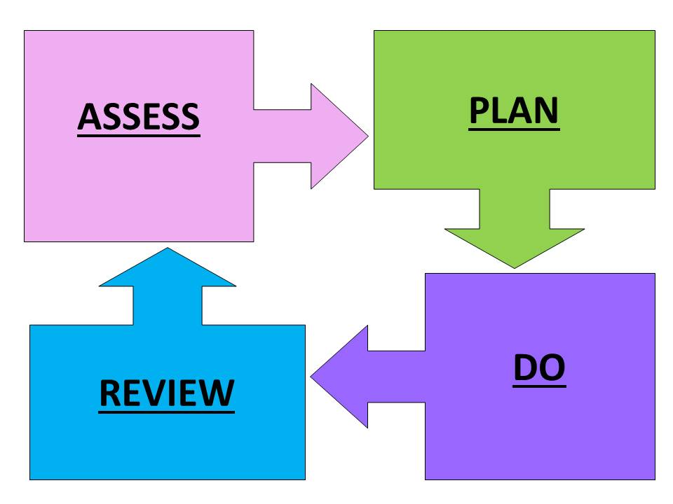

Assess: We will ensure that we regularly assess all pupils’ needs so that each child’s progress and development is carefully tracked compared to their peers and national expectations. We will listen to the views and experience of parents/carers and the pupil. In some cases we will draw on assessments and guidance from other education professionals e.g. Educational Psychologists (EP) and from health and social services.

Plan: Where SEND Support is required the teacher and SENCO will put together a plan outlining the adjustments, interventions and support which will be put in place for the pupil as well as the expected impact on progress and outcomes, including a date when this will be reviewed. Targets for the pupil will be shared with her/him using child friendly language and with parents/carers. All staff who work with the pupil will be made aware of the plan.

Do: The class teacher is responsible for working with the pupil on a daily basis. They will also liaise closely with LSAs or HLTAs who provide support set out in the plan and monitor the progress being made. The SENCO will provide support, guidance and advice for the teacher.

Review: The plan including the impact of the support and interventions will be reviewed each term by the teacher, SENCO, parent/carer and the pupil. This will inform the planning of next steps for a further period or where successful the removal of the pupil from SEND Support.

Staffing and Professional Development

The Leadership Team will take active steps to ensure that its workforce is both aware of and adheres to the aims and stated outcomes that are contained in this policy. This will be reflected in the framework of professional development and staff training.

Responsibilities and Co-ordination of Special Educational Needs

Overall responsibility for all children rests with the Headteacher and the school’s governing body. The school’s governing body must ensure that the necessary provision is made for any child who has special educational needs. The Headteacher has responsibility for the overall management of provision for children with SEN.

There is a named Special Educational Needs Co-ordinator (SENCO) who has responsibility for the day to day implementation of the school’s SEND policy and for the co-ordination for children with SEND. Class teachers are directly responsible for the education of every child in the class, including those on the SEND register. The SENCO keeps the register of all children with SEND within the schools, the register being updated regularly (at least termly). The SENCO liaises with the Headteacher and the Governor with responsibilities for SEND on a regular basis, there being a more formal termly meeting between the SENCO and SEND Governor.

Learning Support Assistants (LSAs), and Higher Level Teaching Assistants (HLTAs) work mainly with individuals and small groups of children with special educational needs following programmes of work organised by the class teacher and SENCO. At times LSAs work with individual children focusing on programmes provided by outside agencies.

Criteria for evaluating the success of the school’s SEND Policy

We believe that successful implementation of this SEND policy will ensure:
- Early identification of children with special educational needs.
- Appropriate support for any child with a special educational need.
- That children with SEND & Disabilities are included in all areas of school life.
- That some children with SEND will improve sufficiently to be removed from the SEND register.
- That children with significant SEND will receive appropriate support from the LEA and other outside agencies.
- That there will be support and information for the parents of children with SEN.
- That our tracking and assessment procedures will be used efficiently to monitor and measure the progress of SEND children.
- End of Key Stage 2 outcomes will reflect the best possible progress of children with SEN.
- Pupils who are on the SEND register make successful transitions to an appropriate Key Stage 3 setting.

PROVISION FOR PUPILS
We provide three ‘waves’ of provision to pupils to ensure that they receive an education appropriate to their abilities:

Wave 1 Provision: Quality First Teaching – whole class
As a school, we strive to ensure that pupils receive good quality whole class teaching. Quality First Teaching is a style of teaching that emphasises high quality, inclusive teaching for all pupils in a class. The needs of all children are taken into account, with high expectations for them. Quality first teaching includes differentiated learning, strategies to support SEND pupils' learning in class, on-going formative assessment and many others. It is designed to move all pupils from where they are to where they need to be. Where there are large numbers of pupils that share the same learning needs, then the best solution is to adjust the planning to cater for them. It means setting a new trajectory for the learning programme to take pupils to where they need to be in terms of age-related expectations.

Wave 2 Provision: Wave 1 plus additional, time-limited, tailored intervention support programmes
Designed to increase rates of progress and secure learning for groups of pupils, which puts them back on course to meet or exceed national expectations. This usually takes the form of a tight, structured programme of small-group support, carefully targeted and delivered by teachers or teaching assistants, who have the skills to help pupils achieve their learning objectives. This can occur outside (but in addition to) whole-class lessons, or be built into mainstream lessons as part of guided work. Critically, intervention support needs to help pupils apply their learning in mainstream lessons. Intervention programmes need to be closely monitored to ensure that they meet pupils’ needs. This is about support for pupil who can get back to achieving age-related expectations. The outcome of Wave 2 intervention is for pupils to be back on track to meet national expectations at the end of the key stage.

Wave 3 Provision: Increasingly individualised programmes, based on independent evidence of what works
Expectations are to accelerate and maximise progress and minimise performance gaps. This will involve one-to-one or very small group support via a specialist teacher, highly- trained LSA or pupil premium teacher, to support pupils towards the achievement of very specific targets. Individual provision may be used on occasions for the small number of pupils who demonstrate exceptional ability, or who require an individualised programme to support their needs.

Intimate Care
This section outlines Bosmere’s approach to supporting pupils in Key Stage 2 who require intimate care due to a disability, medical condition, or specific learning need. The policy ensures that care is delivered safely, respectfully, and in partnership with families, in accordance with safeguarding principles and dignity for the child.
Definition of Intimate Care
Intimate care may include support with:
• Personal hygiene (e.g. washing after toileting, managing menstrual care)
• Changing clothing due to accidents or incontinence
• Assistance with toileting (including use of toilet aids or continence pads)
• Support with managing medical needs such as stoma care or catheterisation
While most pupils in this age group are independent in these areas, some may require additional support as part of their SEND provision.
Key Principles
• All children have the right to dignity, privacy, and respect.
• Intimate care will only be provided when necessary and in line with an individualised care plan.
• Staff will support children to be as independent as possible and to express their preferences.
• Safeguarding is paramount and underpins all aspects of intimate care.
Safeguarding and Vulnerability
Children with SEND, particularly those requiring intimate care, may face increased safeguarding vulnerabilities. All staff must remain alert to any signs of distress, discomfort, or disclosure during care and report concerns immediately following the school’s Safeguarding and Child Protection Policy and Keeping Children Safe in Education (KCSIE).
All staff delivering intimate care must act in accordance with the school’s Safeguarding and Child Protection Policy and follow the school’s Staff Code of Conduct, with particular attention to physical contact, supervision, and professional boundaries
Procedures and Practice
• Individual Intimate Care Plans will be developed for any child who requires ongoing support, created in consultation with parents/carers, relevant professionals (e.g., school nurse), and the child where appropriate. The plan will outline:
o The level and type of care required
o Specific medical needs
o Preferred methods of communication
o Cultural and religious considerations
o A written log will be maintained for each instance of intimate care
• Staffing: Staff members will have received appropriate safeguarding and hygiene training. Staff can request a second adult to be present depending on the circumstances of the personal care the child requires.
• Parental Involvement: Parents/carers will be informed of procedures and encouraged to contribute to the care plan. Any changes to care needs will be discussed and updated as necessary.
• Child Voice and Consent: Pupils will be involved in decisions about their care and supported to express preferences. Verbal consent will be sought before any procedure. Where appropriate, pupils will be encouraged to develop independence through a supported plan.
• Privacy and Dignity: Care will be provided in a private, safe space. Where possible, same-sex staff will provide care unless otherwise agreed. A second adult will be made aware of the care being given, in line with safeguarding protocols.
• Record-Keeping: A log will be kept of all intimate care provided, including date, time, staff involved, and any observations. Any concerns will be reported immediately in line with the school’s safeguarding procedures.
• Health and Safety: All care will follow infection prevention protocols, including the use of personal protective equipment (PPE).
• Emergency Protocols: If a child without a care plan requires immediate support (e.g., soiling), staff will respond discreetly and sensitively. Where possible, parents/carers will be contacted, and support provided in line with safeguarding protocols. All incidents will be logged and reported to the Designated Safeguarding Lead (DSL).

Related School Policies and Documents

- SEND Appendix
- SEND Information Report
- Safeguarding Policy
- Accessibility Plan
- Admissions Policy
- Anti-Bullying Policy
- Behaviour Policy
- Inclusion Policy
- Equality Policy
- Curriculum policies

Related Government Publications

The following documents have informed this guidance which parents may find helpful:
- Special educational needs and disability code of practice: 0-25 years https://www.gov.uk/government/publications/send-code-of-practice-0-to-25
- Special educational needs and disability: a guide for parents and carers https://www.gov.uk/government/publications/send-guide-for-parents-and-carers
- Supporting pupils at school with medical conditions
https://www.gov.uk/government/publications/supporting-pupils-at-school-withmedical-conditions--3
- Keeping children safe in education
https://www.gov.uk/government/publications/keeping-children-safe-in-education

