Bosmere Junior School
South Street
Havant

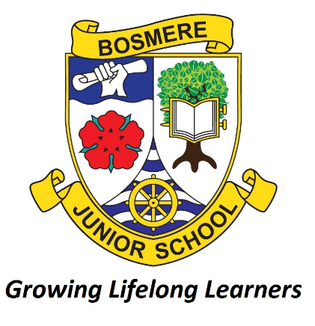

POLICY FOR ENGLISH

Date: | September 2025
Review Date: | September 2028
Responsibility: | English Manager
STATUTORY | No
Checked against Equality Policy

English Manager: | Date:
Subject Governor: | Date:
Headteacher: | Date:

POLICY FOR ENGLISH

The following document has been established in order to outline the agreed practice in the aims, planning, teaching and assessment of English at Bosmere Junior School.

RATIONALE
English underpins the school curriculum by developing pupils’ abilities to speak, read, and write for a range of purposes, in various styles, and for different audiences. They use language to learn, communicate, think, explore, and organise. By enabling children to express themselves clearly, both orally and in writing, we enhance and enrich teaching and learning across all subjects. This foundation equips them with the skills to adapt to a constantly evolving world where writing and communication styles are always changing, ensuring they are well-prepared for future challenges.

AIMS
The school’s aim is to ensure that all children are given equal opportunities to experience the richness of English language, developing the confidence and ability to express themselves effectively, both orally and in writing. By the end of their time at Bosmere, pupils should have developed a strong foundation in reading, including reading for pleasure, where they engage with a wide range of literature—fiction, non-fiction, and poetry—both to read independently and to hear aloud. Through a diverse curriculum, children will build essential skills in reading, comprehension, writing, and oracy, allowing them to articulate ideas clearly and persuasively. All pupils should leave Bosmere equipped with the literacy skills necessary to excel in secondary education and beyond, with a love for reading and the ability to communicate confidently and thoughtfully in various contexts.

CURRICULUM
The time allocated to English is approximately 85 minutes per day, split into 30 minutes for reading and 55 minutes for grammar, spelling, and writing. However, this time allocation is flexible. On occasion, it may be more appropriate to dedicate the full 85 minutes to reading-based activities, while on other days, the entire session may focus on writing, spelling, and grammar. This flexibility allows for a more tailored approach, ensuring that each area of English receives the attention it needs based on the learning objectives of the lesson. Once a week, each year group uses adults across the year group to ensure all pupils engage in small group discussions about a text during guided reading.

In addition to guided reading sessions, exploring reading sessions take place once a week. These sessions, lasting 30 minutes, are designed to foster a love of reading and deepen comprehension skills. Pupils in Year 3 and Year 5, as well as Year 4 and Year 6, are paired as reading buddies on a three-week rota. During these sessions, older children will take an active role in preparing thoughtful questions and engaging activities to share with younger pupils. These sessions provide a valuable opportunity for collaborative learning, where children not only read but also share books, ideas, and insights. In the remaining sessions, teachers are encouraged to explore a variety of texts—including books, library visits, and visual texts—allowing for creative and flexible approaches to reading. This initiative continues to promote a lifelong love of reading across all subjects, enhancing both literacy skills and the enjoyment of fiction.

There is also an expectation that English skills, including oracy, will be integrated across all areas of the curriculum. For instance, pupils will apply their writing abilities in subjects such as science (e.g. writing conclusions), history (e.g., small or extended pieces of writing), and through activities like library sessions, drama, and group discussions. Reading is integral to research opportunities across different subjects, including Project Based Learning tasks. This cross-curricular approach ensures that students not only strengthen their literacy skills but also develop their spoken language skills, seeing the practical application of English in a variety of contexts. By fostering both written and oral communication, we help pupils engage more fully with the curriculum and with each other.

Reading
There is a culture of reading for enjoyment throughout the school. Reading for pleasure is promoted in many ways including, but not limited to, a dedicated book week; love our library events; participation in SLS book award events, pupil librarians, Drop, Stop and Read events, books on legs, Exploring Reading sessions, rewards for regular readers and reading buddies. Volunteers are used where possible to supplement school provision, for example guided reading and 1:1 reading.

Pupils will all have at least one book. This will be their reading for pleasure book. This could be too hard for them to read independently with a purpose of sharing it with an adult.

All children will have a book which is at the right level for them to be able to read independently, with the purpose of developing fluency and comprehension. This may be from the colour coded reading scheme or an assisted library choice book possibly from the early reading section. (If they are higher attaining readers, this may be the same as their reading for pleasure book.)

Those children who require phonics intervention will also have a reading book which is focusing on phonics from our phonics scheme (Essential Letters and Sounds) with a purpose of developing decoding skills.

Where children are still developing decoding skills, we will be using the three + reads approach to teach reading, with each book being read a number of times:
- The first read will focus on decoding (may need to be repeated)
- The second read will focus on fluency (may need to be repeated and certainly should be modelled)
- The third read will focus on comprehension (may need to be repeated)

Phonics
Essential Letters and Sounds (ELS) is used within the school to ensure a consistent approach to phonics. See Appendix 3. All pupils are assessed using ELS when they start at Bosmere. This assessment is used to determine where pupils start on the phonics teaching if needed. Most pupils will start at Phase 3 and progress at a rate that matches their ability. Children in Year Four, Five and Six assessed at Not meeting (N) in word reading in previous end of year milestones are also assessed using ELS and may then have phonics interventions. All staff have ELS and Oxford Owl logins and have had training in using the scheme.
All phonics lessons follow the same structure: review previous learning; teach new Harder to Read Spell (HRS) word and phoneme; apply HRS word and phoneme; review new learning. There is no expectation for teachers to teach the ELS lessons in the way prescribed. Fidelity to the scheme is maintained by ensuring all resources are from ELS and that all phonics reading books are closely matched to the scheme. Children who require phonic interventions will also have a reading book which matches the sounds taught with a purpose of developing their decoding skills.

Writing and Grammar
The English curriculum at Bosmere has been designed with enjoyment at its heart. Each unit uses a rich text driver, with a range of supporting texts, and/or a cross-curricular link to engage pupils and provide meaningful opportunities in which to develop their reading, writing and grammar skills. This curriculum has been planned, with the aid of the HIAS English team, to meet the needs of the national curriculum, to compliment changes to our curriculum in school, and to link with Bosmere’s writing assessment objectives.

In each year group, the individual sequences of work in English follow the three-phase Hampshire model: ‘Stimulate and Generate’, ‘Capture, Sift and Sort’ and ‘Create, Refine and Evaluate’. Before each unit begins, prior learning may be assessed with a ‘Cold Task’ relating to the particular genre being studied. This is an opportunity for pupils to produce a piece of writing with minimal input, allowing teachers to assess existing skills and knowledge. Within the latter two phases of the Hampshire Model, the Pie Corbett ‘Talk for Writing’ guidance is used to allow children the best possible chance of being successful in their writing. Within the ‘Stimulate and Generate’ phase this includes ‘Reading as a Reader’, ‘Reading as a Writer’. The ‘Create, Refine and Evaluate’ phase includes the ‘Innovation Stage’ (modelling and practising short sections) followed by a ‘Hot Task,’ where children have the opportunity to apply and showcase the skills they have been working on thoughout the unit. (see Appendix 1). Pupils are encouraged to plan using a ‘Writing Rectangle’ (Appendix 4), with the focus of all their writing being on Purpose and Audience. Task design allows pupils who are working at Greater Depth to have greater freedom over the style of their writing which best fits the purpose. Additionally, tasks are adapted, expectations adjusted and additional support is put in place to scaffold learning for SEND pupils, allowing them to reach their full potential.

To further consolidate writing skills, Sites of Application tasks/writing flashbacks, are incorporated in each year group. These tasks provide children with the opportunity to apply the skills they've learned in previous writing units. Flashback writing activities have been integrated into writing journeys, with most units including at least one such opportunity, allowing students to build on their prior knowledge and refine their writing techniques.

Grammar is embedded within writing and spelling lessons, with explicit instruction provided once a week to support pupils in mastering key grammar concepts, preparing them for the more advanced terminology required in Year 6. Pupils in Years 3–5 engage in weekly Grammarsaurus activities (Appendix 5) to reinforce and practise their grammar skills, while year 6 access alternative SATS -style activities.

Spelling
Spelling at Bosmere follows the Twinkl spelling scheme as well as a focus on sounds, syllables, and etymology. This scheme organizes the National Curriculum objectives into termly units and provides a variety of teaching activity ideas. However, it is not intended to be a holistic approach and can be adapted to meet the specific needs of the children. For SEND pupils, small-group sessions are available, where alternative spelling lists—linked to phonics—are used to support individual learning needs. Additionally, dictated sentences are incorporated into spelling lessons to reduce cognitive load, allowing children to focus more effectively on both grammar and spelling.

Some year groups or teaching groups use weekly spelling tests, while others rely on ongoing assessment to track progress. All pupils are tested on a selection of words at the beginning and end of each unit. The primary focus is on embedding spelling skills rather than simply testing knowledge, ensuring that children develop lasting spelling strategies and understanding.

All children at Bosmere will have a spelling journal provided by school. This journal will stay at school and should contain the following elements:
- All work completed in spelling lessons, including spelling rules and evidence of children practising these rules and learning words where appropriate.
- ‘Have a go’ page/sheet where children can attempt spellings they are not sure of. A simple template is available at the end of this policy. (see appendix 2)
- A Magpie section at the back of the book where children can collect words, phrases and sentences to use in their writing. This could be subdivided into sections – powerful verbs, amazing adjectives, etc. For some tasks, such vocabulary lists will be within their English books
- Any routine tests/dictations that the children complete. These can either be written straight into the book or stuck in on a folded sheet; for SEND children, such tests will be found in their SEND file.
- The date and learning intention, where appropriate. It should be written at the start of a new unit or new spelling rule. This is not necessary for each individual lesson/practise time.
- Sound buttons, used in phonics to identify individual sounds, can be used to support spelling.

All children are encouraged to ‘Have a go’ at spelling words, using the sheet in their spelling journals, or using room under the work in their English books.

Introducing Have a Go:
- Model writing a sentence and being unsure about how to spell a word. Talk about the tricky part in the word and some of the choices you might have for that part. You could refer to a Grapheme Phoneme Correspondence (GPC) chart/phonics sound mat to find the choices if appropriate.
- Model writing the word with two or three choices on your own enlarged version of a Have a go sheet and then model choosing the one that you think looks right and using it in your sentence. It is important that pupils learn to ask themselves the question ‘Does it look right?’ or ‘Have I seen it like this in a book?’ to help them make their choices.
- If you are still unsure of the spelling, put a wiggly line under it in the sentence to signal that this needs checking by the teacher, or the pupil if appropriate, during proofreading time.
- Model continuing with writing and not checking the correct version of the spelling at this point. This is important so that the flow of writing is not unnecessarily slowed.
- Make sure you model this process briefly in writing in all curriculum areas.

Children should also be taught to make the best use of a spelling journal.

HANDWRITNG
At Bosmere, a cursive handwriting script is consistently reinforced through spelling lessons to support fluent and legible writing. Teachers model correct letter formation and provide clear examples for pupils. We place a strong emphasis on pride in presentation across all subjects, encouraging pupils to take care with their work in every book, not just in English. Pupils who demonstrate consistent, neat, and well-formed handwriting are awarded a pen licence (Appendix 6) as a mark of achievement, which can be withdrawn if standards are not maintained. Prior to being awarded a pen licence, all children must write in pencil. While cursive writing is the expected standard, we recognise that it may not suit all children. In such cases, neat and well-formed print letters are accepted, but pupils are expected to consistently join their letters in handwriting books as a minimum standard. Once awarded a pen licence, pupils may choose to write in pencil if they prefer, allowing for individual comfort while maintaining high presentation standards.

ORACY
We are dedicated to embedding oracy skills across all areas of the curriculum to support pupils in becoming confident and effective communicators. By incorporating speaking and listening activities into lessons, we ensure that oracy is not just taught in isolation but is integral to every subject, from English to science, maths, and beyond. Talk is central to developing and deepening pupils' learning, with spoken language responses valued as both a tool for communication and an important outcome of the learning process. Pupils are encouraged to understand and use different types of talk, such as presentations and discussions, enhancing their ability to express ideas clearly and confidently.

To help structure these discussions, we introduce sentence stems (Appendix 7) that guide students in forming well-thought-out responses and expressing their ideas clearly and coherently. These sentence stems are designed to support pupils at various stages of their learning, encouraging them to engage in meaningful dialogue and critical thinking. Through the development of their speaking and listening skills, pupils build confidence in interacting with others, both academically and socially.

Our sentence stems progression document (Appendix 8) outlines how oracy skills develop year by year, ensuring that each child’s communication abilities grow in a structured and supportive way, empowering them to succeed both in the classroom and in their future lives. Talk is also valued for its social and emotional benefits, supporting students' personal growth alongside their academic development.

TEACHING AND LEARNING
The curriculum is taught in mixed ability classes through a combination of whole class teaching, focused group teaching within the classroom, and individual intervention, if appropriate. A range of teaching strategies are employed, such as modelling and shared writing, and should be appropriate to the skills being taught. Tasks and resources, when appropriate, should be differentiated according to the needs and abilities of the children.
ICT is used to add impact to teaching and enhance children’s learning. This may be in the classroom or ICT suite and can be used to support editing.

PLANNING
Planning will be created by each individual teacher and will be personalised and differentiated to age and ability. Discussion and reviews of planning, including its content and effectiveness, take place within PPA time.

Long Term Plan - a yearly overview of units taught, which identifies topic, the duration of each unit, the purpose, form and audience of the writing, the text driver, possible complementary texts, class reading texts (if different) and links to Bosmere’s assessment objectives (developed from the new national curriculum). What a good one looks like (WAGOLLS) are included within these.
Medium Term Plans – consisting of a breakdown of the three phases - ‘Stimulate and Generate’, ‘Capture, Sift and Sort’ and ‘Create, Refine and Evaluate’, including an overview of the content of each including the hot task and the cold task for the next unit. These are published on the website.
Short Term Plans – pertinent to the individual class and needs of the class teacher.

At Bosmere, we embrace the use of AI to enhance learning experiences. AI tools are utilised to generate tailored examples, worksheets, and activities that meet the diverse needs of our pupils. By personalising learning materials, AI allows us to offer more targeted support, helping each student progress at their own pace and engage with the curriculum in ways that best suit their learning styles.

ASSESSMENT
The assessment of English is in line with the school assessment policy.

Formative assessment is carried out by the class teacher and should be used on a daily/weekly basis to inform future planning. Before starting a new unit of writing, children will complete a ‘cold task’ from which the teacher can select class and personal targets to work on throughout the unit. These targets are positioned in the front of the children’s English books and should dated when the target has been set and hashed in green if the target has been partially completed or highlighted green when fully completed. The dates when the evidence has been seen should be included in the final column.

In accordance with the marking policy, the marking, and responses to writing will focus on the teaching objective of the lesson. Children are regularly given time to respond to the ‘pink to think’ tasks and their responses in green will be checked by the teacher.

Summative assessment includes the use of Macmillan reading tests throughout the school and the Vernon spelling tests. Twinkl reading tests are administered each term in years 3, 4 and 5 and Year 6 undertake SATs tests.
Group reading notes are passed on to the next teacher, with individual notes when required. All adults who hear a group read can contribute to the assessment forms which inform teacher judgements.
A summative English report, appropriate to the relevant year group, is sent to parents annually.

With regards to spelling, assessments to test children’s progress will take place regularly within classroom practice. However, this may not be required every week. Children should be tested on words from their year group lists, but they should also regularly be tested on words which follow the same spelling pattern/rule covered in class. Common exception words should also be included if they have been taught and practised.

MONITORING
The monitoring of English at our school is carefully planned across the year to ensure consistent, high-quality teaching and learning in reading, writing, phonics, grammar, and oracy. Monitoring activities take place through a range of approaches including book looks, learning walks, pupil conferencing, moderation, and observations. These provide leaders and teachers with opportunities to evaluate provision, share good practice, and identify next steps.
Writing is monitored through book looks focusing on teacher feedback, editing, and progression in pupils’ work. Writing moderations take place termly to ensure accuracy and consistency of domain assessments. Learning walks are carried out to observe writing lessons in action, ensuring that scaffolding, feedback, and purposeful writing opportunities are embedded. Pupil conferencing also takes place to explore engagement with writing.
Reading is reviewed through regular book looks, exploring the use of “Race and Read” tasks and guided reading activities. Race and Read five question types (Appendix 9) are used to teach reading skills and these clearly identify the reading domains. Learning walks are used to observe exploring reading sessions, and reading moderation is carried out to check assessment judgements. Monitoring also considers the promotion of reading for pleasure, use of quality texts, and consistency in guided reading approaches.
Phonics is closely monitored through lesson observations, intervention reviews, and checks on the use of agreed structures and modelling of pure sounds. Phonics trackers are used for assessment, and book looks focus on how phonics is applied in spelling. Early Career Teachers are also supported to ensure full understanding of the agreed phonics scheme.
Oracy is monitored through combined learning walks and classroom visits, ensuring that sentence stems are displayed and used to support pupil discussion. Pupil voice is gathered to check confidence and application of oracy strategies.
Grammar is checked through book looks and reviews of grammar tasks across the year groups, ensuring that tasks build progressively towards Year 6 expectations. Dictated sentences and use of grammar interventions are also monitored to ensure consistency.
Termly Year Group Action Plans are monitored to ensure that targeted strategies identified for specific cohorts are being implemented effectively. These plans highlight key priorities in reading and writing for each year group, such as developing comprehension stamina, closing attainment gaps between groups of pupils, and embedding specific interventions. Monitoring involves checking that these actions are being carried out consistently, supporting staff where needed, and evaluating the impact on pupil progress. This process ensures that provision is tailored to the needs of each year group and that identified gaps are addressed in a timely and focused way.

RESOURCES
Reading and writing resources are kept in year group areas or in the library and teachers’ resources are organised to suit the needs of the staff.

The school library is regularly updated with suggestions from the Schools’ Library Service SLS and with new releases. Books are selected to ensure they promote race equality and avoid stereotyping. Additional non-fiction topic books from the SLS are regularly added and changed to meet the needs of the curriculum. The School Librarian regularly liaises with staff in order for this to be effective. The School Librarian also meets weekly with GDS pupils, when appropriate, in each year group to choose texts appropriate to their level, and to ensure a suitable level of challenge in all they read.

For children who need reading support, a coloured graded reading scheme is kept in the year 3 area. At its core is the Oxford Reading Tree, supplemented by a variety of published schemes. Each year group also has access to age appropriate books selected by the librarian. More able readers can borrow more challenging books from the lower shelves of the ‘Reach for the Stars’ bookshelf. This is, again, updated and monitored by the school librarian.

There is an annual review of resources, when the views of staff are sought.

DISPLAYS
Each classroom could display
- The current spelling rule with some examples (and possibly common exceptions) of words or sentences that show the rule being used in context.
- Tier two vocabulary
- Current phonic intervention grapheme
- Harder to Read/ Spell words taught in the phonic intervention
- Recently learnt spelling rules, including examples, for children to refer back to in their writing.
- A wordlist of non-negotiables spellings, using those which children have written on the flap in their spelling journals.

Each classroom is equipped with an English working wall, a dynamic resource that is regularly updated to reflect the current unit of study. The working wall serves as an interactive tool that supports ongoing learning, providing visual reminders of key concepts, vocabulary, and grammar points relevant to the lesson. It is used flexibly to mirror the evolving needs of the class, offering pupils a constant reference point to reinforce their understanding and encourage independent learning. The wall may also feature examples of students’ work, sentence stems, and prompts for oracy activities, ensuring it becomes a central part of the classroom that actively supports both written and spoken English skills.

There is a handwriting display in the corridor which continues to raise the awareness of handwriting. Each year group displays their best handwriting half termly and a most improved hand writer is displayed from Upper and Lower school. Pupils whose work is displayed on this board receive a Head Teacher’s Award (HTA).

EXPECTATIONS FOR HOME
A form of spelling homework will be given out every week. This may be in the form of individual words to be learnt, a sentence containing key spellings to be learnt, revision of a rule or any other relevant task. No more than five spellings per week should be sent home but this could be less – just one or two words might help children to learn a particular rule. Rules/notes will be sent home with spellings where this will aid learning.

Children are expected to read at home at least five times per week, ideally with an adult. They should complete a reading journal (provided by school), colouring an image each time they read, and asking a parent / guardian to sign. Additional reads may be added, and challenges each week offer pupils the chance to extend their reading and earn HTA / house points as appropriate. Reads are logged in school and pupils who read regularly are rewarded with bookmarks. Information about reading for decoding, fluency and comprehension is shared with parents as required.

SOCIAL, MORAL, SPIRITUAL AND CULTURAL CAPITAL OPPORTUNITIES
Teachers plan for opportunities to aid children’s wider development, especially in areas relating to their social, moral, spiritual and cultural awareness and understanding. This is done through:
- A wide exposure to a range of different texts, and media, in lessons in order to educate children about different cultures and social situations.
- Providing a wide range of rich independent reading material which allows the children to develop their Spiritual, Moral, Social and Cultural (SMSC) awareness away from the teacher.
- Units of work related to fables and other stories which allow children to consider moral codes.
- Extensive group and partner work, particularly related to developing spoken language skills in activities such as debates and discussions.
- Supporting pupils in understanding unfamiliar concepts or references in books by using visual aids, such as finding relevant images online, to help bring these ideas to life and enhance their comprehension.

EQUAL OPPORTUNITIES
Children of all ethnic and cultural groups, races, genders, sexual orientation and abilities, have equal access to the English Curriculum. Positive images in terms of all groups are promoted throughout the school, both in the use of language and in the provision of resources.

This policy has due regard to the general duties as described on pg 16 and 17 in the ‘Code of Practice on the Duty to Promote Race Equality.’

All children should have the opportunity to meet their age-related standards and therefore each child should be exposed to the spelling rules and English objectives appropriate to their age. However, in some cases additional catch up may be needed alongside the phonics interventions.

English as an Additional Language (EAL) pupils are supported though the Ethnic Minority and Traveller Achievement Service (EMTAS) and intervention groups as required.

PUPIL PREMIUM
The English skills of pupil premium children are monitored through continual formative and summative assessments, and discussed in depth at Pupil Progress meetings. This information is used to inform planning and establish what further support is needed. The measure of how successful extra support and interventions have been, will be established through future assessment data, with provision being altered accordingly.

CONTINUED PROFESSIONAL DEVELOPMENT
The Subject Manager receives information and resources which arrive in school and distributes them where necessary. Literacy briefings and conferences given by the Literacy Team from the Local Authority are attended and all relevant information is cascaded in staff meetings and twilights.
Specific individual needs for staff are met appropriately with internal training and/or external training.
Generic needs are prioritised and addressed through whole staff INSET using appropriately skilled and external providers or the Subject Manager.

LIBRARY
The school library is designed to encourage children to enjoy choosing and reading books.
The library is constantly updated with a range of fiction and non-fiction books, poetry, plays, big story books, graphic novels and a popular collection of joke books, as well as some old favourites and classics.
A regularly updated selection of New Books is always on display and pupils are encouraged to write Book Reviews and Recommendations.

Themed displays offer the pupils books to support their projects in the classroom:- relating to the seasons (harvest time, summer holidays, Christmas, etc.), literary events (such as celebrating Roald Dahl's 100th birthday, World Book Day, etc.), and specific topics covered across the curriculum.
There are over 7000 books in the Library, many of which have been supplied by the School Library Service. Pupils are allowed to borrow up to 4 books at any time to support their reading and projects in class. Books are borrowed and returned by the pupils using a hand-held scanner linked to ‘Microlibrarian’ computer software.
The library is overseen by the library manager, who is responsible for the purchasing, upkeep and updating of stock.

FOSTERING A LOVE OF ENGLISH
We are passionate about fostering a love of English, recognising it as a cornerstone of our ethos. We believe that a strong foundation in English equips children with the essential skills to express themselves, think critically, and engage confidently with the world. Through a rich and inclusive approach to reading, writing, speaking, and listening, we empower pupils to develop both academically and personally. Our commitment to excellence in English is central to our mission of nurturing curious, creative, and compassionate individuals who are equipped to thrive in a rapidly changing world. We are dedicated to ensuring that every child not only masters key literacy skills but also develops a lifelong passion for learning, communication, and self-expression.

Appendix 1

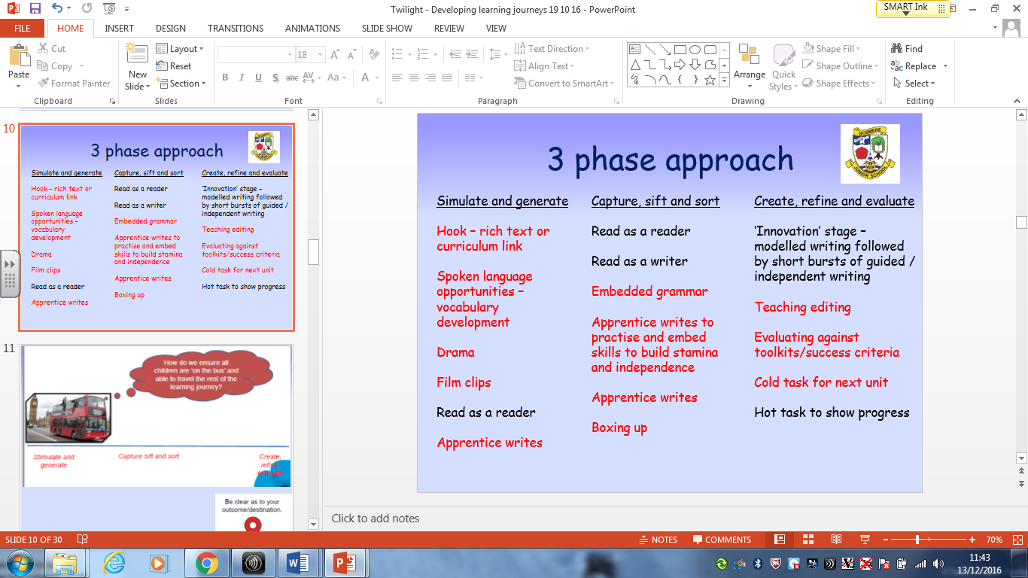

Appendix 2

Have a go

First attempt | Second attempt | Third Attempt | Correct spelling

Appendix 3

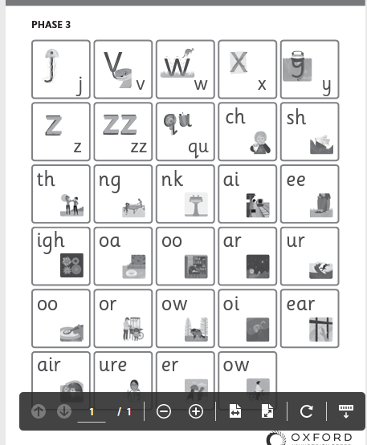
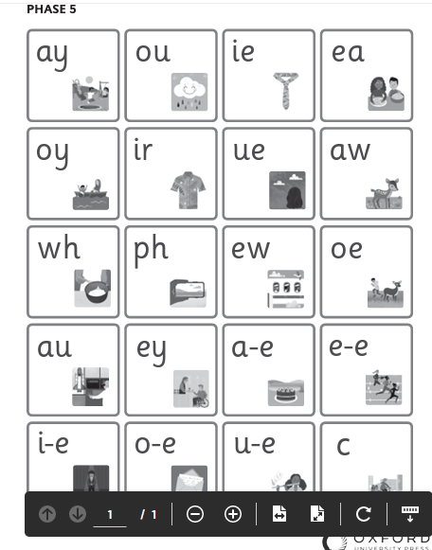

GPC

Appendix 4

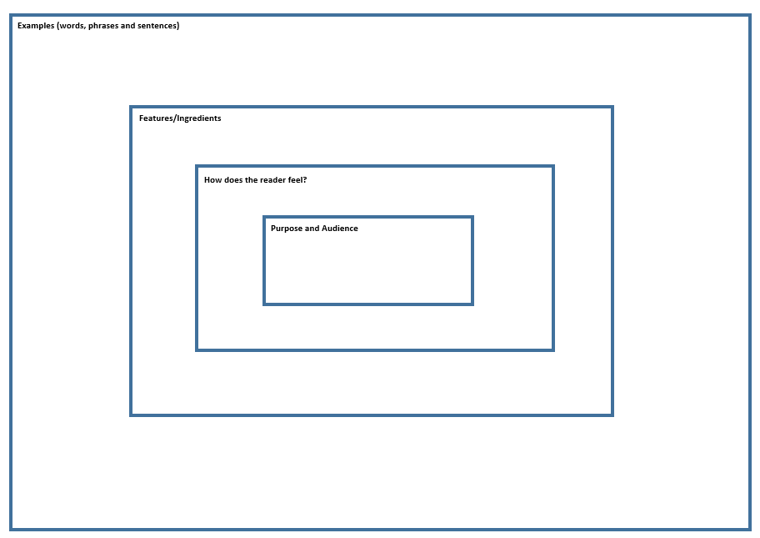

Appendix 5

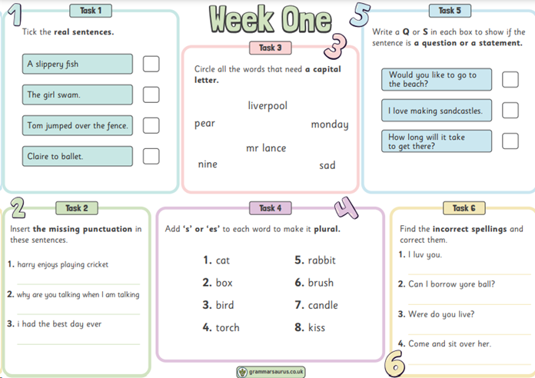

Appendix 6

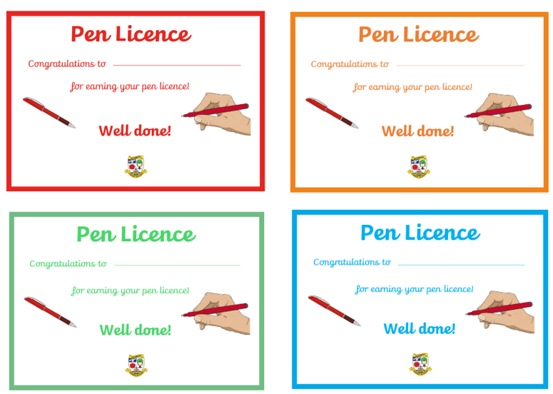

Appendix 7

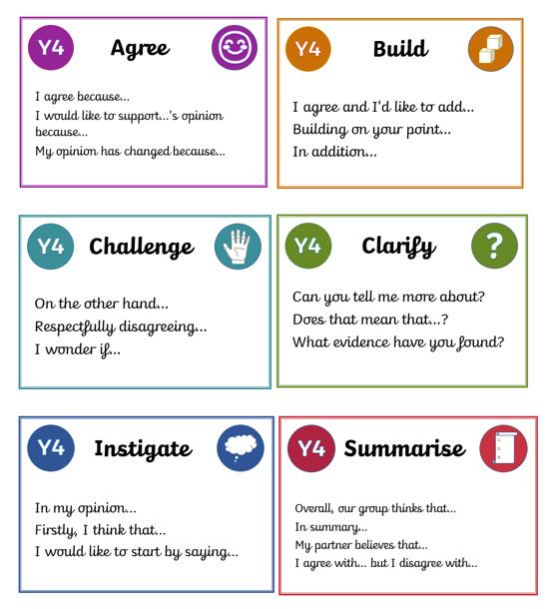

Appendix 8

Sentence Stem Progression Document

Appendix 9 – Read & Race question types



