
Bosmere Junior School
South Street
Havant

Special Education Needs and Disabilities (SEND)
Appendix

Date: | September 2025
Review Date: | September 2026
Responsibility: | SENCO
STATUTORY
Checked against Equality Policy

Inclusion Manager: | Date:
SEND Governor: | Date:
Headteacher: | Date:

Entering Bosmere Junior School
The SENCO liaises with each child’s previous school to help identify children who have been assessed as having SEND. The SENCO ascertains what parental and outside agency involvement there has been to date. Once a child has entered Bosmere Junior School, the school is responsible for assessing the needs of the child and for keeping parents informed of any developments.

SEND Support
When a child is identified as being having SEND, their needs will determine how work needs to be differentiated or whether they require either individual or small group work to reinforce the National Curriculum. This will generally be delivered in the classroom, but the child may be withdrawn to a nearby space if deemed more appropriate.

When a child is listed as ‘SEND Support’ a Pupil Profile will be written with the child, clearly stating their needs. Parents will be informed of their child’s progress and made aware of any extra support their child is receiving regularly through Assessment Updates and at parents’ evenings. The Pupil Profile will be updated on a termly basis and shared with parents at consultation meetings.

For children at SEND Support, the SENCO or Headteacher may also contact an outside agency to obtain advice on how to best support the child. This advice will be passed back to the parent, class teacher and LSA and a suitable support programme devised. The child might also be withdrawn from class to receive additional support with specific areas of learning, speech and language, social skills, behaviour support, improving fine and gross motor skills or reading. The SENCO will monitor the progress of the child and, if necessary, arrange for more advice from outside agencies.

Number of Pupils Identified as SEND Support or EHCP in the school’s SEN Audit: July 2025

 | SEND Support | EHCP | Total in year groups
3 | 18 | 2 (1 applied for by school) | 20
4 | 17 | 7 | 24
5 | 18 | 0 | 18
6 | 11 | 4 | 15
Total | 64 (17.9%) | 13 (3.6%) | 77 (21.4%)
These numbers represent % of the whole school population.(357 on role)

Children with an Education Health and Care Plan

For children with EHCPs, targets will have been set when the final version of the EHCP was first distributed to the school and the child’s parents. The EHCP must be reviewed at least once a year. The annual review will look at the child’s progress towards the targets and new targets agreed for the next year. Further details are contained in the SEND Code of Practice (2015) on the identification and assessment of special educational needs.

Listed below are children with statements or EHCPs, their year group, their area of need and their additional funded hours of support.

EHCPs July 2024
Pupil | Year Group | Area(s) of Need | Level of Support / Banding
EMR | Year 2 | - Communication and interaction | Enhanced B (£5600)
HBT | Year 2 | - Social, emotional, Mental Health
BP | Year 3 | - Communication and Interaction | Enhanced B (£5600)
RW | Year 3 | - Cognition and Learning ( in progress)
HP | Year 3 | - Social, emotional, Mental Health | Exceptional (£8755) and £8000 top up
AH  (PLAC) | Year 4 | - Cognition and Learning  - Moderate Learning Difficulty | Enhanced A (£3333)
FP  (LAC) | Year 4 | - Social, Emotional, Mental Health | Enhanced B (£5600)
SH | Year 4 | - Social, Emotional, Mental Health | Targeted B (£2200)
FP | Year 4 | - Severe Learning Difficulty  - Autism  - Speech, Language or Communication Need | Exceptional (£8755)
GR | Year 4 | - Social, Emotional, Mental Health  - Cognition and Learning | Enhanced A (£3333)
TM | Year 4 | - Social, emotional, mental health | Exceptional ( £8755) and £8820 top up
BC | Year 4 | - Assessment in progress | Targeted B £2231
BC | Year 6 | - Social, emotional, mental health
JS | Year 6 | - Communication and interaction | Targeted B £2231
JC | Year 6 | - Social, emotional, mental health | Targeted B £2231
CS | Year 6 | - Cognition and Learning | Enhanced A (3333

Areas of Need:

Speech, Language and Communication Needs
Children and young people with speech, language and communication needs (SLCN) have difficulty in communicating with others. This may be because they have difficulty saying what they want to, understanding what is being said to them or they do not understand or use social rules of communication. The profile for every child with SLCN is different and their needs may change over time. They may have difficulty with one, some or all of the different aspects of speech, language or social communication at different times of their lives. Children and young people with ASD, including Asperger’s Syndrome and Autism, are likely to have particular difficulties with social interaction. They may also experience difficulties with language, communication and imagination, which can impact on how they relate to others.

Cognition and Learning
Support for learning difficulties may be required when children and young people learn at a slower pace than their peers, even with appropriate differentiation. Learning difficulties cover a wide range of needs, including moderate learning difficulties (MLD), severe learning difficulties (SLD), where children are likely to need support in all areas of the curriculum and associated difficulties with mobility and communication, through to profound and multiple learning difficulties (PMLD), where children are likely to have severe and complex learning difficulties as well as a physical disability or sensory impairment. Specific learning difficulties (SpLD), affect one or more specific aspects of learning. This encompasses a range of conditions such as dyslexia, dyscalculia and dyspraxia.

Social Emotional and Mental Health Difficulties
Children and young people may experience a wide range of social and emotional difficulties which manifest themselves in many ways. These may include becoming withdrawn or isolated, as well as displaying challenging, disruptive or disturbing behaviour. These behaviours may reflect underlying mental health difficulties such as anxiety or depression, self-harming, substance misuse, eating disorders or physical symptoms that are medically unexplained. Other children and young people may have disorders such as attention deficit disorder, attention deficit hyperactive disorder or attachment disorder.

Sensory and/or Physical Needs
Some children and young people require special educational provision because they have a disability which prevents or hinders them from making use of the educational facilities generally provided. These difficulties can be age related and may fluctuate over time. Many children and young people with vision impairment (VI), hearing impairment (HI) or a multi-sensory impairment (MSI) will require specialist support and/or equipment to access their learning, or habilitation support. Children and young people with an MSI have a combination of vision and hearing difficulties. Information on how to provide services for deafblind children and young people is available through the Social Care for Deafblind Children and Adults guidance published by the Department of Health Some children and young people with a physical disability (PD) require additional ongoing support and equipment to access all the opportunities available to their peers

Areas of Need: | Numbers of Pupils with this need listed:
Speech, Language and Communication Needs | 19
Cognition and Learning / Specific Learning Need | 39
Social Emotional and Mental Health Difficulties | 24
Sensory and/or Physical Needs | 5
*Numbers may not match with the number of children on the SEND register as some children have multiple needs

INSET
The school acknowledges the importance of in-service training and the professional development of teaching and non-teaching staff, to help them work effectively and efficiently with children with SEND.
Training needs will be made available through Performance Management of teachers and Individual Performance Plans for support staff. SEND strategies will be included within the induction period of new staff.

Admission arrangements for children with Special Educational Needs
The admission arrangements for children with SEND do not differ from the arrangements for children without SEND unless the child has an EHCP (Education Health and Care Plan). The SENCO will liaise closely with our feeder schools to ascertain details of children with special educational needs so that their needs can be more readily met. Details of admission arrangements can be found in the school’s prospectus and admissions policy.

Admission of children with more complex needs
Wherever possible, Bosmere Junior School promotes the inclusion of children with more complex needs.
Children with disabilities are not treated less favourably unless there is clear justification for doing so.
Access to most areas of the school has been provided for children with physical disabilities by the installation of ramps, handrails and linking doors. However, there are still areas of the school that can only be accessed internally via short flights of stairs. There are two toilets for the disabled situated at either end of the school.
Temporary ramps, stair lifts and other modifications to assist mobility and ensure access can be installed following assessment by and in consultation with Health Service professionals and County Advisory Staff.
(See accessibility policy)

Special provision for Children with English as an Additional Language (EAL)
The aim of Bosmere Junior School is to promote all cultures as being valuable, for this not only creates a more harmonious and understanding environment for all children, it specifically raises the self esteem of children with EAL, encouraging them to take a pride in their culture and their abilities.
The addition of special provision for a child with EAL is not based on intellectual ability but rather on providing opportunities to gain better access to the curriculum. A child who speaks more than one language is supported in both the first/home language and English following an application to EMTAS. The SENCO contacts EMTAS as soon as there is a concern about the progress of a child who has English as a second language. EMTAS then sends a teacher experienced in the child’s home language to carry out an assessment of the child’s needs. If deemed necessary, EMTAS will then supply relevant support which could be in the form of a bilingual assistant working 1:1 in class during the literacy hour or a bilingual teacher working alongside the class teacher.

Curriculum
We provide effective opportunities for all children using as a basis the National Curriculum 2013. In our planning and teaching at Bosmere Junior School teachers set suitable targets, respond to pupils’ diverse learning needs and overcome potential barriers to learning for both individuals and groups of children. The SENCO will monitor the differentiated curriculum provided for children with SEND. They will also support class teachers and LSAs with their planning if requested. Learning objectives are always made explicit but activities may be adapted or planned separately as appropriate. There may be times when there is a flexible approach to the curriculum when teachers or LSAs might withdraw children as groups or individuals in order to meet negotiated targets. Children with SEND will be provided with opportunities to engage in a variety of activities with children who do not have SEND in both curricular and non-curricular activities. On transfer to secondary school or another primary school, be it mainstream or special school, we will liaise appropriately with the relevant staff on behalf of children with SEND.

Resources
At the beginning of each financial year the school’s governing body allocate a sum of money for the resourcing of SEND within the overall school budget. Funding is delegated through the local authority and is primarily based on the school’s census data. Additional funding may also be provided for pupils with an Education Health and Care Plan. At present the majority of SEND funding is primarily used to provide LSAs, HLTAs and ELSA support to helping to meet the appropriate level of provision for those children included in the SEND register and the provision detailed within Education Health and Care Plans. LSAs usually work within the class base. However, there will be times when the child’s needs are more readily met outside the class base, usually in the adjoining shared area or tutorial room. Physical and digital resources are purchased as appropriate and are matched to the needs throughout the school. The SENCO contributes to the school development plan on an annual basis, including the level of resourcing required.

Governors
It is the Governors’ responsibility, with the Headteacher, to determine the school’s general policy and approach to meeting children’s special educational needs. They must set up appropriate staffing and funding arrangements and oversee the school’s work. The governors receive a report on the provision for SEND annually. There is a named governor for Special Needs.

Partnership with Parents
We actively seek to work with parents and value the contribution they make, seeking their involvement as part of the home/school partnership of Bosmere Junior School. As well as the usual termly parents’ meeting to discuss progress, we have an open door policy, whereby parents are able to make an appointment to see a member of staff within a short period of time.

Complaints
We will work with parents to enable difficulties to be addressed by discussions with class teacher, SENCO or Headteacher. If matters cannot be resolved through discussion, parents will be invited to write to the Chairman of the Governing Body setting out their complaint. It is expected that the Governing Body will respond promptly to parent’s concerns.

Support Services
As a school we actively engage with professionals from a wide range of outside agencies to help us meet the needs of our children. Outside agencies include the following:

- Hampshire’s Educational Psychology
- Specialist Teacher Adviser for Specific Difficulties
- Specialist Teacher Adviser for Hearing Impairment
- Specialist Teacher Adviser for Physical Impairment
- Children’s Services
- Physiotherapist
- Occupational Therapist
- Speech and Language Therapist
- Child and Adolescent Mental Health Service (CAMHS)
- PSICON
- Primary Behaviour Support
- South Domestic Abuse Services

Looked After Children:
The ‘Designated Teacher’ for LAC must meet with the carers and representatives from outside agencies three times per year to ensure everyone has a complete picture of the children’s needs and progress. At this meeting a Personalised Education Plan (PEP) is created. Depending on their needs they may also receive pastoral support from the Home School Link Worker & Emotional Literacy Support Advisor.

The table below illustrates the interventions for the LAC who were on the roll in the 2024-2025 academic year.
Pupil and Year | Caring Authority | Identified Need | Intervention | Impact
MBT Year 3 | Hampshire | Childhood trauma | Transition support  Special time facilitated  1:1/ small group support in class | More settled in class  Less inappropriate connection seeking  Improvement in reading levels
HP Year 3 | Hampshire | Childhood trauma | Transition support  Nurture support  1:1 support at all times | HP is happy at school and receives personalised learning
RW Year 3 | Hampshire | Childhood trauma | Transition support  1:1 /small group support in class  Emotional support | Huge improvement in attendance  Some willingness to complete tasks  Will talk about his feelings with trusted adults
CW  Year 4 | Hampshire | Childhood trauma | Transition Support (start of key stage)  Triple-F Lunchtime Support  ELSA support in coping with being taken into care.  1:1 / Small Group intervention groups for academic support | Huge improvement in attendance.  Establishing positive relationships with key staff.  Opportunities for sharing ongoing worries / concerns / feelings with trained ELSA.  CW is needing less 1:1 interventions as the gap between him and class closes
FP  Year 4 | Hampshire | Attachment / Self-esteem  Childhood trauma | Transition Support (start of key stage)  Behaviour Support  Triple-F Lunchtime Support  Thera-parent Therapy | Establishing positive relationships with key staff.  Key staff members moving to support transition  Reduction in frequency of violent/ sexualised incidents  Increased levels of compliance when dysregulated.  Improved integration with class (working within the classroom almost exclusively by the end of the year).
SN  Year 5 | Hampshire | Focus  Relationships with peers  Independence | Transition Support (joined mid-year)  Academic support (writing and metacognition)  ELSA Friendship support when required | Successful integration into class / year group despite joining mid-year.  Solving friendship issues independently  Academic progress including some improvement in independent writing.
PH  Year 5 | Hampshire | Pastoral support,  Academic support (where necessary) | 1:1 pastoral support from the Home School Link Worker & Emotional Literacy Support Advisor  Teacher focus / small group academic support. Writing conferencing. Greater Depth Maths support.  Second chance charity support | Social, Emotional and Mental Health support to address issues related to wellbeing and self-esteem.  Behaviour support when required.  Emotional support provided by Second Chance  Academic support to ensure pupil securely are Age Related Expectations / pushing towards Beyond ARE.

LAC on roll at start of September 2025
Pupil and Year | Year | Caring Authority / Virtual School
Pupil A RW | Year 4 | Hampshire and IOW
Pupil B HP | Year 4 | Hampshire and IOW
Pupil C MBT | Year 4 | Hampshire and IOW
Pupil D FP | Year 5 | Hampshire and IOW
Pupil E CW | Year 5 | Hampshire and IOW
Pupil F SN | Year 6 | Hampshire and IOW
Pupil G PH | Year 6 | Hampshire and IOW

At the time of producing this appendix there was also one pupil with a ‘Special Guardianship Order’. These “orders” are sometimes put in place by Children’s Services when a child is in the care of a family member other than their mother or father. They are a sub category of LAC called Post Looked After Children (PLAC) and are also entitled to Pupil Premium Funding. Again these children will receive additional help in class or small group academic support where necessary.
SEND Progress Data (July 2025)

YEAR 6 – SEND Data 2024-2025
Progress
DOMAIN PROGRESS |  | Y6 M1 | Y6 M2 | Y6 EoY | Y6 EoY (SATS) |  | Progress
Reading | SEN | 13% | 13% | 33% |  | 47% | 20% 34%
 | Not SEN | 66% | 72% | 80% |  | 82% | 14% 16%
Writing | SEN | 7% | 13% | 27% |  | 40% | 20% 33%
 | Not SEN | 61% | 66% | 88% |  | 92% | 17% 31%
Maths | SEN | 13% | 13% | 27% |  | 27% | 14 % 14%
 | Not SEN | 70% | 73% | 86% |  | 87% | 16% 17%

YEAR 5 – SEND Data 2024-2025
Progress
DOMAIN PROGRESS TRACKER |  | Y5 M1 |  | Y5 M2 |  | Y5 EoY |  | Progress
Reading | SEN |  | 5% |  | 10% |  | 11% | 6%
 | Not SEN |  | 74% |  | 77% |  | 79% | 5%
Writing | SEN |  | 0% |  | 0% |  | 5% | 5%
 | Not SEN |  | 65% |  | 63% |  | 70% | 5%
Maths | SEN |  | 5% |  | 10% |  | 11% | 6%
 | Not SEN |  | 75% |  | 77% |  | 86% | 11%

YEAR 4 – SEND Data 2024-2025
Progress
DOMAIN PROGRESS TRACKER |  | Y4 M1 | Y4 M2 | Y4 EoY | Progress
Reading | SEN | 5% | 5% | 4% | -1%
 | Not SEN | 79% | 70% | 75% | -4%
Writing | SEN | 0% | 0% | 0% | =
 | Not SEN | 62% | 62% | 73% | 11%
Maths | SEN | 9% | 10% | 9% | =
 | Not SEN | 65% | 62% | 78% | 13%

YEAR 3 – SEND Data 2024-2025
Progress
DOMAIN PROGRESS TRACKER |  | Y3 M1 | Y3 M2 | Y3 EoY | Progress
Reading | SEN | 22% | 13% | 15% | -7%
 | Not SEN | 56% | 57% | 63% | 7%
Writing | SEN | 0% | 0% | 0% | =
 | Not SEN | 26% | 35% | 40% | 14%
Maths | SEN | 17% | 13% | 15% | -2%
 | Not SEN | 33% | 39% | 56%

STAFFING PROVISION

For the academic year 2024-2025 the staffing provision is as follows:

The Special Needs Co-ordinator designated by the Headteacher is: Mrs C Reed

The Learning Support Assistants and the hours they work are:
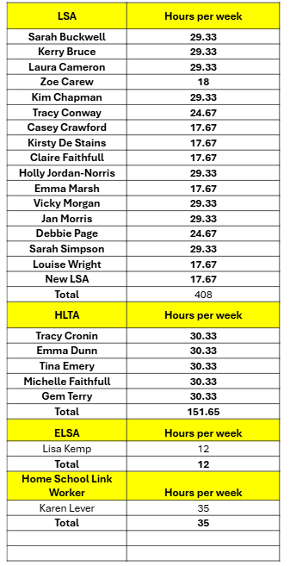

The job descriptions for these roles are listed below.

The Governor(s) with responsibility for Special Educational Needs is:

Mrs. H Faulkner


BOSMERE JUNIOR SCHOOL

JOB DESCRIPTION

POST TITLE: INCLUSION LEADER (SENCo)
(Leading on inclusion for SEND and Disadvantaged Pupils)

RESPONSIBLE TO: HEADTEACHER

PURPOSE: Lead and develop teaching and learning, ensuring equal access and inclusion for Pupils with SEND and disadvantaged pupils

RESPONSIBILITIES:
- To provide effective strategic leadership and management of inclusive practice across the school for all groups of pupils (including higher attainers)
- To be accountable for raising the standards of teaching, learning and attainment for all pupils identified as having SEND across the school (including EAL)
- To take a lead role in supporting the progress and welfare of all disadvantaged pupils across the school (including the role of Designated Teacher for Looked After Children)

KEY TASKS:
- Promote a culture of inclusion within the school community
- Line manage the Learning Support Staff, including supporting with recruitment and performance management
- Ensure the effective induction for newly appointed Learning Support Staff with respect to inclusive practices and where appropriate their specific deployment
- Develop and lead INSET programmes to support effective inclusive practices and provision in school
- Provide a role model for excellent inclusive practices, setting high expectations in relation to standards of pupil achievement and the quality of teaching
- Develop and advise on assessment strategies, data analysis and identified support to ensure the identified standards of pupil achievement are met
- Support teachers and support staff in improving practice through:
  - Pupil progress meetings
  - Joint planning / shared teaching / modelled teaching
  - Observation and coaching
  - Monitoring and feedback
- Analyse and interpret relevant national, local and school data, research and inspection evidence to inform decisions relating to pupils with SEND, higher attainers and disadvantaged pupils
- Establish, review and update as necessary the School Development Plan for Inclusion
- Meet termly with the Inclusion Governor, updating the SEND dashboard
- Report to the Full Governing Body on an annual basis
- Update the annual SEND Information Report and Appendix
- Update the SEND Policy in line with the review cycle
- Lead the strategic management and development of learning support across the school so that all pupils with SEND, higher attainers and disadvantaged pupils make good progress
- Ensure a high standard of provision is in place for pupils with SEND, higher attainers and disadvantaged pupils with a particular focus on ‘Quality First Teaching’
- Ensure an up to date SEND register and provision map is maintained, including the update of SIMS records, including informing parents when children are added to / removed from the register
- Oversee the ongoing updating of Individual Pupil Profiles for pupils with SEND
- Monitor, evaluate and promote improvement strategies to secure effective teaching and learning for pupils with SEND, higher attainers and disadvantaged pupils
- Seek out ways to enrich the learning experience of pupils with SEND, higher attainers and disadvantaged pupils
- Work collaboratively with staff to ensure the effective co-ordination of intervention programmes to support pupils with SEND, higher attainers and disadvantaged pupils, including monitoring and evaluating outcomes
- Ensure that communication with parents of SEND pupils is effectively managed and of consistently high quality
- Liaise with external agencies /advisors as required to support the needs of pupils with SEND and disadvantaged pupils
- Ensure the organisation of Annual Reviews for pupils with EHCPs
- Make applications for further EHCPs where appropriate
- Oversee the smooth transition of pupils with SEND and disadvantaged pupils from KS1 and into KS3
- Liaise with EMTAS and work collaboratively with staff to ensure effective provision for pupils with EAL
- Act as Designated Teacher for Looked After Children, ensuring the completion of termly Personal Education Plans

July 2025


BOSMERE JUNIOR SCHOOL

POST TITLE: Higher Level Teaching Assistant (HLTA)

RESPONSIBLE TO: Class Teacher / Deputy Headteacher

RESPONSIBLE TO: Headteacher

Purpose: To provide learning activities for classes and deliver lessons set by or with teachers, under the professional direction and supervision of a qualified teacher. To support the education and welfare of all pupils, fostering independence and successful learning.

Areas of Responsibility:
- Safeguarding and Child Protection
- Teaching, Learning, and Assessment Support
- Personal Development, Behaviour, and Welfare Support
- Administrative Support
- Wider Professional Responsibilities

Key Duties:
This job description is to be performed in accordance with the provisions of the school’s Pay Policy and within the range of Support Staff duties set out in that document.

Safeguarding and Child Protection:
- To safeguard pupils by following the school’s Child Protection and Safeguarding policies
- Maintain an up to date knowledge of pupils through the reading of all CPOMS logs
- Log all concerns with Designated Safeguarding Leads in accordance with school policies and practice
- Participate in ongoing training e.g. Safeguarding refresher, Prevent training, weekly updates
- Maintain confidentiality at all times

Teaching, Learning, and Assessment Support:
- Assume responsibility for whole class and small group teaching and learning, providing regular cover for PPA and leadership release time, and cover in the absence of the class teacher
- Plan and prepare, with the support of year group colleagues and subject managers, a teaching programme appropriate to the needs of the class
- Work with year groups to provide appropriate learning support for pupils, including running targeted interventions for small groups or individuals
- Develop and implement an effective pedagogy using a variety of teaching strategies to engage students and foster a lifelong love for learning
- Work with colleagues to take responsibility for providing an engaging curriculum that complies with National Curriculum requirements and all school curriculum policies and schemes of work
- Demonstrate a secure knowledge in the subjects and curriculum areas that are being taught
- Adapt teaching methods to meet the diverse needs of all students, including those with special educational needs
- Providing feedback to the pupils in line with the school’s marking policy
- Evaluate pupil responses to activities and adjust plans as appropriate
- Set high expectations that inspire, motivate, and challenge pupils
- Support class teachers with assessment judgements when responsible for delivering a curriculum subject

Personal Development, Behaviour, and Welfare:
- Promote the school's vision and values.
- Support teachers in sustaining classroom environments based on mutual trust and respect, where children feel valued and secure.
- Help develop children’s self-esteem through motivation and encouragement
- Implement the school’s behaviour policy and positive approach to behaviour management
- Have high expectations of behaviour, and establish a framework for discipline with a range of strategies, using praise, rewards and sanctions appropriately
- Manage classes effectively, using approaches which are appropriate to pupils’ needs
- Teach and model conflict resolution through restorative practices
- Promoting the spiritual, moral, social and cultural development of children, including the promotion of British values.

Administrative Support:
- Help maintain an organized learning environment within the year group
- Perform tasks such as creating resources, photocopying, laminating, creating displays, and preparing equipment or materials
- Support the teaching staff in organising and running events in and outside school

Wider Professional Responsibilities:
- Fulfil wider professional responsibilities by participating in professional development, ensuring effective communication and being a consistently positive role model
- Engage in ongoing professional learning to stay updated with the latest educational practices and policies
- Work collaboratively with other teachers, support staff, and school leadership to enhance the educational experience
- Adhere to school policies and practices
- Manage school resources to enhance student learning and ensure the efficient use of materials and equipment
- To provide effective supervision for pupils outside the classroom e.g. during break times, school trips etc
- Take responsibility for improving professional practice through appropriate development, responding to advice and feedback from colleagues
- Administer basic first aid
- Assist children with personal hygiene

March 2025


BOSMERE JUNIOR SCHOOL

JOB DESCRIPTION

POST TITLE: LEARNING SUPPORT ASSISTANT

RESPONSIBLE TO: ASSISTANT HEADTEACHER / SENCo

ACCOUNTABLE TO: HEADTEACHER

PURPOSE: To work in partnership with the teacher to improve outcomes for all pupils by providing the support they need to become independent and successful learners and positive members of our community.

AREAS OF RESPONSIBILITY:
- Safeguarding and Child Protection
- Teaching, Learning and Assessment Support
- Personal Development, Behaviour and Welfare Support
- Administrative Support
- Wider professional responsibilities

KEY DUTIES:
This job description is to be performed in accordance with the provisions of the school’s Pay Policy and within the range of Support Staff duties set out in that document.

Safeguarding and Child Protection
- To safeguard pupils by following the school’s Child Protection and Safeguarding policies
- Maintain an up to date knowledge of pupils through the reading of all CPOMS logs
- Log all concerns with Designated Safeguarding Leads in accordance with school policies and practice
- Participate in ongoing training e.g. Safeguarding refresher, Prevent training, weekly updates
- Maintain confidentiality at all times

Teaching, Learning and Assessment Support
- Work with the class teacher to provide appropriate learning support for pupils within the classroom, including running targeted interventions for small groups or individuals
- Encourage independent learning skills and resilience providing the ‘minimum’ amount of support required for pupils to make progress
- Support the teacher in fostering a lifelong love of learning for pupils
- Develop a clear understanding of the needs of individual pupils that are supported
- Demonstrate a secure knowledge in the subjects and curriculum areas where support is being provided
- Liaise frequently with teachers regarding their role and provide information to school staff about specific pupils e.g. pupil progress meetings, annual review
- Assist with the collecting and collating of SEND data
- Liaise with the teacher to help implement support recommended by outside agencies e.g. Speech and Language Therapist, Educational Psychologist etc

Personal Development, Behaviour and Welfare
- Promote the vision and values of the school
- Support the teacher in establishing a classroom environment based on mutual trust and respect, in which children feel valued and secure
- Help develop children’s self-esteem through motivation and encouragement
- Follow the school’s behaviour policy and positive approach to behaviour management
- Use class-based and school-wide strategies for behaviour management, using praise, rewards and sanctions appropriately
- Support the teacher by providing specific and general supervision in class
- Teach and model conflict resolution through restorative practices
- Support pupils’ emotional needs and provide targeted pastoral support for individuals
- Help the teacher ensure that pupils are supported at key transitions and information is shared with professionals (e.g. end of year, change of setting)

Administrative Support
- Support the teacher in maintaining a well organised learning environment
- Help the teacher to prepare and review pupil profiles
- Assist with photocopying, laminating, making topic books, creating displays of children's work, preparing equipment or materials and other tasks
- Support the teaching staff in organising events in and outside school

Wider professional responsibilities
- Fulfil wider professional responsibilities by participating in professional development, ensuring effective communication and being a consistently positive role model
- Engage in ongoing professional learning to stay updated with the latest educational practices and policies
- Work collaboratively with teachers, other support staff, and school leadership to enhance the educational experience
- Adhere to school policies and practices
- To provide effective supervision for pupils outside the classroom e.g. during break times, school trips etc
- Administer basic first aid
- Assist in maintaining a clean and safe environment during school hours
- Assist children with personal hygiene

January 2025

Pupil Profiles with personalised assessment data:
The SENCO works with the support staff and each child on the SEND register to produce a personalised Pupil Profile which includes important information regarding the child’s needs. As well as providing staff with relevant information the document is used as a discussion point for parents’ evenings and as a transition document at the start of each academic year.
By definition pupils with SEND have “…significantly greater difficulty in learning than the majority of others of the same age….” While we accept that children on the SEND register may not reach Age Related Expectations by the end of the year, we do expect progress to be made. Therefore this we report on personalised assessment information (reading ages, spelling ages, notes on progress) to ensure that their achievements are recognised and celebrated.

 |  | Name: | Joe Bloggs |  | 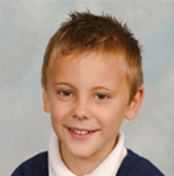
 |  | DOB: | 1/01/2018
 |  | Class: | 6F
 |  | SEND: | Emotional Support
 |  | Milestone: | 1
What I’m good at: |  |  |  | What I find difficult:
- Usually I have a good attitude to my learning with Mrs Fiction  - I love to be active outside and enjoy sport, especially football |  |  |  | - When an adult speaks to me about my behaviour I often over-react and will get myself into more trouble  - I often give up when I find work difficult or think I have made a mistake  - I am sometimes unkind to other people
Things you should know about me:  - I live with my mum, sister and her boyfriend and daughter  - I see my Dad at the weekends  - I have an EHCP for Learning and Emotional Support  - I have ADHD and take medication twice a day |  |  |  | My current targets:  - If I get angry, I will be able to describe to an adult what upset me after I have calmed down.  - I will be able to take turns when playing independently with a friend in three out of four games.
Assessment | Reading |  |  | Writing |  | Maths
End of Previous Year | N (0% close or securely on track) |  |  | N (17% close or securely on track) |  | N (33% close or securely on track)
End of Previous Year | Reading Age 9Y 8M |  |  | Spelling Age 5Y 7M |  | N (33% close or securely on track)
Milestone 1 | N (25% close or securely on track) |  |  | N (33% close or securely on track) |  | N (33% close or securely on track)
Milestone 1 | Reading Age 10Y 8M |  |  | Spelling Age 6Y 4M |  | N (33% close or securely on track)
Milestone 2
Where I’ve made progress: |  |  |  | Who’s going to help me:
- My behaviour in class has improved and I am getting better at engaging and completing tasks  - I am getting better at discussing my behaviour with Mrs Fiction in a calm and polite way  - My reading has improved  - I am writing a lot more in English lessons because I am typing on my laptop  - I have not been leaving the classroom without permission |  |  |  | - 1:1 pastoral support for behaviour when required  - 1:1 Reading  - Behaviour chart and rewards  - Laptop for recording my writing with support from adults with editing  - Peer mentors in class

Provision for SEND
Identification of SEND – There are different ‘Areas of Need’ for Special Needs. These include: Cognition and Learning, Social Emotional Mental Health, Communication and Interaction and Physical Disability In order to improve the consistency of the identification of SEND, teachers and LSAs must use documents which contain ‘descriptors’ of SEND to justify the decision to put a child on the SEND register. It is expected that children will display a minimum of four characteristics, however these characteristics may be displayed across multiple areas of needs. For example a child may have Cognition and Learning difficulties and also have difficult in Communication and Interaction. Below is an example of an SEND Identification Sheet:
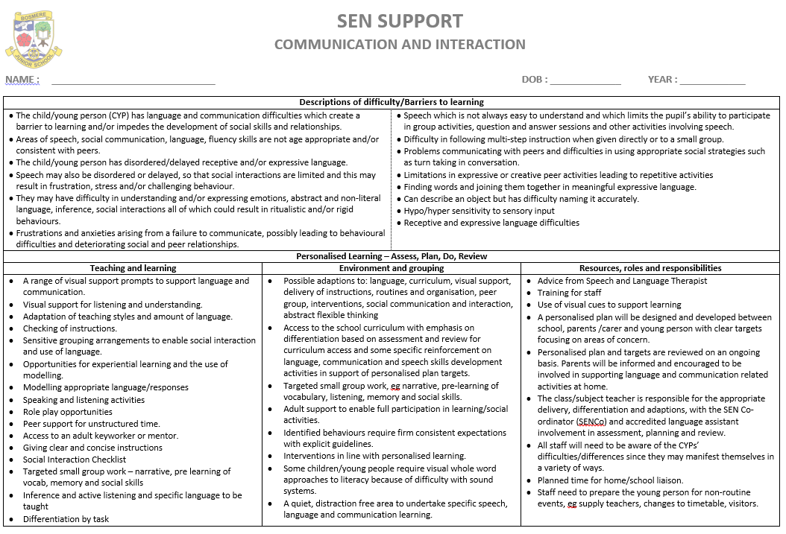

Pupil Progress Meetings and Provision Maps:
Prior to ‘Pupil Progress Meetings’ at each assessment milestone, a provision map for SEND pupils is updated with all relevant assessments to show ongoing progress and attainment. During the meeting the teacher, SENCO and HT determine what additional provision each child needs to meet their learning, emotional and/or physical needs. We ask all class LSAs to join the discussion about the SEND pupils because they often have important knowledge of these children, what barriers to learning they are facing and the progress they have made. After the meeting the provision map is updated with the additional support and intervention programmes that each child will receive.

Year 4 Class SEN Provision Map – Final Assessment (MS3)
Name | SEN Stage | Area of Need | Outside Agency | KS1 Result |  |  | Y3 ARE |  |  | Mile stone | Y4 ARE |  |  | Reading Age & Comp Age | Spelling Age | Reading Provision | Writing Provision | Maths Provision
 |  |  |  | R | W | M | R | W | M | Mile stone | R | W | M
Pupil A | SEN Support | C&L  SLCN |  | WTS | WTS | WTS | N | N | N | MS 1 | N  0 | N  17 | N  17 | 8Y 1M  8Y7M | BL5 | 1:1 reading; Precision teaching; Teacher focus | Spelling intervention; GR group | Teacher focus; Gap intervention; HB group
 |  |  |  |  |  |  |  |  |  | MS 2 | N  0 | N  17 | N  0 | 9Y5M  9Y 11M | 5Y4M | 1:1 reading; Precision teaching; Teacher focus | Spelling intervention; GR group | Teacher focus; Gap intervention; HB group
 |  |  |  |  |  |  |  |  |  | MS 3 | N  38 | C  83 | N  33 | 9Y 8M  10Y7M | 5Y 4M | 1:1 reading; Precision teaching; Teacher focus | Spelling intervention; GR group | Teacher focus; Gap intervention; HB group

Name | SEN Stage | Area of Need | Outside Agency | KS1 Result |  |  | Y3 ARE |  |  | Mile stone | Y4 ARE |  |  | Reading Age & Comp Age | Spelling Age | Reading Provision | Writing Provision | Maths Provision
 |  |  |  | R | W | M | R | W | M | Mile stone | R | W | M
Pupil B | SEN Support | SEMH | PBS  EP | ARE | ARE | ARE | C | C | C | MS 1 | N  62 | N  33 | C  83 | 10Y6M  10Y7M | 9Y 1M | LSA support; 1:1 reading; Small focused GR group (GR) | LSA support; GR group; Spelling intervention | LSA support; GR group
 |  |  |  |  |  |  |  |  |  | MS 2 | N  62 | C  83 | C  100 | 10Y11M  12Y | 9Y 6M | LSA support; 1:1 reading; Small focused GR group (GR) | LSA support; GR group; Spelling intervention | LSA support; GR group
 |  |  |  |  |  |  |  |  |  |  |  |  |  |  |  | Pastoral Support: 1:1 LSA + ELSA
 |  |  |  |  |  |  |  |  |  | MS 3 | C  100 | S  100 | S  100 | 11Y0M 12Y | 9Y 10M

Tracking Sheets
Tracking sheets show when interventions have taken place.

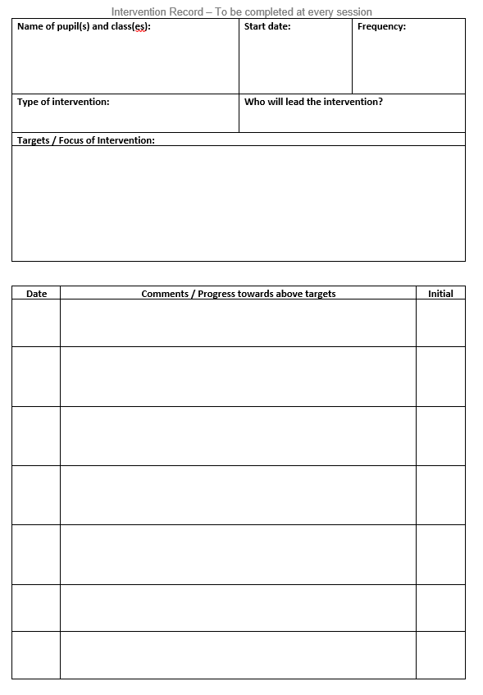

Parent / Teacher Meetings
Our ‘Collaborative Meetings’ put the pupil at the centre of the discussion between parent and teacher regarding their progress. This ensures parents are kept up to date with their current targets. All pupils will go through this progress twice a year.
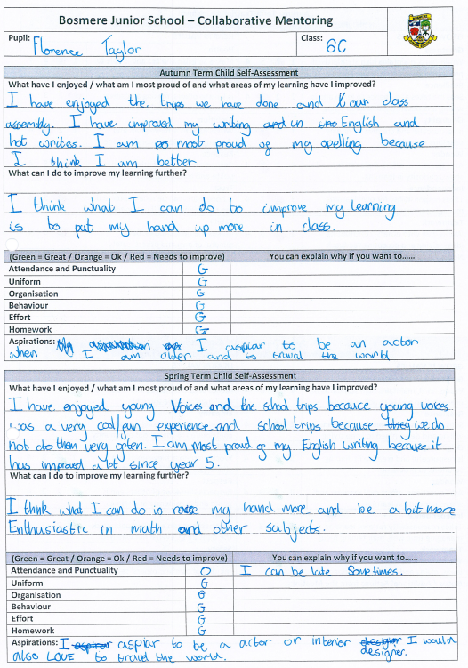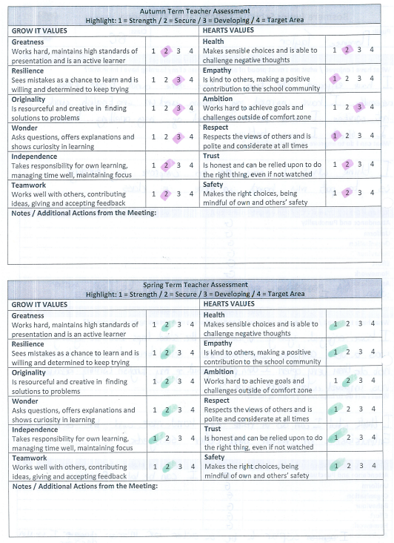

Tracking Backwards
New assessment sheets are being introduced this year for pupils who are not on track in any domains across a subject area. These will help to identify areas where the pupils have made progress and provide a useful tool for planning future provision. These assessment documents will be shared with parents at the assessment milestones.
 | Year 1 | Year 2 | Year 3 | Year 4
Word Reading | - Respond speedily with the correct sound to graphemes (letters or groups of letters) for all 40+ phonemes, including, where applicable, alternative sounds for graphemes that have been taught  - Read accurately by blending sounds in unfamiliar words containing GPCs that have been taught  - Read common exception words that have been taught, noting unusual correspondences between spelling and sound and where these occur in the word  - Read aloud accurately books that are consistent with their developing phonic knowledge and that do not require them to use other strategies to work out words  - Re-read books to build up their fluency and confidence in word reading  Read other words of more than one syllable that contain taught GPCs  Read words containing taught GPCs and –s, –es, –ing, –ed, –er and –est endings  - Read words with contractions [for example, I’m, I’ll, we’ll], and understand that the apostrophe represents the omitted letter(s) | - Read accurately by blending the sounds in words that contain the graphemes taught so far, especially recognising alternative sounds for graphemes  - Read accurately words of two or more syllables that contain the graphemes taught so far  - Read words containing common suffixes  - Read aloud books closely matched to their improving phonic knowledge, sounding out unfamiliar words accurately, automatically and without undue hesitation  - Read further common exception words, noting unusual correspondences between spelling and sound and where these occur in the word  - Re-read books to build up their fluency and confidence in word reading  - Read most words quickly and accurately, without overt sounding and blending, when they have been frequently encountered | - Apply their growing knowledge of root words, prefixes and suffixes (etymology and morphology) as listed in English Appendix 1, both to read aloud and to understand the meaning of new words they meet  Read further exception words, noting the unusual correspondences between spelling and sound, and where these occur in the word | - Apply their growing knowledge of root words, prefixes and suffixes (etymology and morphology) as listed in English Appendix 1, both to read aloud and to understand the meaning of new words they meet  Read further exception words, noting the unusual correspondences between spelling and sound, and where these occur in the word
Monitor and Summarise | - Check that the text makes sense to them as they read and correcting inaccurate reading  - Recall the main points of a narrative in the correct sequence | - Identify and discuss the main events or key points in a text  - Retell a story clearly and with appropriate detail  - Discuss the sequence of events in books and how items of information are related  - Identify or provide own synonyms for specific words within the text | - Show understanding of the main points drawn from more than one paragraph | - Identify main ideas drawn from more than one paragraph and summarising these  Summarise the main details from more than one paragraph in a few sentences, using vocabulary from the text
Select and Retrieve | - Participate in discussion about what is read to them, taking turns and listening to what others say  - Find key points in a story or some key facts from an information text | - Answer questions  - Ask questions  - Extract information from the text and discuss orally with reference to the text  - Understand how to use alphabetically ordered texts to retrieve information | - Uses text features to locate information e.g. contents, indices, subheadings  - Locate and retrieve information using skimming, scanning and text marking  - Begin to recognise fact and opinion  - Retrieve and record information from non-fiction  - Extract information and make notes | - Retrieve and record information from non-fiction  - Recognise and distinguish between fact and opinion
Inference | - Predict what might happen on the basis of what has been read so far  - Make inferences on the basis of what is being said and done | - Predict what might happen on the basis of what has been read so far and their own experience  - Make inferences on the basis of what is being said and done  - Make simple inferences about characters’ thoughts and feelings and reasons for actions | - Predict what might happen from details stated and implied  - Draw plausible inferences, often supported through reference to the text  - Draw inferences such as inferring feelings, thoughts and motives of main characters from their actions  - Justify inferences with evidence | - Predict what might happen from details stated and implied  - Draw sound inferences, supported through reference to the text  - Draw inferences such as inferring characters’ feelings, thoughts and motives of main characters from their actions, and justifying inferences with evidence  - Infer underlying themes and ideas

Name of pupil:__________________________________________________________________ Class: _________________________ Date:_________________________
The objectives that are highlighted have been achieved by the pupil

INCLUSION DEVELOPMENT PLAN 2025 - 2026
School’s key priorities:
Key Priority 1: Continue to improve the quality of education, with a continued focus on the development of oracy
Key Priority 2: Continue to improve behaviour, attitudes and personal development, with a particular focus on the promotion of relational strategies and the development of life skills
Key priority 3: Continue to improve leadership and management, including the development of a Sustainability Leader and a Climate Action Plan

Objectives:  (Refer to whole school priorities where possible) | Success Criteria | Actions planned (with dates): | Cost / Resources  (Time / £ / training) | Review  (Including impact on learning)
Support the needs of increasing numbers of EHCP, CLA and PCLA pupils on roll from September ensuring the review process is effective and timely  KP1&2 | SEND caseload remains manageable by forward planning as much as possible  School provides effective support for all SEND pupils (especially EHCP pupils)  Statutory responsibilities including annual reviews of EHCPs are distributed evenly across the year long calendar  Designated Teacher training completed by Becky Calcott  Becky Calcott inducted to DT role  BC attending and the leading some PEPs by the end of the year  AFIT tool used to support any CLA pupils  PEPs for CLA are completed termly  Clear transition support for SEN pupils  PLAC plans created and used to support transition for these pupils  Individual’s needs supported through creation of pupil premium team | Ensure that information regarding all new EHCP pupils and other high need SEND pupils is shared with all relevant staff and that all meetings and preparation is scheduled to ensure balance across the year.  Continue to review provision for EHCP pupils regularly adapting and sharing as necessary.  Ensure all staff are aware of ordinarily available provision  Complete all annual reviews in a timely manner.  Complete all PEPs in timely manner, sharing all paperwork with relevant staff and outside agencies.  BC to attend two autumn term PEPs. BC to lead PEP in spring term and increase in summer term  Attend CLAs and ensure information is shared  AFIT training attended  Paperwork shared with teachers in timely manner to ensure all paperwork can be completed by the DT prior to meetings  Coordinate any extra transition meetings for yr 2 and yr 6 pupils in liaison with Infant and secondary schools  Extra transition for individual pupils from yr 3 yr 4 etc  Pupils needing additional support identified  Liaison with carers and other schools  Meeting to establish needs within year groups and targeted support offered, | SENCO time  Release time for teachers to attend and prepare for meetings.  LSA meeting time  SENCO time  BC to attend DT training  Release time for BC to shadow PEP meetings  CR and BC AFIT training  SENCO time  SENCO time  SENCO time
Continue to embed new leadership structure and begin NPQSENCO qualification  KP3 | Investigate NPQSenco providers Ambition and Best practice network  Attend any further training as needed  Monitoring schedule in place | Register with most suitable provider  Begin course (18month)  Continue to attend and be an active member of SENCO circles  Continue to attend and be an active member of AHT network meetings  Strategic meetings as part of leadership team  Regular monitoring of ordinary inclusive practice and of interventions | SENCO release time  SENCO release time  SENCO time
Continue to promote positive behaviour  KP2 | ARC action plan completion  ARC conference attended  Reintroduction of trauma informed practice  Increase in nurture therapies available  AFIT used to inform TAC meetings  Executive functioning groups created | ARC action planning tool updated  Attend Silver ARC pathway training  Attend ARC conference and share actions  As part of SMT time investigate  refresher of trauma informed practice shared with all staff  Nurture training provided for one staff member who will increase nurture support available  TAC meetings using AFIT used to support individual pupils. AFIT evaluated and shared with virtual school  Clear one page documents created  TAC used to support transition  Monitor impact of TAC meetings  Pupils supported with planning, working memory, and emotional control skills | SENCO/HT to attend meeting  SENCO release and travel costs  VS training- KB released  KB Bereavement training £600  Year team release time  Twilight on Executive functioning as part of neurodiversity training
LSAs supported in their role and training provided  KP3 | LSA needs analysis completed and bespoke training program created and delivered to support SDP | Evaluation of previous year training  Timetable created for LSA training to include regular updates and further training on individual programs and nurture support  HLTA regular meetings set up to allow discussion time | LSA meeting and SENCO time

