
Bosmere Junior School
South Street
Havant

School Uniform Policy

Date: | September 2025
Review Date: | September 2028
Responsibility: | Headteacher
STATUTORY | Yes
Checked against Single Equality Policy

Chair of Governors: | Date:
Headteacher: | Date:

Section 1
Rationale:

Bosmere Junior School is committed to promoting equality and value for money and to ensuring that no child is discriminated against due to their religion or belief, economic circumstances or social and cultural background. This policy contains provisions to meet these objectives and has been created with health and safety, value for money and practicality at its heart.

Additionally, it is important that our pupils feel a sense of belonging to our school. We believe that wearing a smart and practical uniform allows all pupils, regardless of their backgrounds, to feel equal to their peers and confident in their appearance. We also believe it is important for pupils to wear clothing that is conducive to a successful learning environment, including activity-appropriate clothing, such as sports attire.

This policy has due regard to the DfE School Uniform Guidance (April 2024).

Section 2:
Roles and Responsibilities:

The Governing Body is responsible for:
- In consultation with the Headteacher and school community, establishing a practical and smart school uniform that accurately reflects the school’s vision and values;
- Ensuring that equal opportunities are considered regarding the school’s uniform and that no person is discriminated against;
- Listening to the opinions and wishes of parents/carers, pupils and the wider school community regarding changes to the school’s uniform;
- Ensuring that the school’s uniform is accessible and affordable.

The Headteacher is responsible for:
- Enforcing the school’s uniform on a day-to-day basis;
- Ensuring that school staff understand this policy and know what to do if a pupil is in breach of the policy;
- Listening to the opinions and wishes of the school community regarding the school’s uniform and making appropriate recommendations to the Governing Body;
- Providing pupils with exemptions as appropriate e.g. for a pupil who has a broken arm and requires a loose-fitting top.

Teaching and support staff are responsible for:
- Ensuring that pupils dress in accordance with this policy at all times;
- Taking appropriate action when pupils are in breach of this policy;
- Ensuring that pupils understand why having a consistent and practical school uniform is important e.g. to establish school identity.

Parents/carers are responsible for:
- Providing their children with the correct school uniform as detailed in this policy;
- Informing the Headteacher if their child requires a more relaxed uniform policy for a period of time, including why;
- Ensuring that their child’s uniform is clean, presentable and the correct size.

Pupils are responsible for:
- Wearing the correct uniform at all times, unless the Headteacher has granted an exemption;
- Looking after their uniform as appropriate;
- Respecting why a school uniform is important to the school e.g. to develop a sense of belonging.

Section 3:
Bosmere Junior School Uniform

The school endeavours to ensure that our uniform is as gender neutral as possible. All items of clothing and footwear must be labelled with the pupil’s name.

3.1 Full School Uniform
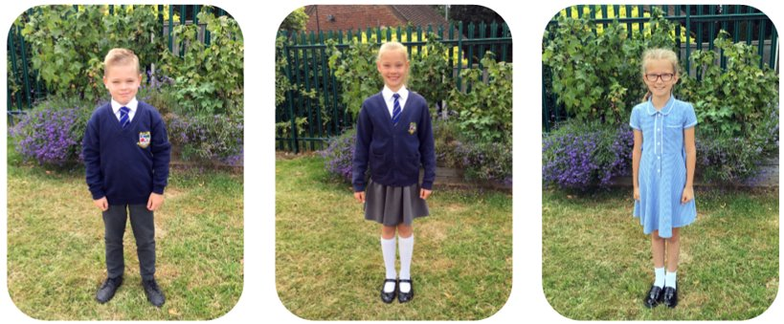
Shirt – white with collar for a tie
School tie (available from the school shop)
School sweatshirt or cardigan (available from the school shop) / Plain navy blue jumper or cardigan
Skirt, pinafore dress or trousers / shorts – grey or navy blue (school style)
Not black
Socks / tights – black / grey / navy (white socks are permissible with skirts but not under trousers)
Shoes – all black – Boots / open toe sandals are NOT permitted
(All black trainer style shoes are permitted)
No white / coloured soles or logos
A blue and white check dress (school style) may be worn in hot weather

3.2 PE Kit
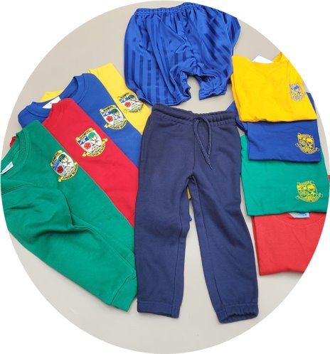
Pupils are asked to come into school on the day of their PE / Games lesson wearing their PE kit. They can wear it for the full school day.

House colour T-shirt with school logo (available from the school shop)
School royal blue shorts (available from the school shop)
House colour sweatshirt with school logo (available from the school shop)
Plain navy blue joggers - no logos permitted (available from the school shop)
Trainers – these can be any colour (Plimsolls are not suitable for PE or Games)
Socks – black / grey / navy / white / plain house colour

3.3 Cost and Availability

In accordance with the School Admissions Code, Bosmere Junior School ensures that the School Uniform Policy does not discourage parents from applying for a place for their child. The school is committed to meeting the DfE’s recommendations on costs and value for money.

In order to give parents discretion over where to purchase their child's uniform, very few items of the school uniform are 'branded'. Only school ties, PE t-shirts and PE sweatshirts have to be purchased through the school's uniform shop. The school stocks other items in order to sell them at cost price to parents to support with uniform costs.

Every care is taken to ensure that our uniform is affordable for all current and prospective pupils, and that the best value for money is secured through reputable suppliers. The school works with multiple suppliers to obtain the best value for money possible. Any savings negotiated are passed to parents where possible.

The school does not amend uniform requirements regularly and takes the views of parents and pupils into account when considering changes to school uniforms. Where changes are required, the school ensures that assistance is provided to parents struggling to meet the associated costs.

The school uniform shop stocks the following items:
- School ties
- School sweatshirts/cardigans with the school logo
- House colour PE T- shirts and sweatshirts with the school logo
- School royal blue PE shorts
- Plain navy joggers

The school uniform shop is run through the school office. Parents can contact the office to place an order. This can also be done through ParentMail.

The school uniform shop also stocks a range of ‘nearly new’ items, which can be purchased for a small donation to the school. Parents are encouraged to donate clothing to the school when their child outgrows it or leaves the school.

3.4 Jewellery
- Watches may be worn (not a smartwatch);
- Pupils should remove watches for physical activity for safety reasons;
- Pupils whose ears are pierced must only wear one pair of small plain stud earrings;
- Earrings should not be worn to school on the days where PE takes place; if they must be worn, they should be covered by surgical tape which must be provided by the parent;
- No other type of jewellery should not be worn to school for safety and security reasons.
3.5 Hair / Make Up
- Hairstyles should be smart and moderate in style; pupils should not have their hair dyed or bleached / shaved, including patterns;
- Any hair accessories should be discreet and uniform colour i.e. no large flowers/bows;
- Long hair should be tied up to avoid health and safety risks and ensure that children’s vision is not impeded;
- Pupils should NOT wear any form of makeup (including nail varnish).
3.6 Bags
- Pupils should use an appropriately sized bag to carry their books and equipment;
- It should hold books and reading diaries comfortably without causing any damage;
- Large bags / large rucksacks are discouraged due to space on children’s pegs;
3.7 Religious Clothing / Ceremonial Wear

Some religions and beliefs require their members to conform to a specific dress code. The school does not discriminate against any religion or belief; however, the school weighs the needs and rights of individual pupils against the health and safety concerns of the entire school community.

Bosmere Junior School endeavours to allow religious requirements to be met, wherever possible. Please make an appointment with the Headteacher to discuss the policy and to make any requests for religious clothing / ceremonial wear to be worn in school. Parents’ concerns and requests regarding religious clothing are dealt with on a case-by-case basis by the Headteacher and Governing Body.

3.8 Equality

The school is required to ensure that this policy does not discriminate unlawfully. Every step has been taken to ensure that the cost of similar uniform items, for example, trousers versus skirts, are not disproportionate.

The school endeavours to ensure that our uniform is as gender neutral and inclusive as possible. We do not insist that children of any identified gender must wear specific items of clothing.

Section 4:
Adverse Weather

4.1 Hot Weather

Pupils are not required to wear their jumpers/cardigans during hot weather. In heatwaves, pupils will be instructed to remove their ties once in school. Pupils are also advised to wear sun screen and bring a hat into school.

4.2 Cold / Wet Weather

During cold / wet weather, pupils are required to wear coats when they are outside. Additional layers underneath the usual school uniform are accepted, where these are completely covered by the school uniform.

Section 5:
Non-Compliance

Parents will be contacted if their child is not wearing the correct uniform. Individual family / exceptional circumstances will always be taken into account and a time span may be agreed to rectify the problem.

Where appropriate, pupils may be loaned the correct item of uniform from the school.

5.1 Complaints and Challenges

The school endeavours to resolve all uniform complaints and challenges locally and informally, in accordance with the school’s Complaints Policy. To make a complaint, parents should refer to the Complaints Policy and follow the stipulations outlined. When a complaint is received, the school will work with parents to arrive at a mutually acceptable outcome.

Governors are willing to consider reasonable requests for flexibility to allow a pupil to accommodate particular social and cultural circumstances.

