

BOSMERE JUNIOR SCHOOL

Handbook for Parents/Carers
Academic Year 2025 – 2026

Welcome to Bosmere Junior School!

This handbook is intended to answer some of the most frequently asked questions about the day to day running of the school; it is full of useful information.

The handbook will be updated from time to time during your child’s time at the school. Changes to information will be headlined in Bosmere News.

Updated June 2025

SAFEGUARDING CHILDREN

The staff and governors of Bosmere Junior School are committed to safeguarding and promoting the welfare of children and young people and expect all staff members and visitors to share this commitment.

Our Safeguarding and Child Protection Policy can be seen on the school website and a paper copy is held in the school office.

Our Designated Safeguarding Leads are Mrs Robinson, Mr Adam and Mrs Lever.

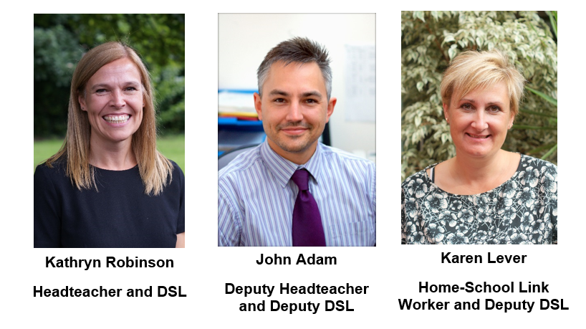

If you have any enquiries, please visit the staff at the school office who are always happy to help.

CONTENTS

Subject |  | Page(s)
SCHOOL ORGANISATION | - Staff List | 4
HOME SCHOOL COMMUNICATION | - ParentMail  - Contact Information  - Home School Link Worker  - Emergency School Closure  - Parental Permissions Booklet | 5-7
PARENT HELPERS |  | 7
POLICIES |  | 7
THE SCHOOL DAY | - School Times  - Arrangements for the start and end of day  - Cycling/Scooting to School  - Parking  - Security | 7-8
ATTENDANCE | - Lateness  - Sickness and Diarrhoea Bug  - Head lice | 9
SCHOOL UNIFORM | - P.E.Kit Boys and Girls  - School Uniform Shop  - School uniform health and safety  - Hair/Make-up  - Lost Property  - Mobile Phones | 10-13
BEHAVIOUR | - School values  - Rewards  - Behaviour Cards | 13-15
FOOD IN SCHOOL | - School Meals  - Packed Lunches  - Water Bottles | 15-17
HEALTH | - Food Allergies  - Asthma  - Administering Medication at School  - Illness or Accidents Whilst at School  - First Aid | 17-18
HOMEWORK |  | 18
EXTRA CURRICULAR ACTIVITIES | - Bosmere Staff Run Clubs (Free)  - Activities Organised and Run by Outside Agencies  - Before and After School Care  - PTA and Fund Raising  - Charity Fund Raising  - Easyfunding | 19-21
SCHOOL TERM AND HOLIDAY DATES | - Planned INSET Days | 22-23
SCHOOL STAFF
Headteacher: Mrs Kathryn Robinson Deputy Headteacher: Mr John Adam
Assistant Headteacher/SENCO: Mrs Charlotte Reed
Year Groups (* Year Co-ordinator)
Year 3 | Year 4 | Year 5 | Year 6
Mr James Baker* | Mrs Leanne Austen* | Mrs Lorna Browne* | Mr Olly Kershaw*
Miss Ellen Dawes | Miss Aimee Jackson-Hughes | Mrs Aly Dawson | Mrs Lucy Barnard
Miss Amy Jenner | Mr Isaac Parrack | Miss Megan Lawrence | Miss Becky Calcott
Mrs Helen Baker | Mrs Nicola White | Mr Paul Sherlock
Learning Support Assistants (*HLTA)
Year 3 | Year 4 | Year 5 | Year 6
Ms Zoe Carew | Mrs Sarah Buckwell | Mrs Laura Cameron | Miss Tina Emery*
Mrs Kim Chapman | Mrs Kerry Bruce | Mrs Emma Dunn* | Mrs Holly Jordan-Norris
Ms Tracy Conway | Ms Kirsty De-Stains | Mrs Jan Morris | Mrs Sarah Simpson
Ms Casey Crawford | Miss Michelle Faithfull* | Mrs Vicky Morgan | Mrs Louise Wright
Mrs Emma Marsh | Mrs Debbie Page
Ms Gem Terry*
Collaborative Pupil Premium Team:
Mrs Lorna Browne | Mrs Tracy Cronin* | Mrs Charlotte Reed | Mrs Debbie Wicks
Other Roles:
SENCo | Mrs Charlotte Reed
Spanish Teacher: | Mrs Helen Baker
Librarian: | Mrs Rebecca Dunn
Home School Link Worker / ELSA: | Mrs Karen Lever
ELSA: | Mrs Lisa Kemp
Nurture Support: | Mrs Kerry Bruce
Sport Coach: | Miss Tina Emery
Administrative Staff:
Office Manager: | Mrs Alison Reilly |  | SIMS Manager: Mrs Emma Chappell
Admin Assistant: | Mrs Justine Clark
Site Management Team:
Mr Dan Moore (Site Manager)  Miss Michelle Faithfull |  | Mrs Kim Chapman (Caretaker)  Mrs Chris Horn |  | Miss Tina Emery (Caretaker)
Lunchtime Supervisors:
Mrs Nicole Badham (Snr) | Mrs Kim Jones | Mrs Karen Skinner
Ms Tracy Conway | Mrs Patricia Macey | Mrs Sue Vine
Mrs Carrie Groves |  | Mrs Paula Wilson (Snr)
Governors (See website):
John Adam (DH) | Jackie Lowe | Tam Simmons
Joanne Armitage | Lee Nolan | Sarah Smith
Jo Brooks | Martin Poliszczuk | Gem Terry
Nick Durkee | Mike Powell | Kate Treagust
Helen Faulkner | Kathryn Robinson (HT) | Brian Swan
HOME SCHOOL COMMUNICATION:
The school operates an open door policy for the purposes of good communication between parents and staff. Parents are welcome to come to the school at any time during the working day and should always report to reception, where a member of the office team will be available to help. Appointments to discuss matters with a member of the teaching staff or the Headteacher will be arranged at the earliest available opportunity. Staff can also be contacted via email. All email addresses follow the format initial.surname@bosmere.hants.sch.uk, for example Mrs Robinson would be k.robinson@bosmere.hants.sch.uk.

To keep you updated with your child’s academic progress, a Milestone Report will be sent home in November and February. The school also holds consultation evenings in the Autumn and Spring terms; on these occasions an appointment system operates through the ParentMail app. In addition, an annual report will be issued towards the end of the Summer term.

ParentMail
At Bosmere we believe in working in partnership with parents; to facilitate this we use ParentMail as our main means of communication between school and home. Newsletters, letters from year groups regarding school trips and events, PTA and Governors correspondence will be emailed home via ParentMail. You must be registered in order to receive emails.

To register for ParentMail you will need to search for the ParentMail App and download it. (This is a free App). Further information will be given for new parents in September. Once you have registered you will be able to pay for school lunches, trips and visits online. All correspondence from school will also be published on the school website www.bosmere.hants.sch.uk

Contact Details
We rely upon parents to keep us up to date with new contact details including new mobile numbers, work details, e-mail address etc.

Home School Link Worker
At Bosmere Junior School we know that children achieve more when both home and school work in partnership to support a child's development.
Mrs Karen Lever is our Home School Link Worker (HSLW). She is in school every day 8.30am-3.30pm and usually at the main entrance to the school 8.30-9am. She is here to offer support, advice, guidance and a listening ear to parents/carers and pupils on an individual basis.
Mrs Lever can support children on a 1:1 or small group basis with:
- lack of confidence and low self-esteem;
- break down/difficult family relationships;
- behavioural, emotional and social difficulties;
- friendship issues;
- transition between schools.
She can also support parents with:
- developing and maintaining a positive relationship with the school;
- helping children to increase school attendance, minimise absences and lateness and encouraging children into school;
- referring to and working with a range of professionals for support i.e. School Nurse, CAMHS, Southern Domestic Abuse Service etc.;
- managing a problem at home, such as substance misuse, domestic abuse or poor physical or mental health.
Mrs Lever will help and encourage all families to see school as a friendly, approachable place. Phone the school to arrange an appointment or drop in and ask for a chat!

Emergency School Closure
Heavy snowfall preventing staff from travelling to school, heating failure or loss of basic utilities such as electricity, gas or water will all result in an emergency closure of the school. Should this happen, the following will take place:
- An email will be sent via ParentMail;
- Radio Solent (96.1FM or 103.8FM) will broadcast the closure and list the school on its website: www.bbc.co.uk/radiosolent;
- Hampshire County Council website www.hants.gov.uk will list the school as closed;
- A message will be put on the school Facebook and Instagram page;
- If possible, staff will be at the main entrance, the Park Road South entrance and at Tesco to inform parents arriving with children of the closure.
- Children arriving without adults will be brought into school and their parents will be contacted.

Parental Permissions Booklet
When your child joins Bosmere, you will receive a booklet containing permission forms which we ask you to sign and return to school as soon as possible. These permissions will last the whole time your child remains at Bosmere.

PARENT HELPERS
Want to become a parent helper? – It’s simple! Please contact your child’s teacher or the school admin staff to register your interest. A DBS Certificate will be required and Mrs Reilly, Office Manager will organise this with you.

POLICIES
All school policies are available for inspection in the school office or on the school website: www.bosmere.hants.sch.uk
If you would like a paper copy of any policy please request this at the office.

THE SCHOOL DAY

School Times
SESSION TIMES:
Morning session:  L/S Morning break*  U/S Morning break* | 8:50am  10:25am  10:45am | -  -  - | 12:10pm  10:40am  11:00am
LUNCH: | 12:10pm | - | 1:10pm
Afternoon session:  Afternoon break* | 1:10pm  2:10pm | -  - | 3:30pm  2:25pm

*WET BREAKS - If your child has adequate wet weather clothing and footwear he/she may play outside during a wet break.

Arrangements for the start and end of the school day
At the start of the day, children can be dropped off at either of the school gates from 8:30am. They will be supervised on the playground and will start going into school from 8:45am. The playground gates close at 8:50am. If children arrive after 8:50am they must go to the office and will receive a late mark. At the end of the day, parents are allowed onto the playground from 3:20pm. The children come out of school at 3:30pm. Discuss going home arrangements with your child on a daily basis; this is particularly important when clubs operate.

Cycling/Scooting to school – the following rules apply:
- It is left to the parents’ discretion whether they accompany their child to school - the decision as to whether a child is competent to cycle to and from school rests with the parent;
- Children must wear a helmet when riding a bike;
- Children should not cycle/scoot on the school grounds;
- A cycle/scooter rack is available for children to use. The school cannot accept responsibility for scooters/bikes.

Parking
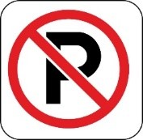
The school car park is for staff only. Parents, please encourage your children to walk on the paths and not through the car park. Parents can only use the staff car park with permission from the Headteacher.

South Street is too congested to accommodate parents’ cars so we advise you to use our “PARK AND STRIDE” approach! As well as being able to park free at Tesco for up to 3 hours, we have secured the following options for this:
- Prince Georges Street Car Park,
- East Pallant Car Park,
- Town End House Car Park (HBC spaces only – not LiveLink Private car park space - limited availability)
The above car parks are available FREE to Bosmere parents/carers between 8.15am and 9.05am (for morning school run) and between 2.30pm and 4pm (for afternoon collection). This is TERM TIME ONLY and does not apply during school holidays and school closure days. You do not need to display anything.
(NB the Meridian Centre Car Park is NOT included in this scheme.)

PLEASE DO NOT ARRANGE TO MEET YOUR CHILD ON THE ROUNDABOUT. Parking on double yellow or zig-zag lines outside the school (including the bus stop in Park Road South and the turning circle) is illegal. Traffic wardens regularly patrol and issue tickets. BE WARNED!

Security
Bosmere Junior School is a secure site. Gates remain locked at all times, except for the start and end of the day. Entry to the school is only possible via the main door at any other time. If you wish to speak to a member of staff ALWAYS use the front entrance stating who you are at the video intercom located on the wall to the right of the doors. Please report to the school office. Security cameras have now been placed outside and inside the main entrance.

ATTENDANCE

Parents have a legal responsibility to ensure that children attend school regularly and on time. A child not attending school is considered a safeguarding matter. If your child is absent, we need to know why so we ask you to telephone as soon as possible on the first day of absence and every day thereafter. If we do not hear from you, we will contact you via text or by telephone to ask for the reason for absence. We will continue to try all contacts until a response is received. If no response is received, a home visit will be made.

Lateness
A child arriving to school after the playground gates have closed (8.50am) must report to the school office (reception) before going to class. Any lateness is recorded in the register: L = 20 minutes or less and U = 21 minutes or more. U is recorded as an unauthorised absence.

Requests for leave of absence
Following Department for Education regulations, Headteachers may not grant any leave of absence during term time unless there are exceptional circumstances.

Parents wishing to apply for leave of absence need to complete an application form in advance and before making any travel arrangements. Forms are available from the school office / website. In the majority of cases, absence from school for a family holiday will not be authorised. If term time leave is taken without prior permission from the school, the absence will be unauthorised.

Medical Appointments
Children who need to leave school for medical appointments and return later, need to be registered at the office on exit and entry. Where possible, doctor and dentist appointments should be made outside of school hours or during school holidays.

Sickness and Diarrhoea bug
If your child suffers from a sickness and diarrhoea bug, please keep them off school for 48 hours from the last episode of sickness or diarrhoea.

Head Lice
Pupils with live head lice do not need to be sent home from school; they can go home at the end of the day, be treated, and return to school the following day. Nits (head lice eggs) may persist after treatment, but successful treatment should kill crawling lice.

Ongoing absence / lateness or unauthorised absence
Where pupils are identified as being at risk of poor attendance, we will contact parents to discuss the reasons and offer support if needed.
Insufficient improvement with ongoing absence, or 10 sessions of unauthorised absence may result in the issuing of a Penalty Notice, or the involvement of the Hampshire County Council Legal Intervention Team if a Penalty Notice has previously been issued. Further information is available at the following link:
http://www3.hants.gov.uk/education/hias/learning-behaviour-attendance/attendance-guidance-for-parents/possible-penalties.htm

If you are having any problems with your child relating to attendance, please contact our Home School Link Worker, Mrs Lever.

SCHOOL UNIFORM
School Uniform
Shirt – white with collar for a tie
School tie (available from the school shop)
School sweatshirt or cardigan (available from the school shop)
Skirt, pinafore dress or trousers/shorts – grey or navy blue (school style)
Not black
Socks/tights – grey/navy (white socks are permissible with skirts but not under trousers)
Shoes – all black - Boots are NOT permitted
(All black trainer style shoes are permitted)
No white / coloured soles or logos
A blue and white check dress (school style) may be worn in the Summer Term only

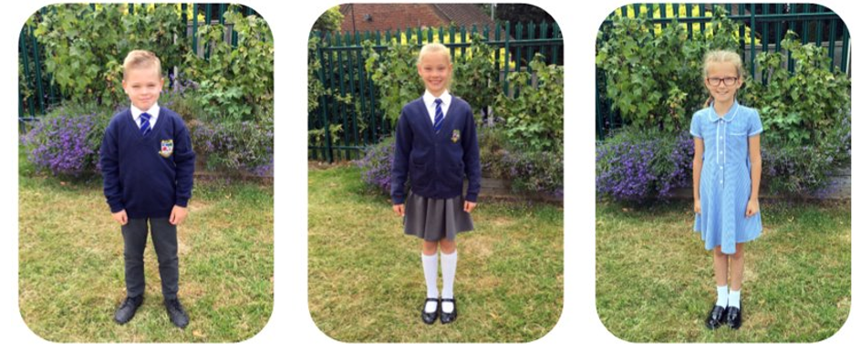

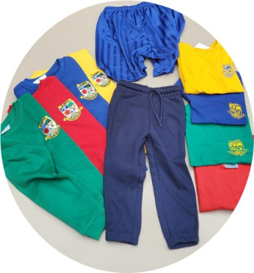
P.E. Kit (Worn to school on days when children have P.E. / Games)
House colour T-shirt with school logo (available from the school shop)
School royal blue shorts (available from the school shop)
House colour sweatshirt with school logo (available from the school shop)
Plain navy blue joggers - no logos permitted (available from the school shop)
Trainers (Plimsolls are not suitable for P.E. or games)
Socks– black/grey/navy/white

School Uniform Shop
The School Uniform Shop stocks the following items:
- School ties
- School sweatshirts/cardigans
- House colour P.E. T- shirts and sweatshirts
- School royal blue P.E. shorts
- Plain navy joggers

The uniform shop is run through the school office. You can contact the office to place an order. This can also be done through ParentMail, when your child begins to attend the school. Uniform can then be collected from the school office or will be sent home with your child.

Each term we hold a Pre-loved Uniform Event, where uniform can be obtained for a small voluntary donation to PTA funds.

School Uniform – health and safety rules:
- Open toe sandals are not suitable school shoes;
- For safety reasons children should remove watches for physical activity. It is the policy at Bosmere School that children whose ears are pierced must only wear one pair of small plain stud earrings. No other is acceptable. (Earrings should not be worn to school on the days where P.E. takes place.) Any other type of jewellery should not be worn to school for safety and security reasons.

Hair/Makeup
Children at Bosmere should not have extreme hair styles, i.e. have their hair dyed or bleached nor should they have their head shaved, including patterns. Any hair accessories should be discreet and uniform colour i.e. no large flowers/bows.
Children should NOT wear any form of makeup (including nail varnish).

Lost Property
Lost property is to be found in the school conservatory. Please ask your child to ask an adult in their class to help them look for any missing items. We encourage all children to respect their own and other people’s property. We ask parents to assist us by clearly marking all clothing including coats, hats, gloves etc., trainers, bags, lunch boxes and water bottles. Please use either labels or an indelible pen. Named lost property is returned directly to children. Parents are welcome to come in at any time to look for lost property during the school day.
At the end of each half term unnamed lost property is displayed in the entrance lobby, please come in and check for lost items.

ALL CLOTHING MUST BE NAMED

Mobile Phones and Smart Watches
Mobile phones are part of modern society and a large number of pupils will now own a mobile phone. We understand that for safety reasons some parents may want their child to carry a mobile phone in order to be able to contact a family member after school/before school. The decision to allow a child to bring a mobile phone to school rests with a parent. Please be aware:

- The school will not accept responsibility for loss, damage or theft of a mobile phone.
- The decision to allow a child to bring a mobile phone to school rests with a parent. Parents and pupils must be aware that bringing a phone to school carries the risk of loss, damage or theft. For this reason the school would discourage parents to allow their children to bring phones to school.
- Mobile phones must remain switched off during school hours and kept out of sight. This includes break and lunchtimes. Mobile phones are not allowed to be used on site – this is defined as ‘inside the school gates’ and includes the playground at the beginning and end of the day.
- Any pupils seen using their mobile phone during school hours will have their phone confiscated. Phones must not be seen or heard on the school site.
For more details, please see the school policy on Mobile Phones.

Smart-Watches should not be worn to school if they have a:
- Camera
- Game(s)
- Calculator
- Link to a phone for the purpose of messaging
There are some watches which have more limited functionality e.g. simpler Fit-bits which just record data about the wearer that might be acceptable, but an adult may question a child about the watch and check it to ensure that it is appropriate for school. School staff also do not always have the time or expertise to identify which Smartwatches have certain functionality. To save time your child may simply be asked to put their watch in their bag until the end of the day.
Simple analogue and digital watches remain completely appropriate for school and we would recommend them for helping children to develop their understanding of time.

BEHAVIOUR
At Bosmere we have two sets of values which we promote:

Our ‘HEARTS’ Values promote the idea that ‘It’s what we are like in our hearts that matters’:
Be…Healthy, Empathetic, Ambitious, Respectful, Trustworthy, Safe;

Our ‘GROW IT’ Learning Values look at developing the skills to be ‘Lifelong Learners’:
Greatness, Resilience, Originality, Wonder, Independence, Teamwork.
We have a set of “Golden Rules”, linked to our HEARTS values which we ask children to follow:
- Make sensible choices;
- Be polite and kind to others;
- Always do your best:
- Listen to adults and follow instructions;
- Be honest and look after other people’s property;
- Stay safe

PROMOTING POSITIVE BEHAVIOUR | REWARDS
- Adults role-model positive behaviour  - Praise  - House Points  - Headteacher Awards, certificates and badges  - Public commendation  - Reference to / recognition of school values  - Appropriate praise from teachers or supervisors  - Pastoral support  - SEN support | Teachers are encouraged to develop rules and sanctions within their individual classrooms. Whole school rewards include:  - House Points  - Headteacher Awards  - Pupil of the Week  - Attendance Awards  - Behaviour Awards

Headteacher Awards
These may be awarded by any member of staff to children who display particularly clear examples of behaviour in conjunction with the school values. They specifically reward the individual.
3 Headteacher Awards = Bronze Certificate + Text Message to parents
5 Headteacher Awards = Silver Certificate + Text Message to parents
10 Headteacher Awards = Gold Certificate + Letter from Headteacher
20 Headteacher Awards = Platinum Certificate + Headteacher Award ‘Platinum’ Badge
30 Headteacher Awards = Values Certificate + GROW IT Badge

White, Yellow, Orange or Red behaviour cards may be given to a child if they break the school rules. The reasons for giving out a behaviour card may include the following:
White | Yellow | Orange | Red
White Cards are given to children where there is conflict or behaviour that we feel requires a restorative meeting.  Restorative meetings give children who have been harmed the opportunity to explain the impact to those responsible, and for those responsible to acknowledge this impact and take steps to put it right.  These cards help us to see if any children frequently require help in managing relationships with their peers. However, they do not replace the Yellow, Orange and Red cards which continue to be used to help manage more significant behaviour issues. | Stopping other children from learning | Persistently disrupting the class | Refusing to complete work set by an adult
 | Playing roughly on the playground | Fighting | Causing injury through unprovoked violence
 | Being unkind to another pupil / creating conflict | Purposefully hurting other people’s feelings | Bullying
 | Being disrespectful toward others | Deliberate rudeness to an adult | Refusing to follow instructions from an adult
 |  | Lying to an adult | Consciously lying to adults and blaming others
 | Misusing other people’s property | Deliberately taking, moving or damaging other people’s property | Serious vandalism or theft
 | Rude language | Inappropriate language / swearing | Aggressive or abusive swearing at another person
 | Ignoring safety rules | Being deliberately unsafe | Creating a dangerous situation (may put others at risk)
 | Repeatedly forgetting homework, PE kit, school equipment or school uniform | Deliberately ignoring expectations on homework, PE kit, school uniform and school equipment
*Please note that summary serves as a guide to help ensure a consistent approach, but other factors may affect the consequences of a child’s behaviour e.g. SEND, aggravating factors, safeguarding issues etc.

FOOD IN SCHOOL
School Meals
- Children may either have a healthy cooked lunch from school or bring in a healthy packed lunch from home. Children having school lunches are able to pre-order the meal of their choice from the menu available. If you know your child is going to arrive at school after 9.30am, please ring the school office to book a meal;
- Water is provided for all children having school meals at lunchtime;
- School meals are currently £3.20 per day, £16 per week;
- Meals should be paid in advance weekly on the first day of the week. We encourage parents to pay for school meals using ParentMail; however, if you are unable to access ParentMail, dinner money should be enclosed in an envelope with your child’s name and class written on the front.

If you think your child may be entitled to Free School Meals you can check eligibility by going on to the following website: http://www.cloudforedu.org.uk where you will get immediate confirmation. It is important for your child’s education that you register for free school meals if you are entitled, as this does mean that your child will be eligible for additional resources (Pupil Premium funding) and does not mean your child cannot bring a packed lunch to school. If you have any queries on this matter, please contact our admin team.

Packed Lunches

At Bosmere we continually promote a healthy lifestyle, encouraging all pupils to take part in increased levels of activity and make healthy food choices. Bars of chocolate, sweets or fizzy drinks are not permitted in school, or to be taken on school visits. We have a few children in school that may have an extreme reaction to any nut products in their immediate environment. For this reason, please do not send any nuts/nut products/peanut butter sandwiches etc. to school with your child for lunch. We ask that parents providing a packed lunch also provide a drink.

Snacks
Children may bring in a piece of fruit or vegetable snack or a plain biscuit (no chocolate) for break time if they wish. (NB Fruit is not provided.)

Water Bottles
All children should have a water bottle in school every day. This should have a sports top, rather than a screw top, as screw tops often lead to water being spilt on work. It also needs to be clear / semi-opaque so that it is easy to check that it is water being brought into school. Bottles should be clearly marked with child’s name and class and children will need to take their bottles home daily to be cleaned. Children have access to their water bottles throughout the day.

HEALTH
Food Allergies
Please let the school know if your child has a food allergy (not just an intolerance or dislike). Education Catering Supplies, the company that provides Bosmere’s school meals, require a Special Diets Request form to be completed before a child with a food allergy can have a school meal. This form is available from the school office on request.

Asthma
Asthma inhalers are kept in classes so children have easy access to them. Please complete an ‘Administration of Medicines/Treatment Consent Form’ and bring it to the school office together with your child’s inhaler. Children will not be allowed to go out on trips without their inhaler so please notify us if and when your child no longer requires it.

Administering Medication at School
The admin staff will administer prescribed medicines to your child if needed. Please bring the medicine clearly named to the school office and complete a permission slip. All medication is stored and administered in the medical room (apart from children’s asthma inhalers, epi-pens etc). These arrangements protect all your children from the loss or misapplication of medicines. Any Calpol should be supplied by parents.

Illness or Accidents Whilst at School
If your child is ill or has an accident at school, it may be necessary to contact you
urgently. It is essential that we have your home telephone number, mobile number and details of another person who may be contacted in an emergency.
In exceptional circumstances, where the problem is serious and contact with you could not be made, the Headteacher will act “in loco parentis”.


First Aid
A range of staff members hold either First Aid at Work, Emergency Aid, First Response or Paediatric First Aid.
HOMEWORK
Children are expected to take a pride in their homework and present it both formally and creatively depending on the tasks.
The school’s agreed practice for homework is that:
- Homework is set on a regular basis;
- Tasks will be made clear to children and matched to their abilities;
- Homework will generally follow on from work which has taken place in class but may take many different forms;
- It may sometimes consist of preparation for work yet to be done;
- It should sometimes involve the participation of the parents;
- Timescales for completion of homework will be made explicit, with several days for completion to allow for other commitments;
- Support will be provided in school where difficulties with homework are experienced;
- Children who have not made the effort to complete expected tasks in class may be asked to complete work at home.

All children are expected to complete homework. Regular completion of homework of a high standard is recognised and celebrated. Children who do not complete their homework may be given an opportunity to succeed in this through a homework session in school leisure time at the teacher’s discretion. If a child consistently fails to complete homework, parents will be contacted.

The amount of homework increases as children move through the school. Times vary each week, depending on the tasks set and the amount of effort children wish to put in. There is usually a minimum expectation of 1 to 2 hours per week in Year 3 and Year 4 and 2 to 3 hours per week in Year 5 and Year 6.

In every year group homework includes:
- reading with an adult (expectation of at least 5 times per week)
- learning spellings
- learning number facts/tables

In addition to this, each half term a choice of up to 6 project style homework tasks is set in each year group. There is an expectation that children complete at least one of these tasks by the end of the half term. Any additional tasks completed are recognised and celebrated. Some homework will be provided online via platforms, such as MyMaths, Times Tables Rockstars and MS TEAMS.
EXTRA CURRICULAR ACTIVITIES
Bosmere Staff Run Clubs (Free)
A club newsletter and timetable is circulated at the beginning of each term. There is always a wide variety of activities on offer, either before school, at lunchtime or after school.


Cancellation of staff run clubs
If a club has to be cancelled 24 hours or more before it takes place, children will be informed and an email/text will be sent to parents through ParentMail. If a club is cancelled on the day it takes place due to inclement weather or staff illness, the following procedure will take place:
- a text will be sent through ParentMail informing you of the cancellation;
- children will be told by staff that they can only go home without an adult if their parent has contacted the office. Therefore, if you are happy for your child to walk home independently, you must inform the office;
- any children who are not collected on time can wait in school.

Please note that several after school activities continue until 4.40pm or sometimes later.

Activities Organised and Run by Outside Agencies (Fees Apply)

In addition, a range of clubs is provided each term by outside agencies. It is their responsibility to provide information regarding dates, times and costs for their classes at the beginning of each term, as well as notifying you of any changes to their set programmes. They will take a register at the beginning of each class and will hold their own emergency contact lists.

Before and After School Care
A breakfast and after school club is available. ‘Lisa’s Club’ is run by Mrs Kemp (our ELSA at Bosmere). The club hires the school’s facilities in order to have sufficient space but please be aware that it is a separate organisation from the school. If you are interested in a space Mrs Kemp can be contacted on 07853 630117.

PTA and Fund Raising
All parents are automatically members of the PTA whilst their child is a pupil in the school. An Annual General Meeting is held each September when a new committee is formed. (This is unlike other committees as it is very informal.)
The PTA support many events during the year, details of which are sent to parents in the newsletter. The PTA previously paid for the overhaul of the Adventure Play Area, and are currently saving to buy a new school mini bus.

As you can see from the above the PTA makes a massive contribution to our school environment. Do come along to the AGM and see what goes on! Details of dates and times for meetings will be published in the Newsletter and on the school website.

Charity Fund Raising
As a school, we support charities in many ways including:
School PTA | Last day of each half term – “non-uniform day” for a contribution of £1
Beacon Food Bank | Harvest festival food parcels
Beacon Food Bank | Reverse Advent Calendar at Christmas
Macmillan Cancer Support | Coffee morning and cake sale
School Council chosen charity | Changes each year

Easyfunding
Many of our parents order a variety of products online and by signing up to Easyfunding you can help raise money for Bosmere Junior School. You can help raise a FREE donation for us every time you shop online. 4,000 shops and sites will donate, so you can help us out when you buy the things you would be buying anyway - at no extra cost to yourself!
Please download the app and start making money for us!
https://www.easyfundraising.org.uk/causes/bosmerejunior
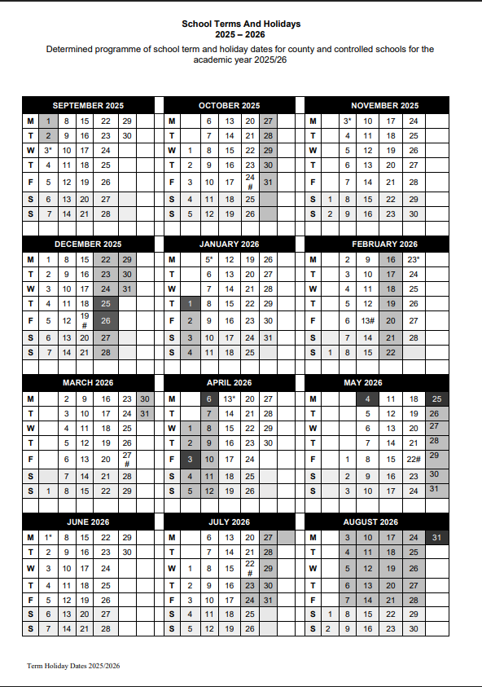
Planned INSET days for 2025 - 2026
- 3rd September 2025
- 3rd October 2025
- 23rd February 2026
- 13th April 2026
- 1st June 2026

There is so much going on at Bosmere it is really hard to fit into one booklet. If you have any other questions we have not been able to answer just come in and ask!

You can also keep up to date with what is going on at school by checking the Bosmere School website: www.bosmere.hants.sch.uk

You can also follow us on Facebook – search for Bosmere Junior School.

