
Bosmere Junior School
South Street
Havant
PO9 1DA

SUPPORTING PUPILS WITH MEDICAL NEEDS POLICY

The purpose of this policy is to ensure that there is a plan in place to support pupils with medical conditions and that employees are aware of their responsibilities and that relevant staff understand the administration of medicine arrangements, so that these children can play a full and active role in school life, remain healthy and achieve their academic potential.

Date: | December 2024
Review Date: | December 2027
Responsibility: | Senior First Aider
STATUTORY
Checked against Equality Policy

Senior First Aider: | Date:
Chair of Governors: | Date:
Headteacher: | Date:

Introduction
Section 100 of The Children and Families Act 2014 places a duty on the Governing body of this school to make arrangements for supporting children at their premise with medical conditions. The Department of Education have produced statutory guidance ‘Supporting Pupils with Medical Conditions’ and we will have regard to this guidance when meeting this requirement.

We will endeavour to ensure that children with medical conditions are properly supported so that they have full access to education, including school trips and physical education. The aim is to ensure that all children with medical conditions, in terms of both their physical and mental health, are properly supported in school so that they can play a full and active role in school life, remain healthy and achieve their academic potential.

It is our policy to ensure that all medical information will be treated confidentially by the Headteacher and staff. All administration of medicines will be arranged and managed in accordance with this document. All staff have a duty of care to follow and co-operate with the requirements of this policy.
This policy also adheres to the Equality Act 2010 and the SEND Code of Practice.
We recognise that medical conditions may impact social and emotional development as well as having educational implications.

Key Roles & Responsibilities
Statutory Requirement: The governing body should ensure that the school’s policy clearly identifies the roles and responsibilities of all those involved in the arrangements they make to support children at school with medical conditions.

The Governing Body is responsible for:
- Ensuring that the policy for supporting pupils with medical needs is in place and reviewed at regular intervals
- Ensuring that appropriate resources, including staff, are available to enable the policy to be applied

The Headteacher is responsible for:
- Ensure staff are aware of the policy and trained appropriately.
- Ensuring that the procedures as laid out in the policy are known and followed by all staff

The inclusions manager (SENCO) is responsible for:
- Ensuring that all relevant staff are made aware of a pupils’ condition
- Ensuring that cover arrangements are in place, in case of staff absence, to ensure a suitably trained member of staff is always available
- Monitoring of individual health care plans
- Liaising with the teacher advisor for disabilities and other professionals involved in supporting pupils with medical needs
- Liaising with the school nursing service regarding health care plans and training
- Ensuring that individual health care plans are in place and up to date
- Ensuring that pupils and parents are involved in the development and review of the child’s individual health care plan

Teachers and Support Staff are responsible for:
- Considering the needs of pupils with medical conditions when risk-assessing specific events
- Liaising with the teacher advisor for disabilities and other professionals involved in supporting pupils with medical needs
- Carrying out day to day support in accordance with the individual health care plan
- Attend relevant training sessions to maintain competency

External Agencies (e.g., Clinical Commissioning Groups, School Nurses):
- Provide specialist advice and training for staff
- Assist in the development of IHPs

Pupils:
- Pupils will be involved in discussions about their medical support needs and will be expected to contribute to the development of, and comply with, their individual health care plan

Parents:
- Parents should be involved in the development and review of their child’s individual health care plan
- They are responsible for carrying out any action they have agreed to as part of its implementation
- They are responsible for ensuring that they, or another nominated adult, are contactable at all times

Local Arrangements
Identifying children with health conditions
Statutory Requirement: The Governing body will ensure that the policy sets out the procedures to be followed whenever a school is notified that a pupil has a medical condition.

We will aim to identify children with medical needs on entry to the school by working in partnership with parents/ carers, feeder schools and following the process outlined in the document ‘Process for identifying children with a health condition’ produced by the Southern Health School Nursing Team in conjunction with the Children’s Services Health and Safety Team. We will use the ‘Health Questionnaire for Schools’ (Appendix A) to obtain the information required for each child’s medical needs to ensure that we have appropriate arrangements in place prior to the child commencing at the school to be able to support them accordingly.

Where an Education Health Care Plan or other similar document already exists this will be used as part of the transition process.

Where a formal diagnosis is awaited or is unclear, we will plan to implement arrangements to support the child, based on the current evidence available for their condition. We will ensure that every effort is made to involve some formal medical evidence and consultation with the parents.

Individual health care plans
Statutory Requirement: The Governing body will ensure that the school’s policy covers the role of individual healthcare plans, and who is responsible for their development in supporting children at school with medical conditions.
We recognise that Individual Healthcare Plans are recommended in particular where conditions fluctuate or where there is a high risk that emergency intervention will be needed, and are likely to be helpful in the majority of other cases, especially where medical conditions are long term and complex. However, not all children will require one. The school, healthcare professional and parent will agree based on evidence when a healthcare plan would be inappropriate or disproportionate. See Flow Chart (Appendix B)
The SENCO will ensure that IHPs created by health professionals (e.g. Epilepsy nurse) are shared and adhered to by staff. In some cases the SENCO may be required to lead the creation and review of IHPs, collaborating with parents, healthcare professionals and pupils.
A healthcare plan (and its review) may be initiated in consultation with the parent/carer, by a member of school staff or by a healthcare professional involved in providing care to the child. The SENCO will work in partnership with the parents/carer, and a relevant healthcare professional e.g. school, specialist or children’s community nurse, who can best advise on the particular needs of the child to draw up and/or review the plan. Where a child has a special educational need identified in a statement or Educational Health Care (EHC) plan, the individual healthcare plan will be linked to or become part of that statement or EHC plan.
We may also refer to the flowchart contained within the document ‘Process for identifying children with a health condition’ for identifying and agreeing the support a child needs and then developing the individual healthcare plan.
We will use the individual healthcare plan template (Appendix C) to record the plan.
If a child is returning following a period of hospital education or alternative provision (including home tuition), we will work with Hampshire County Council and the previous education provider to ensure that the individual healthcare plan identifies the support the child will need to reintegrate effectively.
Statutory Requirement: The governing body should ensure that all plans are reviewed at least annually or earlier if evidence is presented that the child’s needs have changed. Plans should be developed with the child’s best interests in mind and ensure that the school assesses and manages the risks to the child’s education, health and social well-being and minimise disruption.
Health care plans will be reviewed during the first week of the Autumn term for new pupils including year 3. Health care plans of pupils in years 3, 4 and 5 will be reviewed during the summer term in preparation for transition to their next teacher. Health care plans can be reviewed at any time when the need arises. Information regarding pupils with individual plans is also shared with staff at the initial September INSET.
Statutory Requirement: When deciding what information should be recorded on individual health care plans, the governing body will use the school template (see appendix C attached).
Staff training
Statutory Requirement: The Governing Body should ensure that this policy clearly sets out how staff will be supported in carrying out their role to support children with medical conditions, and how this will be reviewed. It should specify how training needs will be assessed and by whom training will be commissioned and provided.
The school policy should be clear that any member of school staff providing support to a child with medical needs should have received suitable training.
Staff must not administer prescription medicines or undertake any health care procedures without the appropriate training (updated to reflect any individual healthcare plans)
All new staff will be inducted on this policy when they join the school. Records of this training will be stored in the school office.
All staff will be provided with awareness training on the school’s policy for supporting children with medical conditions which will include what their role is in implementing the policy. This training will be carried out annually or following any changes.
The awareness training will be provided to staff by Headteacher or Deputy Headteacher at whole school staff meeting.
We will retain evidence that staff have been provided with the relevant awareness training on the policy by keeping minutes of meetings and staff signing annually to say they have read the statutory policies.
Where required we will work with the relevant healthcare professionals to identify and agree the type and level of training required and identify where the training can be obtained from. This will include ensuring that the training is sufficient to ensure staff are competent and confident in their ability to support children with medical conditions. The training will include preventative and emergency measures so that staff can recognise and act quickly when a problem occurs and therefore allow them to fulfil the requirements set out in the individual healthcare plan.

Any training undertaken will form part of the overall training plan for the school and refresher awareness training will be scheduled at appropriate intervals agreed with the relevant healthcare professional delivering the training.

A ‘Staff training record – administration of medicines’ form (Appendix D) will be completed to document the type of awareness training undertaken, who attended the training, the date of training and the competent professional providing the training.

The child’s role
Statutory Requirement: The Governing body will ensure that the school’s policy covers arrangements for children who are competent to manage their own health needs and medicines.
Pupils with medical conditions will often be best placed to provide information about how their condition affects them. They should be fully involved in discussions about their medical support needs and contribute as much as possible to the development of, and comply with, their individual healthcare plan. Other pupils will often be sensitive to the needs of those with medical conditions.
In a limited number of circumstances (and in discussion with parents), children that are competent will be encouraged to take responsibility for managing their own medicines and procedures. This will be recorded in their individual health care plan. There will also be appropriate arrangements for monitoring and record keeping.
For example, children with asthma will be permitted to self-administer their blue reliever. However children tell an adult when they are self-administering and there is a form within the class medical boxes for adults to record that this has taken place.

If a child refuses to take medicine or carry out a necessary procedure, staff should not force them to do so, but follow the procedure agreed in the individual healthcare plan. Parents should be informed so that alternative options can be considered
Managing medicines on school premises
Statutory Requirement: The Governing Body will ensure that the school’s policy is clear about the procedures to be followed for managing medicines.
The administration of medicines is the overall responsibility of the parents/carers. Where clinically possible we will encourage parents to ask for medicines to be prescribed in dose frequencies which enable them to be taken outside of school hours. However, the Headteacher (or Deputy Head teacher in their absence) is responsible for ensuring children are supported with their medical needs whilst on site, therefore this may include managing medicines where it would be detrimental to a child’s health or school attendance not to do so.
We will not give prescription or non-prescription medicines to a child under 16 without their parent’s/carer’s written consent (a ‘parental agreement for setting to administer medicines’ form will be used to record this (Appendix E), except in exceptional circumstances where the medicine has been prescribed to the child without the knowledge of the parents. In such cases, we will make every effort to encourage the child or young person to involve their parents while respecting their right to confidentiality. Non-prescription medication that is administered on a ‘needs must’ basis e.g. paracetamol / antihistamines, will be recorded on the Record of Medicine Administered to all Children form (Appendix G).

Any medication regularly administered to a child or young person will be recorded on “Administration of Medicine to an Individual Child” form (Appendix F). The name of the child, dose, expiry and shelf life dates will be checked before medicines are administered.

We will only accept prescribed medicines that are in date, labelled, provided in the original container as dispensed by the pharmacist and include instructions for administration, their dosage and storage. Insulin is one exception, which must still be in date but will generally be available to schools inside an insulin pen or a pump, rather than its original container.

We will only administer non-prescribed medicines on request from the parent if they are in clearly identifiable packaging and only on a short term basis (Where the school have concerns they will seek further guidance from their link School Nurse).
All other pain relief medicine will not be administered without first checking maximum dosages and when previously taken. We will always inform parents.
Emergency medicines will be stored in a safe location but not locked away to ensure they are easily accessible in the case of an emergency.
Types of emergency medicines include:
- Injections of adrenaline for acute allergic reactions
- Inhalers for asthmatics
- Injections of Glucagon for diabetic hypoglycaemia

Herbal and homeopathic remedies will not be recommended as part of routine NHS care, but parents / carer(s) / guardians may choose to administer these to their children. It is recommended by the NHS that schools do not accept and administer herbal or homeopathic remedies.

Storage
All medicines should be stored safely. Children should know where their medicines are at all times and be able to access them immediately. Where relevant, they should know who holds the key to the storage facility. Medicines and devices such as asthma inhalers, blood glucose testing meters and adrenaline pens should be always readily available to children and not locked away. This is particularly important to consider when outside of school premises, e.g. on school trips
Some medicines e.g. asthma relievers will be kept in the class medical box which is kept with the class during lesson times and left at the medical station during lunchtimes.

Controlled drugs will be securely stored in a non-portable container which only named staff will have access to. We will ensure that the drugs are easily accessible in an emergency situation. A record will be kept of any doses used and the amount of the controlled drug held in school. There may be instances where it is deemed appropriate for a child to administer their own controlled medication. This would normally be at the advice of a medical practitioner. A child who has been prescribed a controlled drug may legally have it in their possession if they are competent to do so, but passing it to another child for use is an offence (it is very unlikely that a Key Stage 2 pupil would be need to have a controlled drug in their possession while on the school site).
Where medicines need to be refrigerated, they will be stored in the refrigerator in the medical room in a clearly labelled container. There will be restricted access to a refrigerator holding medicines.
Storage of medication whilst off site will be maintained at steady temperature and secure. There will be appropriately trained staff present to administer day to day and emergency medication and copies of individual health care plans will be taken off site to ensure appropriate procedures are followed.
Disposal
It is the responsibility of the parents/carers to dispose of their child’s medicines. It is our policy to return any medicines that are no longer required including those where the date has expired to the parents/carers. Parents/carers will be informed of this when the initial agreements are made to administer medicines. Medication returned to parent/ carers will be documented on the tracking medication form.

Sharps boxes will be in place for the disposal of needles. Collection and disposal of these will be arranged locally through the child’s parents or the Havant School Nursing Team who will remove them from site.

Medical Accommodation
The medical room will be used for most medical administration/treatment purposes. However, individual needs will be assessed to meet specific requirements e.g. asthma inhalers and epipens will be kept with the class medical box which travels around the school site with the children.

Record keeping
Statutory Requirement: The governing body should ensure that written records are kept of all medicines administered to children.

A record of what has been administered including how much, when and by whom, will be recorded on either the ‘Administration of Medicine to an Individual Child Record’ form (Appendix F) or the ‘Medicine Administer to all Children’ form (Appendix G). Copies of these forms are kept in either the Medical Room or the class Medical Box (depending on the needs of the individual child). Any possible side effects of the medication will also be noted and reported to the parent/carers.
Parents are informed when their child has been unwell at school.
Emergency procedures
Statutory Requirement: The Governing body will ensure that the school’s policy sets out what should happen in an emergency situation.

Where a child has an individual healthcare plan, this will clearly define what constitutes an emergency and provide a process to follow. All relevant staff will be made aware of the emergency symptoms and procedures. We will ensure other children in the school know what to do in the event of an emergency i.e. informing a teacher immediately if they are concerned about the health of another child.

Where a child is required to be taken to hospital, a member of staff will stay with the child until their parents arrives, this includes accompanying them to hospital by ambulance if necessary (taking any relevant medical information, care plans etc that the school holds).

Day trips/off site activities
Statutory Requirement: The Governing body should ensure that their arrangements are clear and unambiguous about the need to support actively pupils with medical conditions to participate in school trips and visits, or in sporting activities, and not prevent them from doing so.
We will ensure that teachers are aware of how a child’s medical condition will impact on their participation in any off site activity or day trip, but we will ensure that there is enough flexibility for all children to participate according to their own abilities within reasonable adjustments.
We will consider what reasonable adjustments we might make to enable children with medical needs to participate fully and safely on visits. We will carry out a risk assessment so that planning arrangements take account of any steps needed to ensure that pupils with medical conditions are included. We will consult with parents and pupils and take advice from the relevant healthcare professional to ensure that pupils can participate safely.
Unacceptable practice
Statutory Requirement: The governing body will ensure that the school’s policy is explicit about what practice is not acceptable.

Although school staff should use their discretion and judge each case on its merits with reference to the child’s individual healthcare plan, it is not generally acceptable practice to:
- prevent children from easily accessing their inhalers and medication and administering their medication when and where necessary
- assume that every child with the same condition requires the same treatment
- ignore the views of the child or their parents; or ignore medical evidence or opinion (although this may be challenged)
- send children with medical conditions home frequently for reasons associated with their medical condition or prevent them from staying for normal school activities, including lunch, unless this is specified in their individual healthcare plans
- if the child becomes ill, send them to the school office or medical room unaccompanied or with someone unsuitable
- penalise children for their attendance record if their absences are related to their medical condition, e.g. hospital appointments
- prevent pupils from drinking, eating or taking toilet or other breaks whenever they need to in order to manage their medical condition effectively
- require parents, or otherwise make them feel obliged, to attend school to administer medication or provide medical support to their child, including with toileting issues. No parent should have to give up working because the school is failing to support their child’s medical needs
- prevent children from participating, or create unnecessary barriers to children participating in any aspect of school life, including school trips, e.g. by requiring parents to accompany the child
Liability and indemnity
Statutory Requirement: The governing body will ensure that the appropriate level of insurance is in place and appropriately reflects the level of risk

Staff at the school are indemnified under the County Council self-insurance arrangements.

The County Council is self-insured and has extended this self-insurance to indemnify school staff who have agreed to administer medication or undertake a medical procedure to children. To meet the requirements of the indemnification, we will ensure that staff at the school have parents’ permission for administering medicines and members of staff will have had training on the administration of the medication or medical procedure.

Complaints
Statutory Requirement: The governing body will ensure that the school’s policy sets out how complaints may be made and will be handled concerning the support provided to pupils with medical conditions

Should parents or pupils be dissatisfied with the support provided they should discuss their concerns directly with the school. If for whatever reason this does not resolve the issue, they may make a formal complaint via the school’s complaints procedure. Making a formal complaint to the Department for Education should only occur if it comes within scope of section 496/497 of the Education Act 1996 and after other attempts at resolution have been exhausted.

Appendix A: Health Questionnaire for Schools
Please complete the questionnaire below and return it to school
It is important that all children with medical conditions are supported to make sure that they are able to access their education. Some children with medical conditions may need care or medication to manage their health condition and to keep them well during the school day. Could you please complete the questionnaire below and return it to school as soon as possible so that we are able to assess your child’s health needs and make arrangements to support them if necessary. In order to ensure that any medical needs are appropriately met in school we may need to discuss your child’s health with the School Nursing service or another health professional who is involved in your child’s care.

Name of child ……………………………………………………….. Date of Birth …………………………….

Home Address………………………………………………………………………………………………………..

………………………………………………………………………………………………………………………….
Does your child have a medical condition/ health concern?

YES |  | NO

If YES please give details

Does your child have a medical condition/health concern that needs to be managed during the school day?

YES |  | NO

If YES please give details

Does your child take medication during the school day?

YES |  | NO

If YES please give details

Does your child have a health care plan that should be followed in a medical emergency?

YES |  | NO

If YES please give details and provide school with a copy

The above information is, to the best of my knowledge, accurate at the time of writing and I give consent to the school to discuss this information with the School Nursing service or other health professionals who are involved in my child’s care.

Signature(s) Print Name
[Parent/ Carer with parental responsibility]

Date Contact number ______________________________
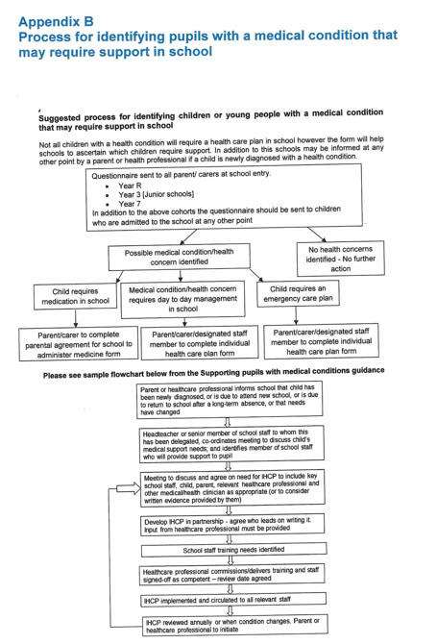
Appendix C: Individual Health-Care Plan

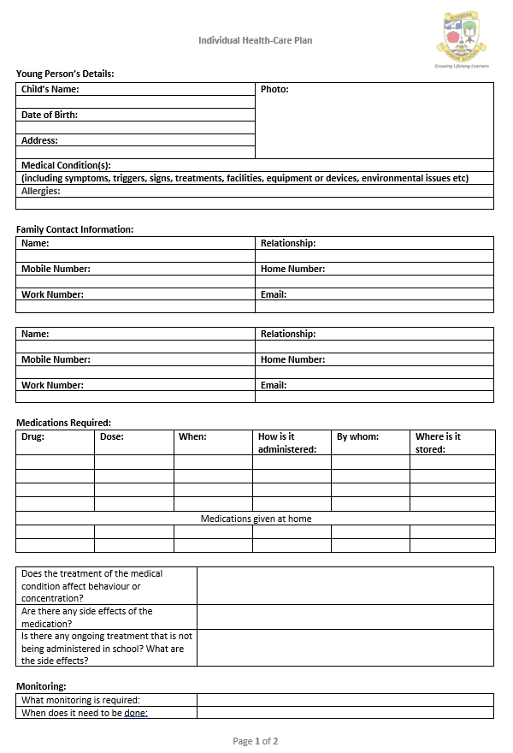
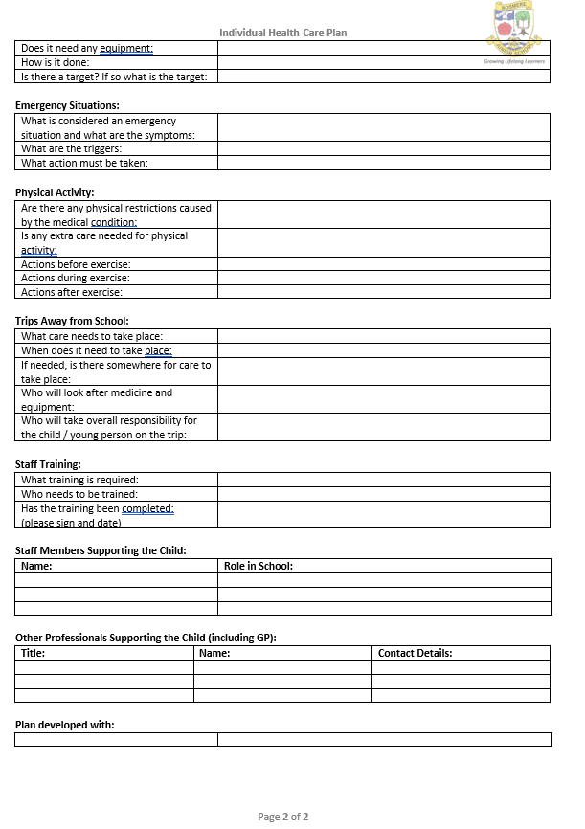
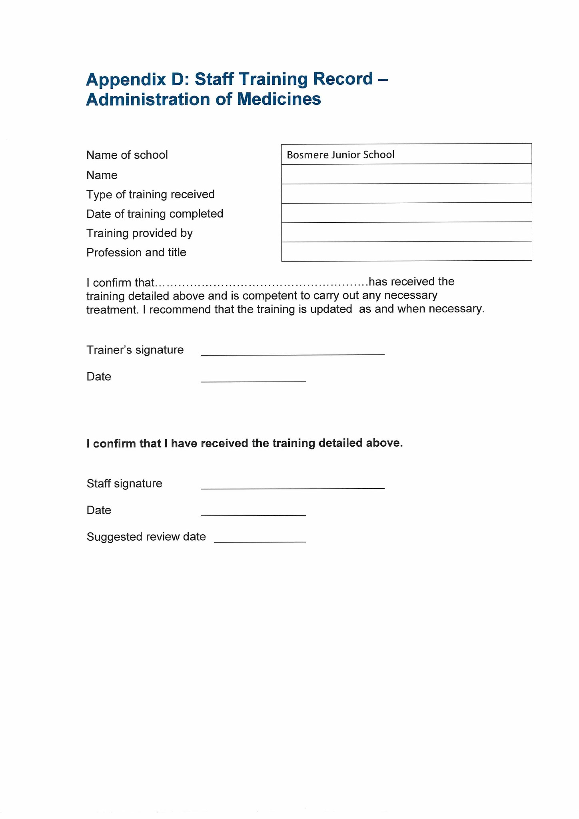
endix C parental agreement for setting to administer medicine

Appendix E: Parental Agreement for Bosmere Junior School to Administer Medicine

The school/setting will not give your child medicine unless you complete and sign this form, and the school or setting has a policy that the staff can administer medicine.

Date for review to be initiated by
Name of school/setting
Name of child
Date of birth
Group/class/form
Medical condition or illness
Medicine
Name/type of medicine
(as described on the container)
Expiry date
Dosage and method
Timing
Special precautions/other instructions
Are there any side effects that the school/setting needs to know about?
Self-administration – y/n
Procedures to take in an emergency
NB: Medicines must be in the original container as dispensed by the pharmacy

Contact Details
Name
Daytime telephone no.
Relationship to child
Address
I understand that I must deliver the medicine personally to | [agreed member of staff]

The above information is, to the best of my knowledge, accurate at the time of writing and I give consent to school/setting staff administering medicine in accordance with the school/setting policy. I will inform the school/setting immediately, in writing, if there is any change in dosage or frequency of the medication or if the medicine is stopped.

Signature(s) Date
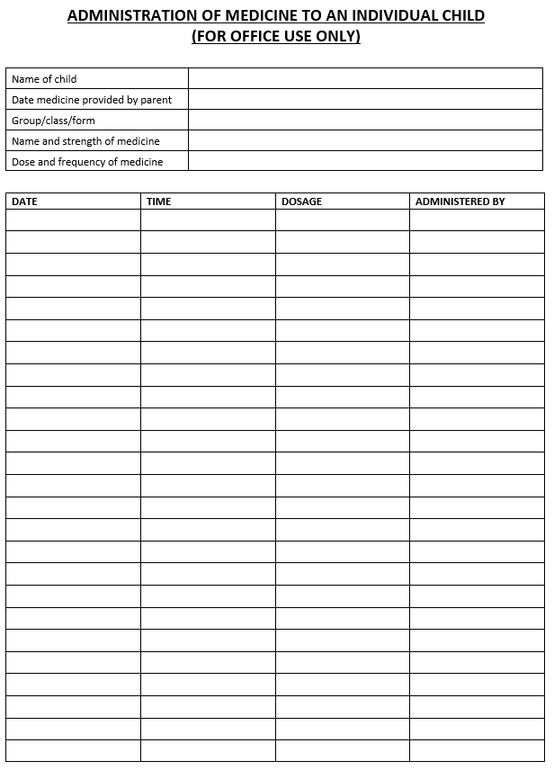
Appendix F



