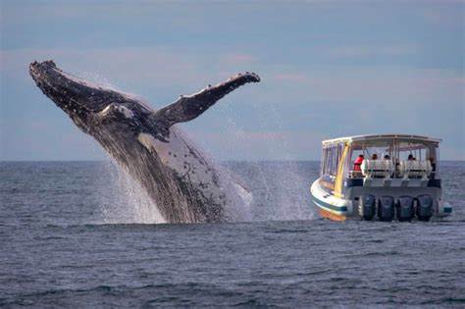
The Whale Watchers competition

BRITA is working with Whale and Dolphin Conservation (WDC) to help tackle single-use plastic pollution which has devastating effects on marine life including huge animals like whales and dolphins.
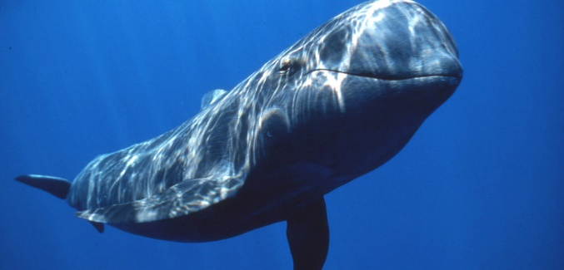
BRITA is inviting school children up-and-down the country to enter an exciting competition to win £3,000 to spend on a sustainability initiative of their choice, based on an area they are focused on improving within their school.

All you need to do is to create a unique and eye-catching design for the BRITA recycling bin that will inspire other people to reduce, reuse and recycle to protect the environment.
Collect your entry form from Mrs Dunn in the Library.
All entries need to be returned to Mrs Dunn
by Tuesday 11th October at the latest


