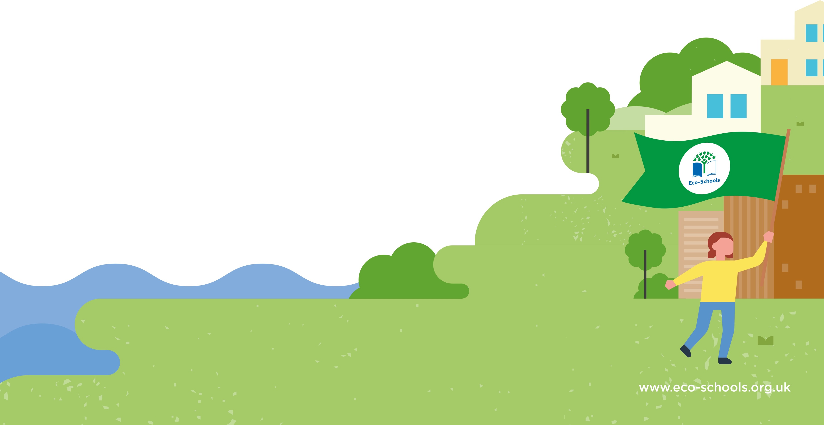
Action(s):
Class Keep Fit km
Encourage healthy snacks and lunches
PSHE – looking after our mental well being
Y4 Gardening projects
HEARTS mornings

How we will monitor progress:
Check recycling points every month

Evaluation:
How long will it take?
One half term – by December 2021

Who is responsible?
Class eco-rangers
Lunchtime Litter Pickers
Action(s):
Every class to turn off lights and monitors when not in use
Inform peers about saving energy in and out of school

Eco-Schools Topic:
Energy

Date:
How long will it take?
By April 2022

Who is responsible?
Class eco-ambassadors
Aim:
To encourage healthy bodies and healthy minds
How we will monitor progress:
Regular reports from class ambassadors
Evaluation:
Eco-Schools Topic:
Healthy Living

Aim:
To reduce, reuse and recycle more in all areas of school
Action(s):
Regular litter picks at lunchtimes
Create recycling points in classroom and hall
Eco-Schools Topic:
Waste

How long will it take?
Ongoing but we expect to see immediate effect

Who is responsible?
Class eco-monitors
How we will monitor progress:
Check meter readings
Evaluation:
Action Plan
Aim:
To reduce energy use in school

